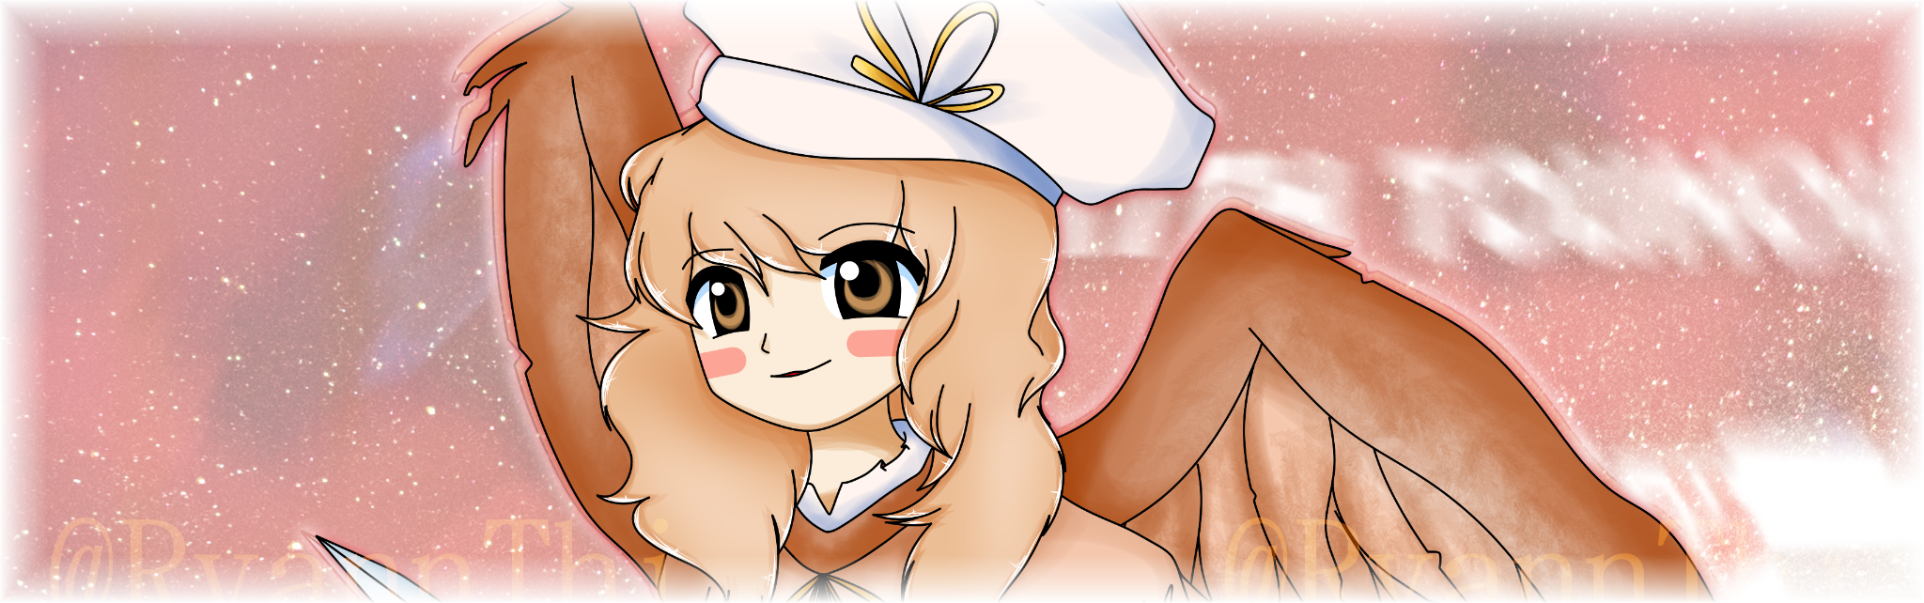

Hello everyone! If you don’t know me, I’m Ryann Thierry, developer of numerous fangames who has also participated in most editions of the Bullet Hell Artistry contest! My latest (and bronze winning!) entry to the contest was [*東方夢郷寇　～ the Renaissance of Vernacular Disassimilation*](https://ryann1908.itch.io/th-trovd), so you might know me from that. Also, I’m getting a bachelor’s in Game Design.

Just as a foreword, I don’t like ranking works in a specific numbered way, since I’m a big advocate for a more ample interpretation by using alphabetic/tier ranking, but since the contest rules limits to that, I’ll have to abide by it!

Who thought I’d see the day I’d become a judge 😭, either way, this is how I plan on ranking up the entries down below, which will make your entry be judged from 0 to 100 👇!

The table below is automatically updated from [this](https://docs.google.com/spreadsheets/u/0/d/1h6sfl92gLbHrZp1OVc0JNsvB-CZGhwmsgNSxH4sHJoQ/edit) spreadsheet of my rankings.

| Developer | Game Name | Pattern eval/ | Beauty eval/ | Misc. eval/ | **Total Score** |
| --- | --- | --- | --- | --- | --- |
| Luna & Roka | *Top 6 sussiest Touhou characters* | 15,33 | 15 | 4 | **34,33** |
| Zino | *Artisans of Bullet Hell* | 28,12 | 33 | 15 | **76,12** |
| Akemi Yume | *Project Seijun: Voiceless Innocence Vesselmancy* | 24,61 | 28 | 10 | **62,61** |
| Fuzzbearplush | *The Other Incident Solvers* | 23,28 | 22 | 11 | **56,28** |
| Makuta Matara | *Hell Sink Her* | 26,14 | 30 | 14 | **70,14** |
| Syoudre | *Dealing with Doppel Characters* | 25,7 | 35 | 17 | **77,7** |
| Pickled Cow | *BHA6* | 15,85 | 9 | 6 | **30,85** |
| razzy | *Random Boss Rush* | 28,66 | 19 | 10 | **57,66** |
| Kevinmonitor | *BHA6* | 24,66 | 21 | 7 | **52,66** |



# Pattern evaluation

* + 40 points in total across all patterns, divided across:
    - Glamour (aka prettiness)
    - [Fun](https://youtu.be/KvAJkvtr_Ng?t=1398)
    - Difficulty

*The top-notch patterns in my opinion are those who:*

*look great (has a good mixture of different danmaku styles, consistent coloration with the boss’ thematic, clear visibility when necessary (I do not disown patterns that explicitly use lack of visibility as their gimmick, but I don’t recommend having them in abundance in your game), etc);*

*are fun (properly telegraphed, with a defined objective (consistently dense/fast or nicely segmented presence of both and/or others);*

*and that have a solid difficulty (not varying* ***wildly*** *in comparison to other patterns shortly before this one, or proving to have a grasp as to when transition between gameplay styles/toughness)*

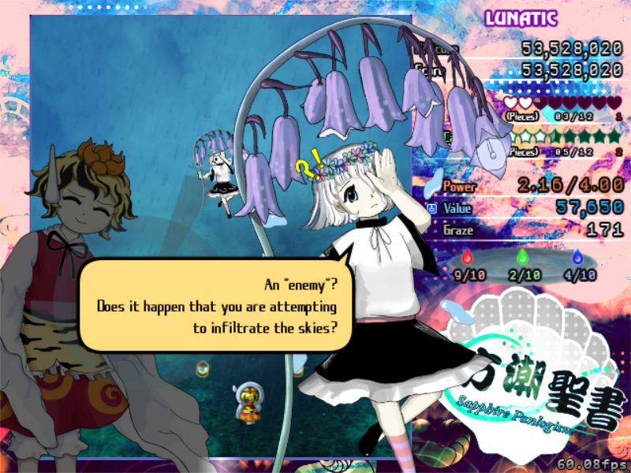

[*東方潮聖書 ～ Sapphire Panlogism*](https://urbanmagic.itch.io/thsp) is a fangame that has insane patterns! Everything was carefully crafted to perfectly match the characters featured in the work and has become a staple for me when thinking of fun, unique fangames. The difficulty is also very consistent with only a few tough spikes here and there, but in the bigger picture, it’s very nicely sparkled.

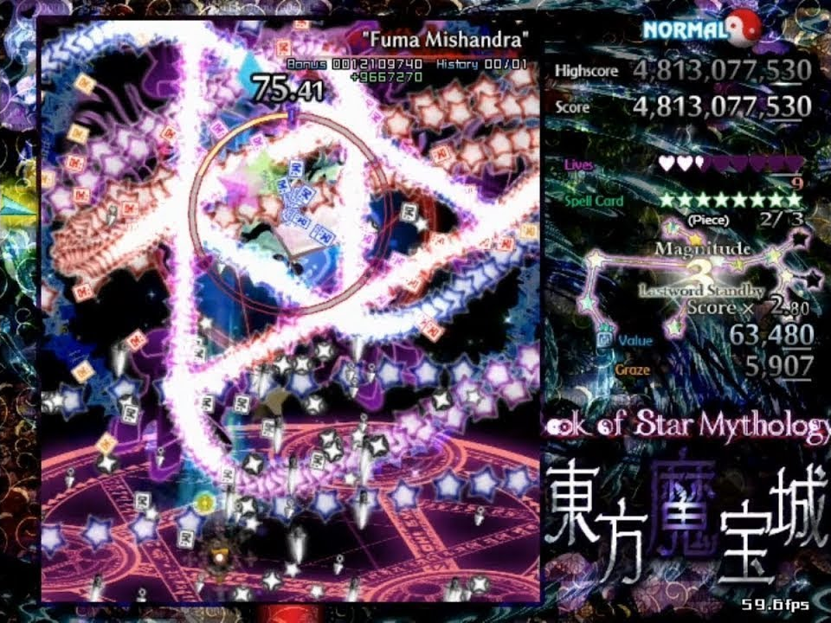

[*東方魔宝城 ～ Book of Star Mythology*](https://cyber-mace.wixsite.com/th-bosm/home) is another incredible example of fun, fair danmaku that grabs you alongside all of its helping elements and pulls you in for a great ride. It’s one of the most known fangames for a reason! Sometimes the flashiness is a little too much in terms of visibility, but overall, it is very well architectured!

# 

# Beauty/atmosphere evaluation

* + 40 points in general, divided across:
    - Style
    - Consistency
    - Music and Sound

*Having a beautifully crafted entry to me is one of the most important things in my opinion, since most of the time the first impressions are the ones who stick! Personally, this begins at the game’s download page itself, but I can’t rank that up. In that case, I’ll be looking for:*

*solid style (having an entry with a precise pixel style, or hand drawn aesthetics, or anime styled visuals, or accurate recreation of ZUN’s style, you name it, will definitely count! If you’re able to follow a unique or good arrangement of your elements, portraits, interface, and any other things that contribute to your visual identity, I will very much enjoy it!);*

*consistency (keeping the style you chose for your entry to a T in regards to consistency is definitely important, you wouldn’t want your* [*Bendy and the Ink Machine*](https://joeydrewstudios.com/batim)*-style HUD to clash with your* [*Blue Devil in the Belvedere*](https://store.steampowered.com/app/1365750/__Blue_devil_in_theBelvedere/)*-styled portraits);*

*music and sound (a huge part of immersion is making sure the viewer gets entranced within your project, and music and sound play a huge part on that; a good placement of your sounds could greatly improve the perception of the player on a pattern of yours! not only that, but a killer track could also pump the player’s heart up and get them excited to see what’s coming up next!)*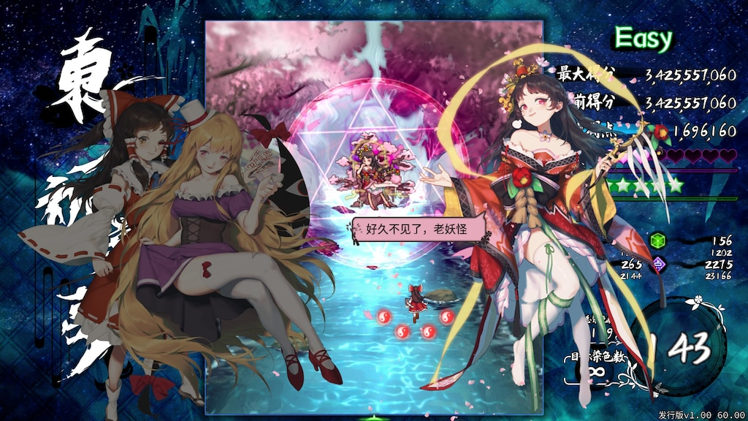

[*东方祈华梦 ～ Elegant Impermanence of Sakura*](https://store.steampowered.com/app/1252320/Touhou_Kikamu__Elegant_Impermanence_of_Sakura/) is a gorgeous game with impeccable immersion and lovely visuals. The game itself is a lesson to many developers on how to reach an amazing presentation and create a very satisfying experience. 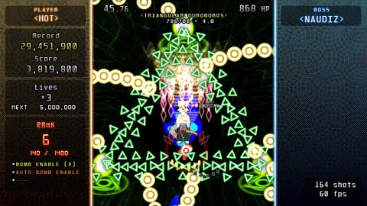

Deviating a little from the usual Touhou fare, [*The Nameless Avatar*](https://dogsday.itch.io/tna) is also another example of great consistency and adherence to a set style, embracing the alternative shmup style and delivering a fantastic experience.

# 

# Miscellaneous evaluation

* + 20 points in general, divided across:
    - Optimization/polish
    - Quirkiness

*This category is more so a combination of other things I think are good to have, but don’t necessitate their own category.*

*For a pleasant experience to anyone playing your game, it’s optimal to have good optimization (lol). Make sure you’re using your resources efficiently and if possible, test your game on lower-end machines to ensure a nice gameplay flow. Providing accessibility options is also a bonus! I will pay attention if your game features access to stuff like that.  
 I also* ***LOVE*** *avant-garde stuff in any game. If you have anything interesting to offer by developing an unique experience or having any quirky mechanic in your game that still abides by the guidelines I’ve mentioned before, you’ll truly have my heart 💖*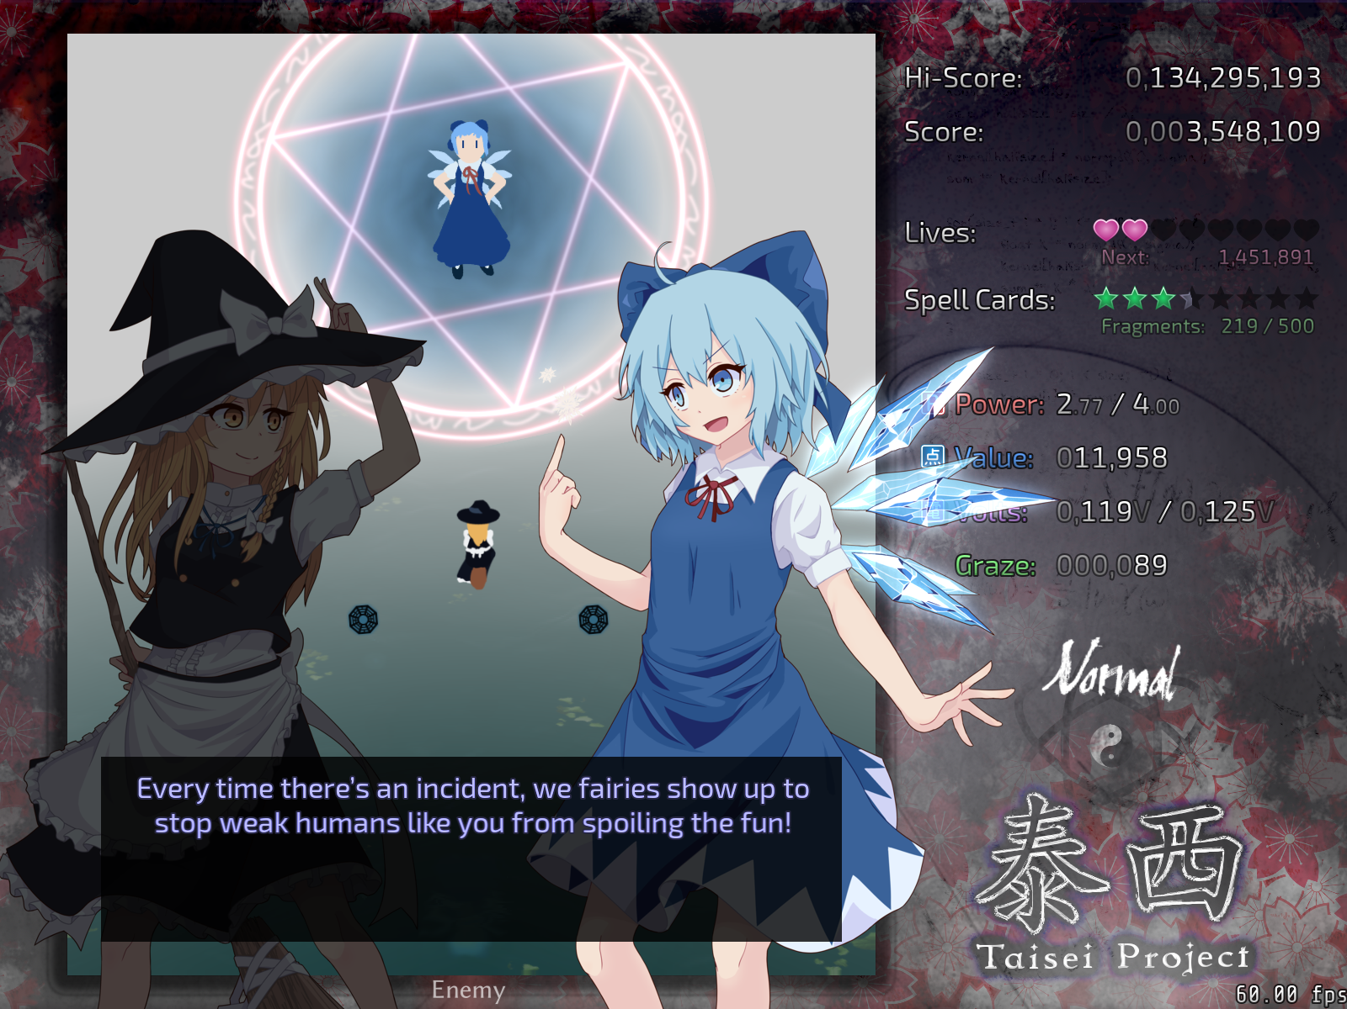

Some excellently optimized fangames include [*Taisei Project*](https://taisei-project.org/), which not only is built from the ground up in a self-made engine, features awesome effects and runs marvelously even in the lowest of ends computers. Adding performance options to your game is already a huge step to help people with lower specs to play it!

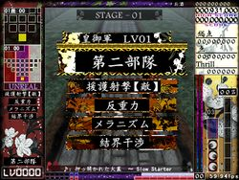

And another (partially controversial) work that I’ve come to adore is [*連縁天影戦記　～ Brilliant pagoda or haze castle*](http://mugentrick.tubakurame.com/Lenen/Teneisenki_main_en.html), a game with a myriad of awesome (yet, kinda flawed) mechanics that greatly adds replayability and hooks me in with the set of diverse combinations you can come up with in the game. It’s certainly very quirky! I could also mention similarly styled games such as [100th Black Market](https://store.steampowered.com/app/2097720/Black_Market_of_Bulletphilia___100th_Black_Market/), [Impossible Spell Card](https://store.steampowered.com/app/937570/Danmaku_Amanojaku__Impossible_Spell_Card/) and so on.

**Game Analysis**

First of all, congratulations to everyone who submitted their entries! And also, better luck next time to those who attempted but weren’t able to complete them in time. What matters is your dedication to your projects and the evolution you went through that you were able to gather from developing these games! I suggest reading stuff from all the entries since a lot of things I comment about them can be applied for most if not all entries too.

Now, I’ll write down the analysis I made from all of these games starting off by time of submission. Btw, here’s my first impressions on all of them: [Bullet Hell Artistry 6 - Live Impressions](https://youtu.be/LEnmGHzB_x8)

## Top 6 sussiest Touhou Characters

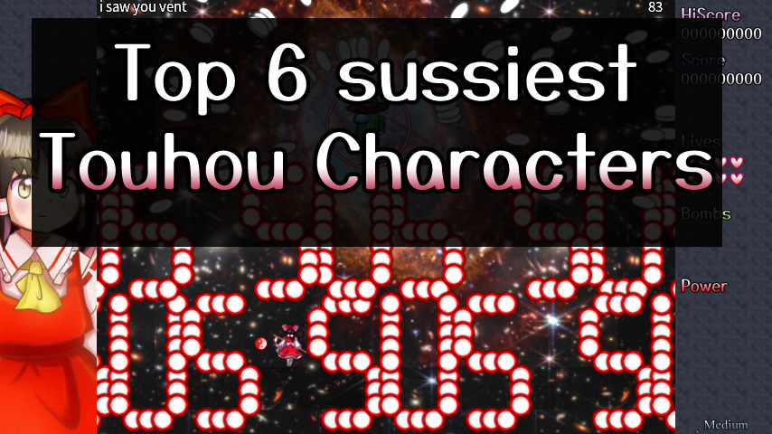

*Developed by: Luna & Roka*

*Engine: Custom (with very good performance according to the devs)*

This was definitely not something I was expecting from these developers (even though Roka *has* done a peculiar project called SiMP before…), but the comical nature of it definitely super resembles the nature of a certain other developer also present at this contest… Either way, it’s a quick and nice little game.

Information about the game came alongside the Discord post Luna made submitting the entry talking a little bit about the game.

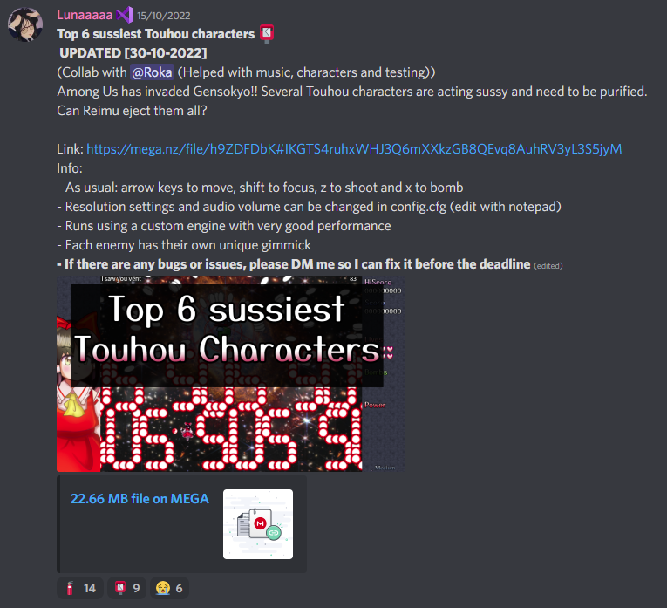

Which isn’t the most elegant way of presenting it, but what’s important is that it exists!

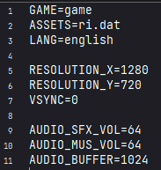

The settings file is the only place that can be altered to change the game’s options. A little bit inorganic, but better than nothing. Unfortunately no full screen option.

Also, they work, so that’s good (even though I don’t know what’s audio buffer but that’s ok).

But let’s get into the actual game already.

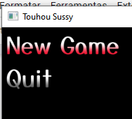

Again, it’s a shame there’s no options in the title screen because that’s definitely a first step into having good accessibility. By the way, could we also just call this game Touhou Sussy?

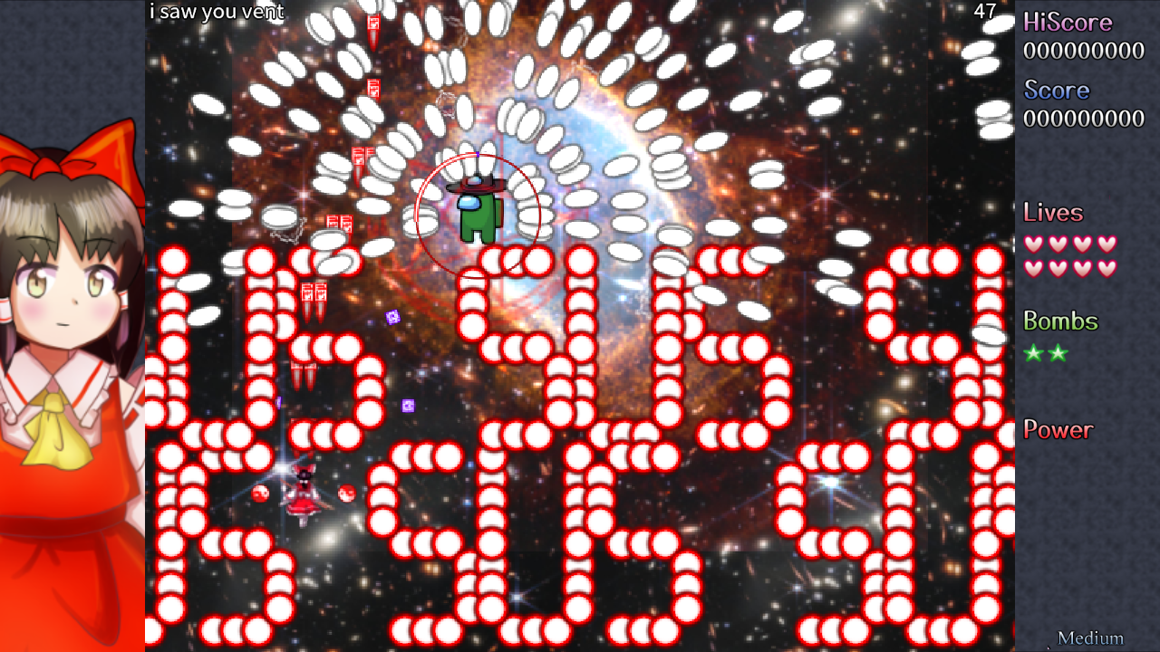

After selecting New Game from the main menu, we’re shot into action pretty much immediately after the game starts. We’re greeted by this tEoSD-inspired HUD and this cute Reimu and a character that I most surely cannot tell if it is official or an OC.

Attack 1: ***“i saw you vent”*** | **Score: 9**

The first attack “i saw you vent” (pictured above) is a near-static pattern of horizontally scrolling SUSmaku and a slightly random white jelly forming an arch over the player. You must cross between the SUSmake while still trying to shoot the boss. It’s a pretty simple pattern so not much to say here. Pretty fair I suppose.

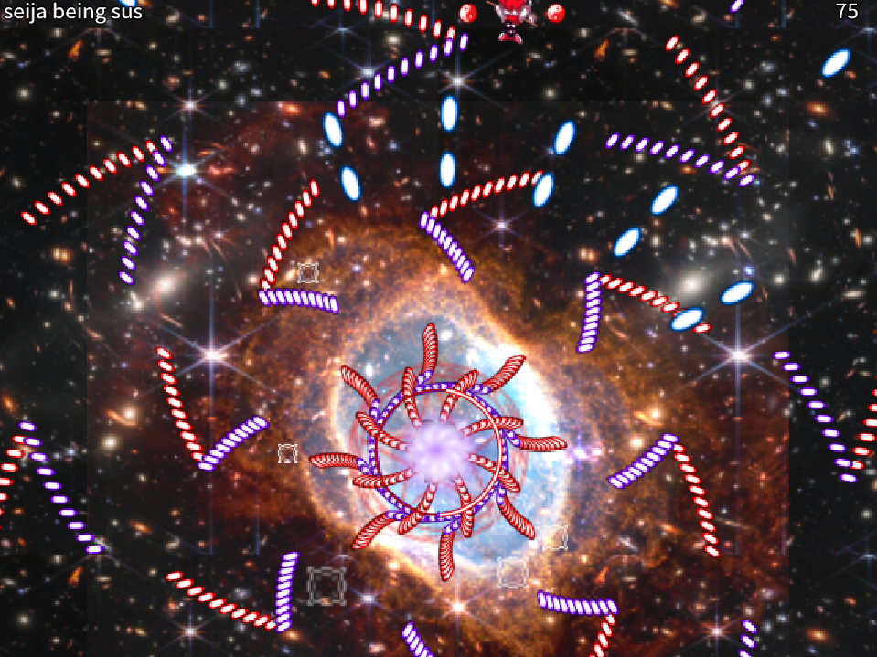

Attack 2: ***“seija being sus”*** | **Score: 13**

This one already takes the first shot at having a different mechanic than a basic pattern. It tilts the screen, much like the character it’s based on, but it’s still a very much static pattern with not a lot of value attached to it. It only tilts once, so you’re stuck in this upside down state until you manage to finish off the attack, which ain’t the most fun thing. It’s a little bit disorienting at the beginning, but it gets manageable after a little while.

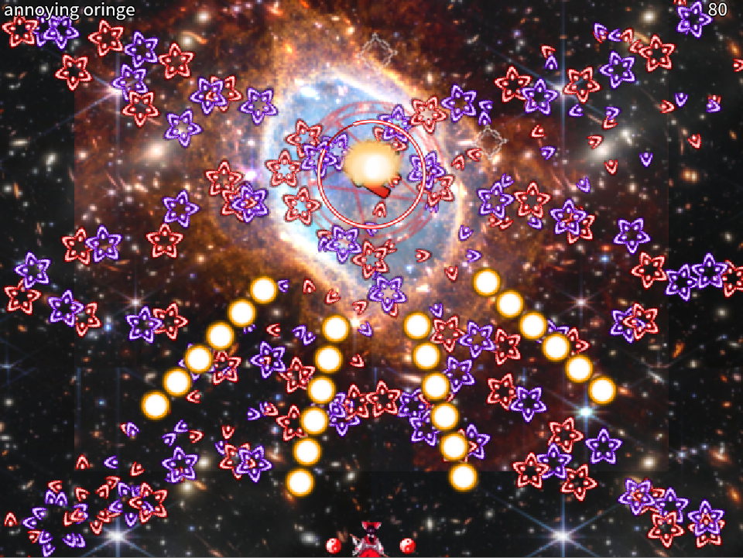

Attack 3: ***“annoying oringe”*** | **Score: 15**

Another simple pattern, though I do like the semi symmetry here. Though I definitely thought of Chen instead when seeing this for the first time. I like the micrododging here though, so far the most precise pattern out of the other ones.

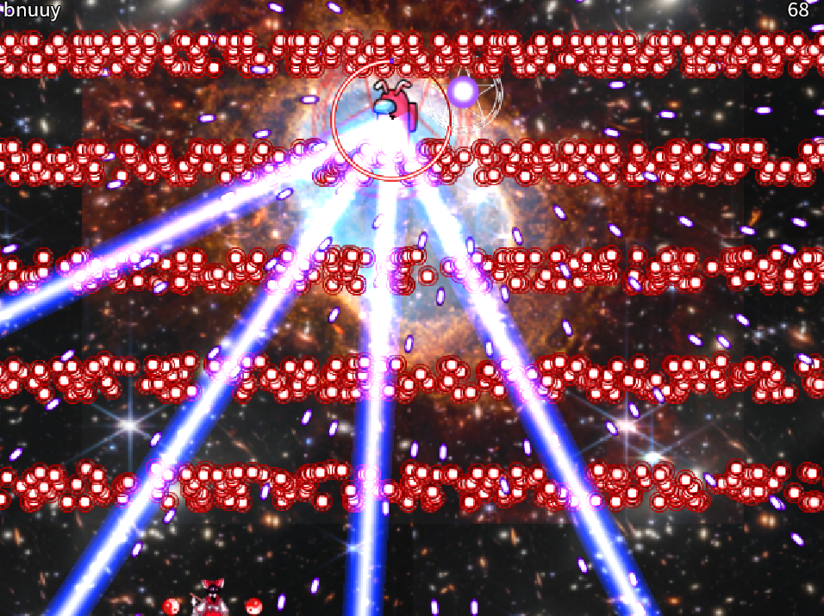

Attack 4: ***“bnuuy”*** | **Score: 17**

Lasers! This one is definitely in character with Reisen. However the red walls take too long to reach the player and the lasers aren’t an active thread for the player to be in danger, so it leaves a blank space in terms of dodging. After you die, this repeats, so it’s a little bit boring

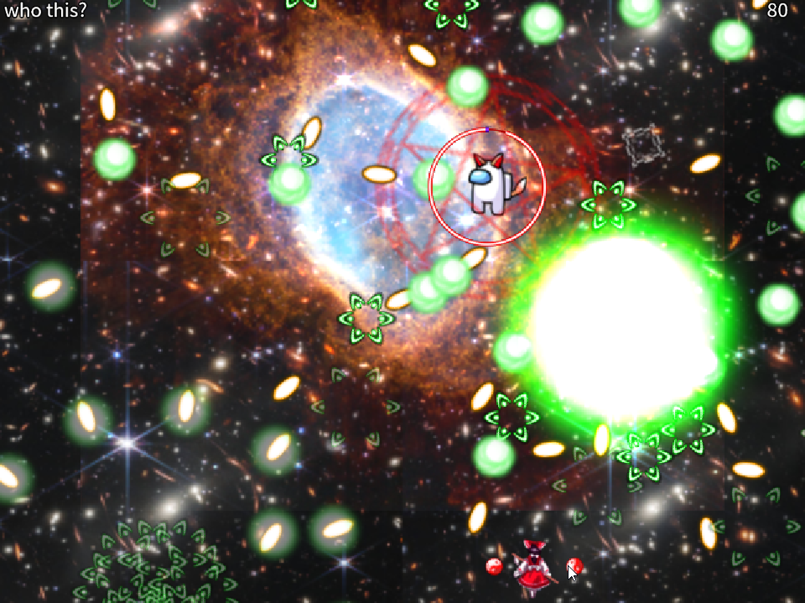

Attack 5: ***“who this?”*** | **Score: 18**

For real, I don’t know who this is supposed to be, lmao. This is a little bit more engaging though, since it takes the skill to predict when the bullets will finish fading. Reminds me of UM’s extra stage.

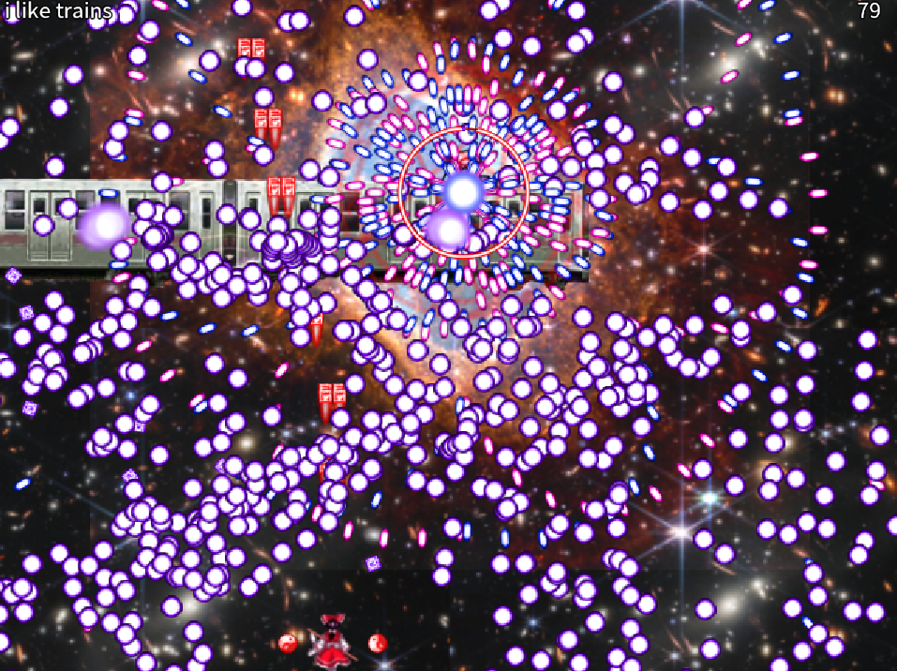

Attack 6: ***“i like trains”*** | **Score: 20**

Love the reference on the spell name. This one’s definitely the best pattern in the game. Snappy, cool looking and fair to dodge. I love the use of Yukari’s actual train image from the fighting games shooting danmaku. Also, the amulets kept following the train.

Overall, it’s not a very complex game, but perhaps it’s more of a tech demo for the engine? In gameplay, I felt like Reimu was perhaps a little too weak, and her bomb felt weak and a little underwhelming as well. It only having the minimum required pattern count also increases the perception of it being basic.

Regarding ***beauty/atmosphere stuff***:

The game seems to be aiming for a tEoSD-like inspired design, though while succeeding in some parts, in general it doesn’t hold up to full consistency. I assume it’s because the engine is still very much in development and is not ready for its full potential, but the beginning of this is promising. I’m glad the developers mentioned that the music is based off of the Among Us chime during chatting, because otherwise I wouldn’t have noticed this golden reference. The main menu/pause are very crude and could definitely have more work on them. The Reimu chilling on the left side of the screen is also kinda random. The background was also… very strange. You could see the cropping marks of the galaxy background texture. Some fonts didn’t match up either, such as the spell name and timer being very basic compared to what’s usually in place. Power didn’t really need to be shown if there’s no such a system in place here. In general, the pacing was a little bit chaotic, and I wish I had a little bit of a smoother impression. The ending was pretty sudden too.

Talking about music and sound, I don’t have much else to comment on, but I’m glad all attacks have proper shooting sounds and keep things engaging, and so do the menus. The only critique I have on them is that the player death sound is too low compared to the rest of the sound effects.

***Score: 15***

Regarding ***miscellaneous stuff***:

As I mentioned, the game’s lack of easy-to-access settings already is something that is a shame to me, but also some other basic things could be added to the project, such as the ability to restart the game. However, since it is a direct-to-action game, it isn’t such a problem to just hit Quit at the pause menu and then New Game again, but the less clicks/selects you have in your game to do an action like this, the better. Overall, it just needs more development and polish to the engine.

***Score: 4***

## Touhou - Artisans of Bullet Hell

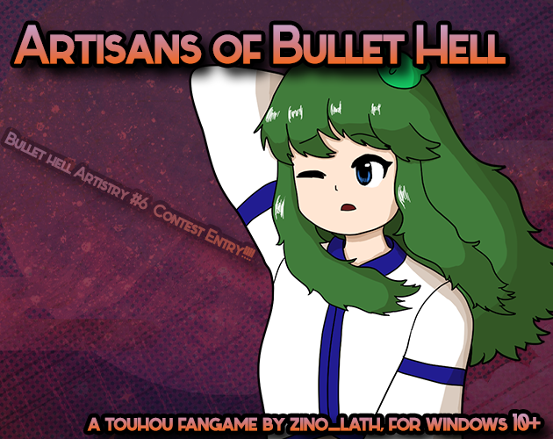

*Developed by: Zino*

*Engine: LuaSTG-Sub*

This is another game from a recurring contestant, Zino! This time with a slight engine change and a lot more polish from their previous entry (if you could consider that a proper submission…). Regardless, the script succeeded in meeting my expectations from this user, especially regarding danmaku.

Information about the game came alongside the Discord post Zino made submitting the entry and also the itch.io page the game is hosted on.

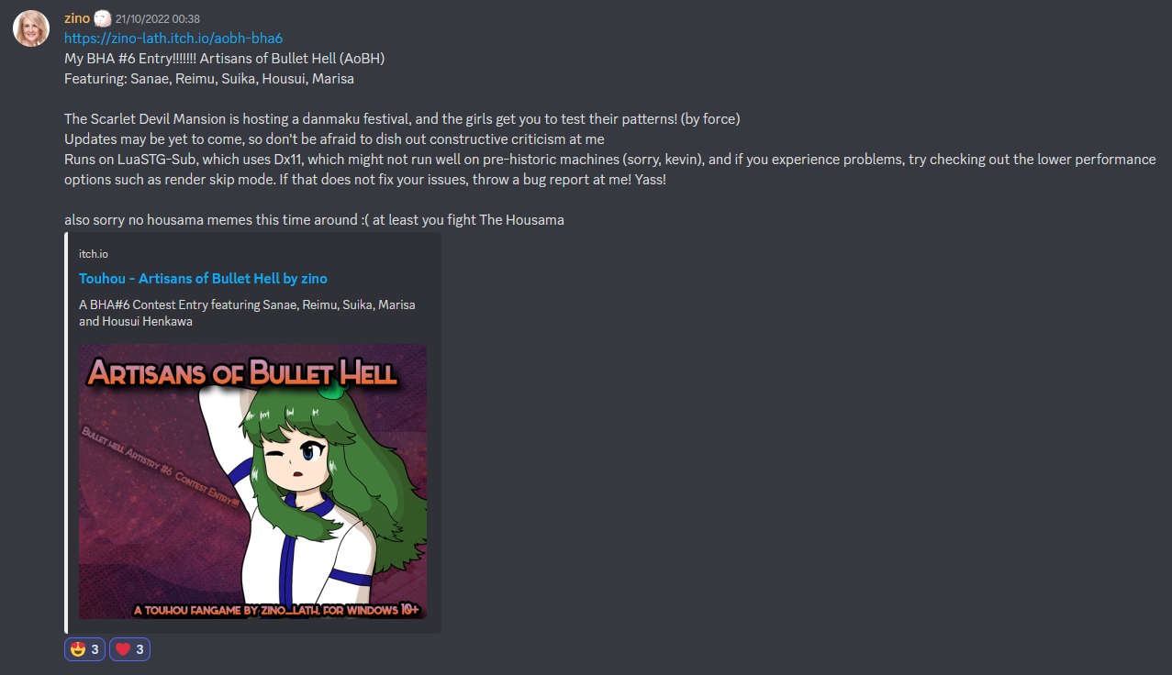

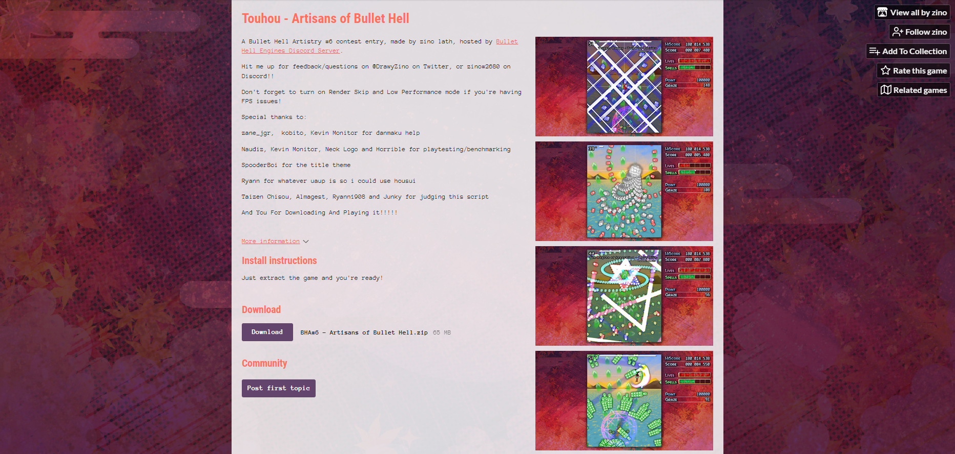

The page is pretty concise when comparing it with the game’s visuals, which is awesome.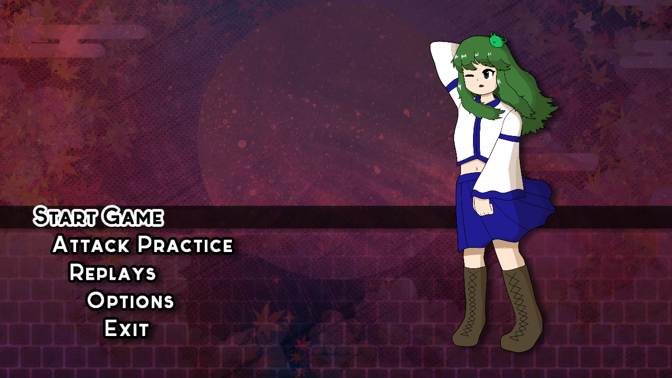

Starting off the game, you can see some work was definitely put in this title screen. However, it boggles me why the heck there is no logo or text about the game’s name. It’s just something commonly essential to a title screen, especially in Touhou style. The selection dynamic is a little bit slow to my taste, but nothing extraordinary. They work! And as I can see, you don’t have to wait for the visuals to update to enter one of the options, it just jumps to the next action as you select it. The music’s great, too! It definitely sets a good mood for the player. Wish it displayed who composed it, though. Credits are only listed on the itch.io page. It’s a good step, though. Thanks for including attack practice?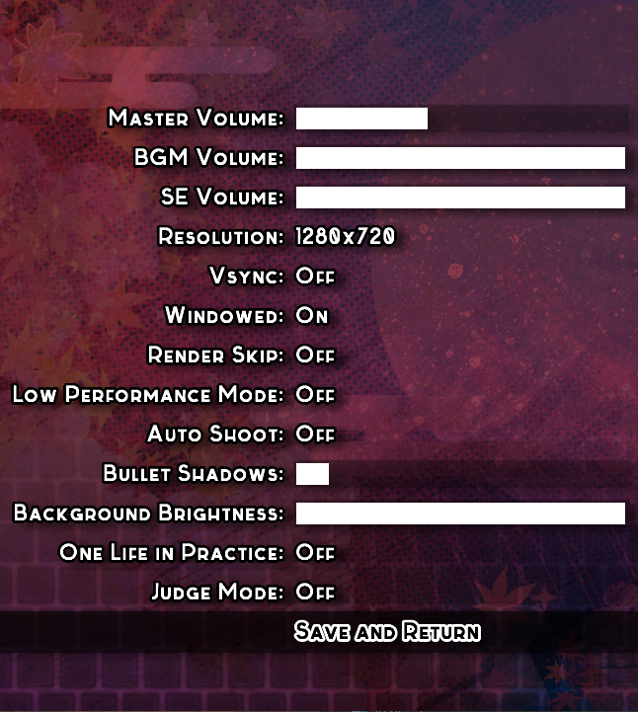

The options menu offers *plenty* of settings, which is phenomenal (some things here are especially rare to see in smaller games like these). However I did notice a bug where reducing the master volume previews it to you in real-time, but not increasing it back (in fact, it just decreases it even more).

I’m happy to see a simple yet combinatory type of player selection, too.

I forgot to mention, but I do think 16:9 Touhou games are a charm in and out of themselves. I think 4:3 fits a lot more Touhou games with either a big focus on replicating ZUN’s stuff or trying to develop something more classic-like. This game feels very modern in its conception and it pays off quite nicely.

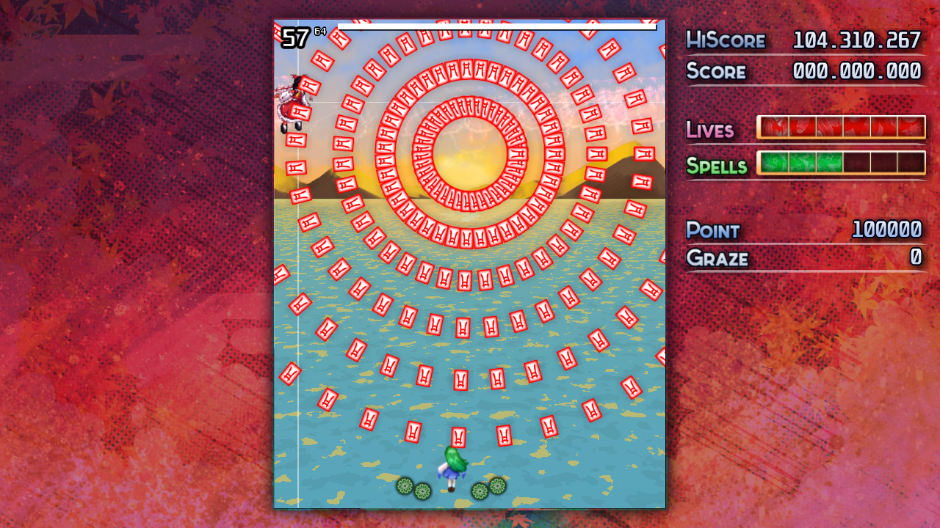

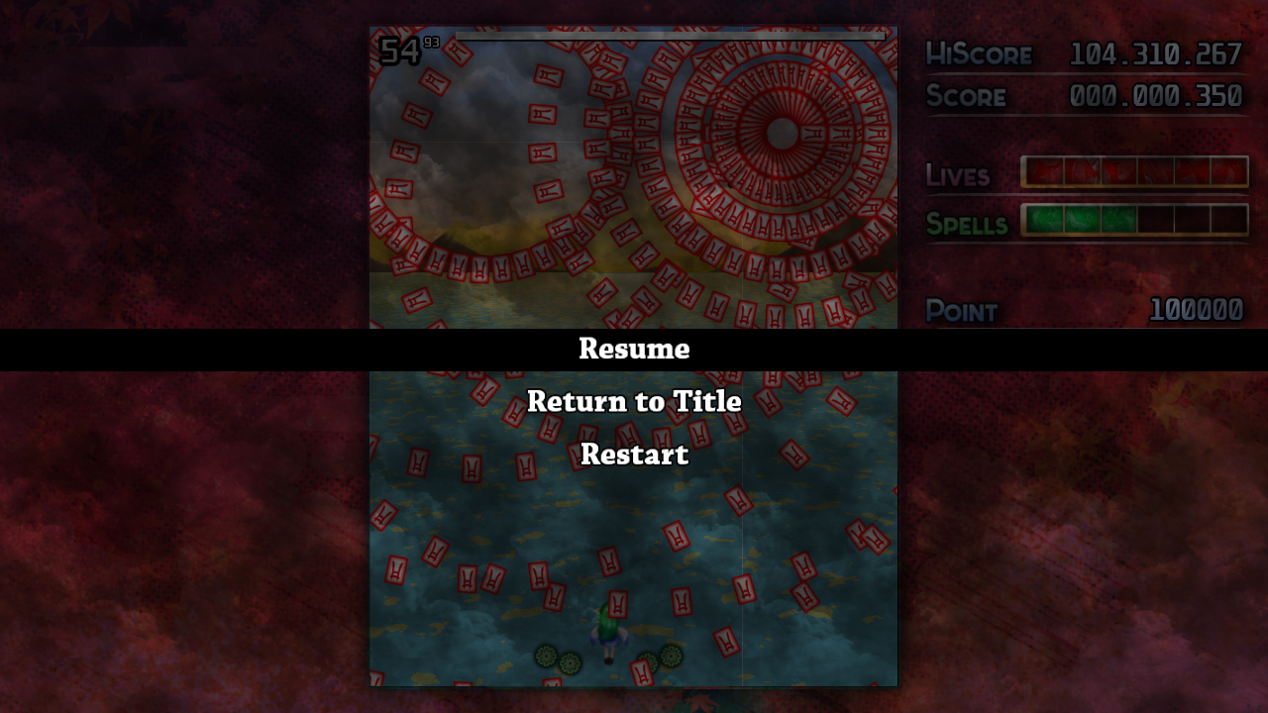

After choosing our preferred shot type and bomb, we are nearly abruptly introduced to the first boss of the game, Reimu. After pausing to take this screenshot, I’d like to mention the pause screen could definitely have a little bit more work on it to be consistent with the rest of the game, as it feels dark, gloomy and dirty which definitely isn’t the same vibes that the rest of the entry gives. The default LuaSTG fonts help feed the feeling it’s not very well polished, not to mention no sound effects, but alas.

Attack 1: ***Nonspell (Reimu)*** | **Score: 26**

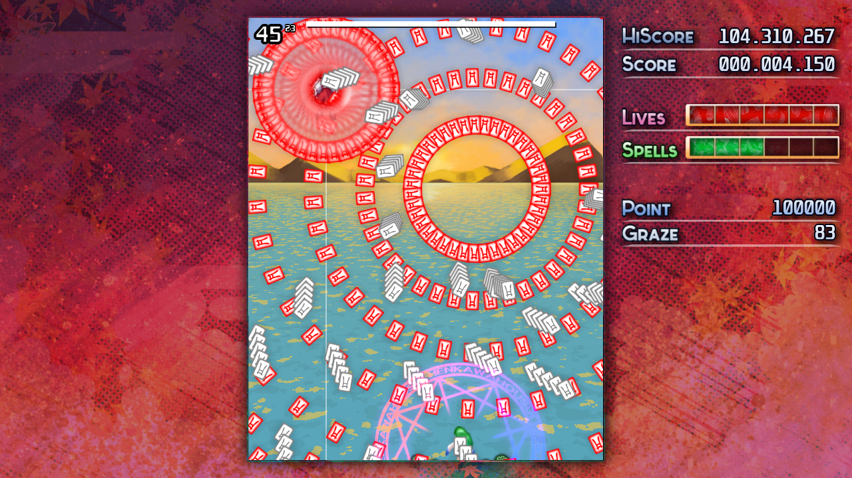

It’s a simple Reimu attack, but it is a great first introduction to the game. Not too hard, but not boring. Very in-character with Reimu. The last white amulet bullets can be a little hectic to deal with, but with a good strategy it’s not difficult to avoid them. Feels nice to play.

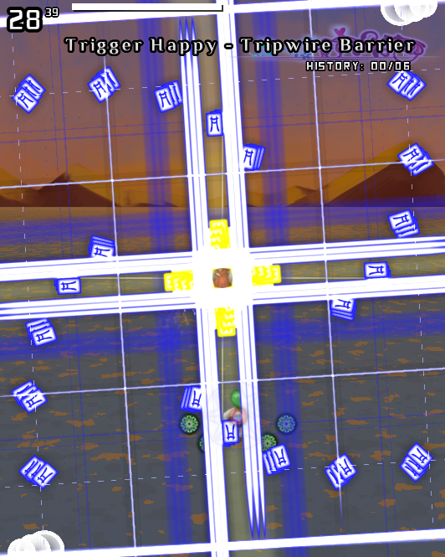

Attack 2: ***“Trigger Happy - Tripwire Barrier”*** | **Score: 32**

Before I even get to talk about the pattern itself, I’d like to mention it’s heavily triggering (lol) to see spell card names written like this, instead of the conventional *Text Sign “Text Here”* sort of default. I understand this could be a creative liberty taken by the author, but it just feels off.

Okay, now, about the pattern itself: I really enjoy the concept behind it, but the execution could be a little bit better. The telegraphing tools aren’t the best, they definitely could be clearer, and maybe a little bit less bland-looking (though I can understand if it is this simple to not obstruct player vision), and perhaps the timing between the waves could be bigger (in general, my opinions would to nerf this pattern a little more). Fits Reimu!

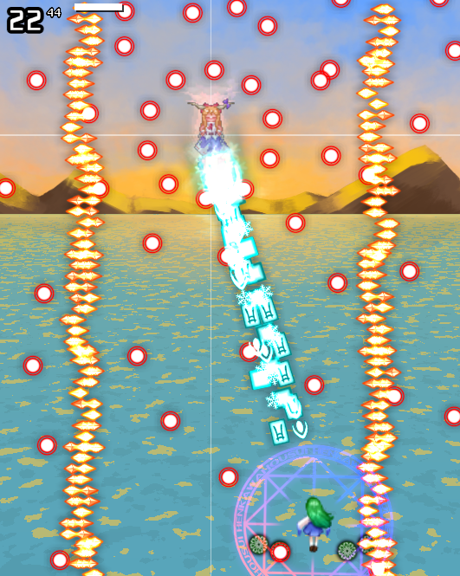

Attack 3: ***Nonspell (Suika)***| **Score: 28**

Switching up characters now, we have Suika. Not much to say about this nonspell, other than it can be a little overwhelming (sorta like the other attacks) at first glance. Replaying it shows how easy it can be, so while it’s not a free spell, it’s definitely a very learnable one. Again, the telegraphing is a little bland, but it works well this time around. This one feels a little in character too.

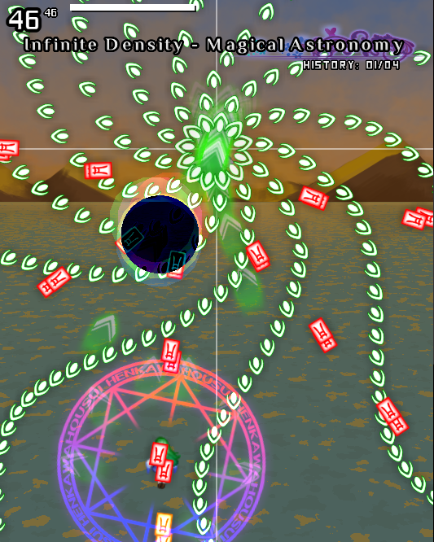

Attack 4: ***“Infinite Density - Magical Astronomy”*** | **Score: 21**

I won’t say this one disappointed me, but I definitely had higher expectations when I saw this kinda cool looking black hole pop out into the game. The pattern is also pretty easy compared to everything else up to this point, so it gives out this kind of unfinished vibes. I appreciate the blinking and coloring changing of the bullets whenever the “effect” happens. I also definitely expected something more related to micrododging seeing the “infinite density” part of the spell card title.

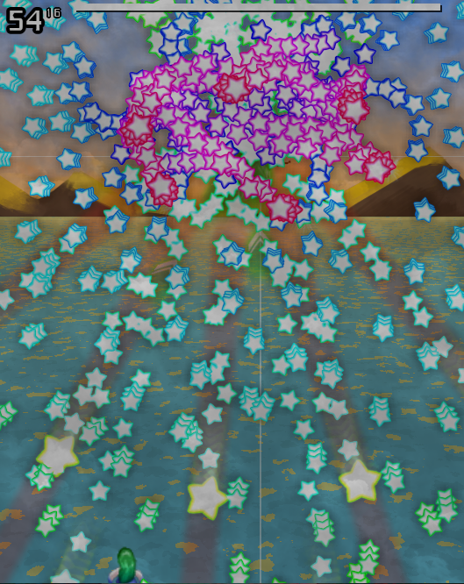

Attack 5: ***Nonspell (Marisa)*** | **Score: 26**

Not the most complex looking thing, but I appreciate how thematically accurate this nonspell is to Marisa. Simple, but kinda fun to dodge. Not much to say I suppose.

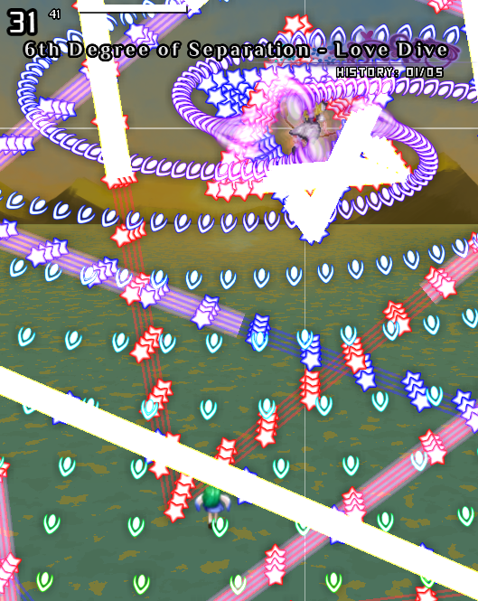

Attack 6: ***“6th Degree of Separation - Love Dive”*** | **Score: 36**

Probably the coolest spell in the game! Has the right amount of player engagement, looks fun to watch and is fun to play. The visuals of it are great, and due to it being a little more focused on tight dodges and calculated moves, the only thing that suffers on this spell is the health amount, since most of the time the player will be right below Marisa dealing tons of damage. Feels like a fresh take on Marisa yet very in character for her!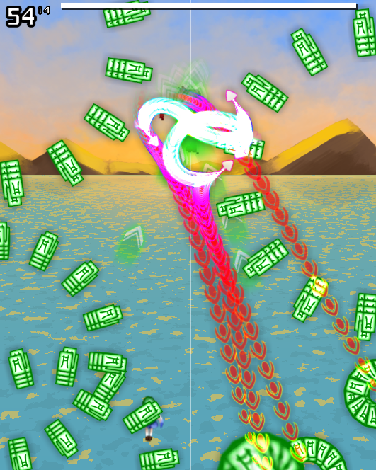

Attack 7: ***Nonspell (Housui)*** | **Score: 29**

Probably the most complex looking nonspell of the game. The curves created by Housui are cool and not hard to dodge, and it feels very diverse every time I play it, the visual flair adds a lot to it. The only suggestion I’d have for this non is to make the colors of the amulets spawned diverse too, and perhaps add a little more health?

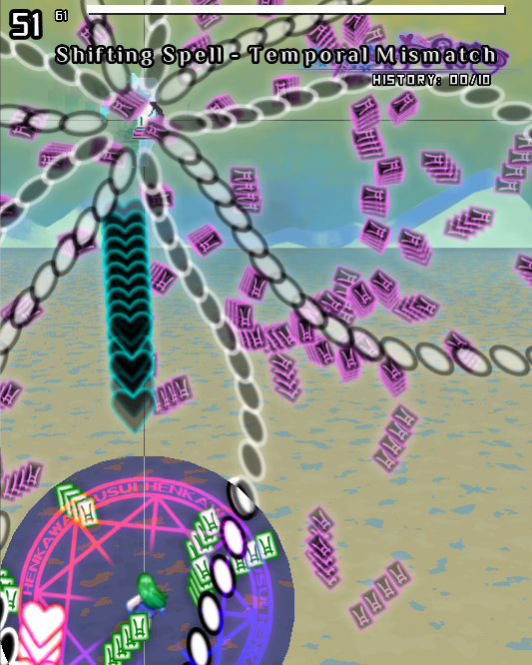

Attack 8: ***“Shifting Spell - Temporal Mismatch”*** | **Score: 27**

Perhaps the hardest attack of the game. The waves feel very unpredictable and the delay between the outer circle and the inner one is massive, and to complicate things further, the area to dodge is tight and the speed some of the bullets here travel is very complex to determine when is the right time to move. Housui moves all over the place and that interferes directly with the expected danmaku angles and it’s definitely hard. I was only able to capture it once and if there is a specific strategy I should’ve tried, it definitely didn’t come to me. Despite that, it’s an interesting finisher, but not as grand as I expected.

Mechanically wise, I felt like dying could have a little bit more of an impact within the game in terms of a tangible feeling of death. Len’en (pardon me using Len’en as a standpoint) makes you have a grasp when colliding with a bullet, and, since this game has a deathbomb gap similar to that of the JynX’s series, it would make sense to inform the player via a more intense visual stimulus and/or a sound effect when hitting a projectile. Post-death could also be improved by just following the trend of having the player blink repeatedly (even if subtly) to inform the user you’re still within the invulnerability frames. I understand the magic circle beneath the player is used to symbolize that, but personally I only really noticed that’s the reason it exists after a couple deaths already.

The shot types don’t really feel the best to use, there’s not much feedback to the player whether they are really hitting and they don’t feel powerful (the fade out effect is very subtle when hitting entities, and there is no shooting or hitting sounds for them)

Regarding ***beauty/atmosphere stuff***:

I love the intensity the game has following a more modern take on Touhou, the interfaces are mostly consistent between themselves and I enjoy the style the visuals present to us. The only character portrait in the game is Sanae, on the title screen. The drawing isn’t the most polished, but the dynamics of the portrait fit well within the vibes the title screen and the remaining content of the entry gives.

I’d like to shout out for the background design too, despite being a colorful afternoon scenery, I found no problem in being able to distinguish bullets from the semi-bright background they’re rendered over. This could also be extended to the bullet graphics themselves, which have very clearly defined borders and have shadows under them (optionally, thanks!).

Despite having a pretty original title screen, I couldn’t help but notice the unfortunate addition of CtC sprites as the boss sprites (except Housui) and using uncredited music during the boss battles, which in my opinion doesn’t really fit well within the context of the game.

I don’t really enjoy using a white cross to denote the boss position, but it’s better than nothing, though I’d really like if it was also optional alongside some other features the game provides while also having the typical Touhou boss marker in the bottom of the UI during the game.

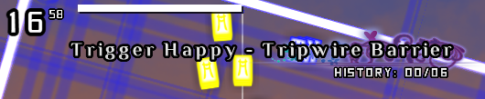

One other thing I’d like to mention is that the spell card label display also feels a little inconsistent with the rest of the interface (font wise, image-style wise, positioning is also a little weird).

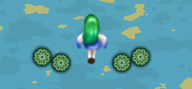

Something regarding the player itself is how it feels like Sanae’s options have more of an importance than her… herself, I guess. The shadows beneath them just give out this vibe of importance while the player feels like just an asset between them. Honestly, I’d prefer if this shadow was swapped out between them or removed entirely. The item graphics also feature this intense shadow which isn’t necessary either.

In general, I can see this game having a lot more to it if it had more development time. I miss this “depth” that the title screen music gives to it at the beginning of the entry, as it turns out to be way more of an arcade-like experience than more so of an atmospheric journey.

***Score: 33***

Regarding ***miscellaneous stuff***:

I greatly appreciate the thought-out options screen with a lot of accessibility options and easy user interface (you only missed input settings in-game!!), which definitely is something that most scripts miss out on when they release. The author's disposition to be open about contacting them and accepting feedback is commendable, too, and I also appreciate them actually putting out their entry to the public, which is an advance for them considering their last entry went into the forgotten pits of unlisted projects…

Despite me being able to see a lot of areas that could have a little bit more polish, I’m afraid it would be too untasteful of me to point them out and deduct points considering this still is a game jam with not a lot of time in hands of the developers to fix everything up. The features this game offers is already a huge step forward so I’ll use that as the holder for the other things I thought could be better.

The only thing missing out on this category to get a perfect score would be gimickyness. The game ain’t be wildin’!

***Score: 15***

## Project Seijun: Voiceless Innocence Vesselmancy

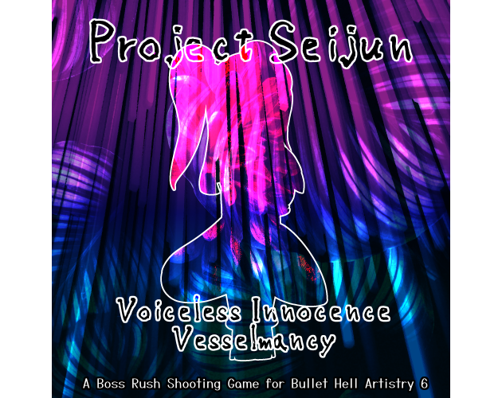

*Developed by: Akemi Yume*

*Engine: Danmakufu ph3sx*

I’m glad to see another returning contestant here, especially considering Akemi conquered *twice* spots at previous editions' top 3 rankings! This game has very interesting patterns and I’m happy to see a plethora of original characters featured!

Information about the game came alongside the Discord post Akemi made submitting the entry and also the itch.io page the game is hosted on.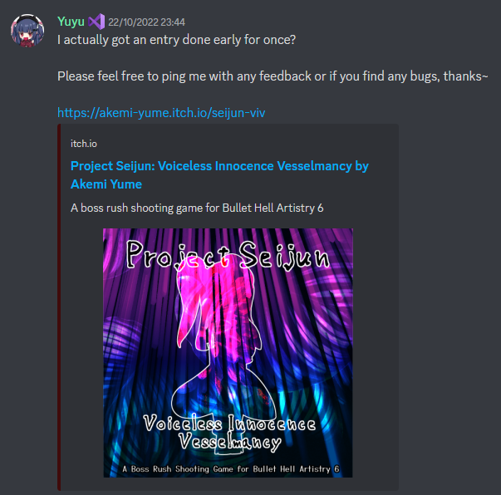

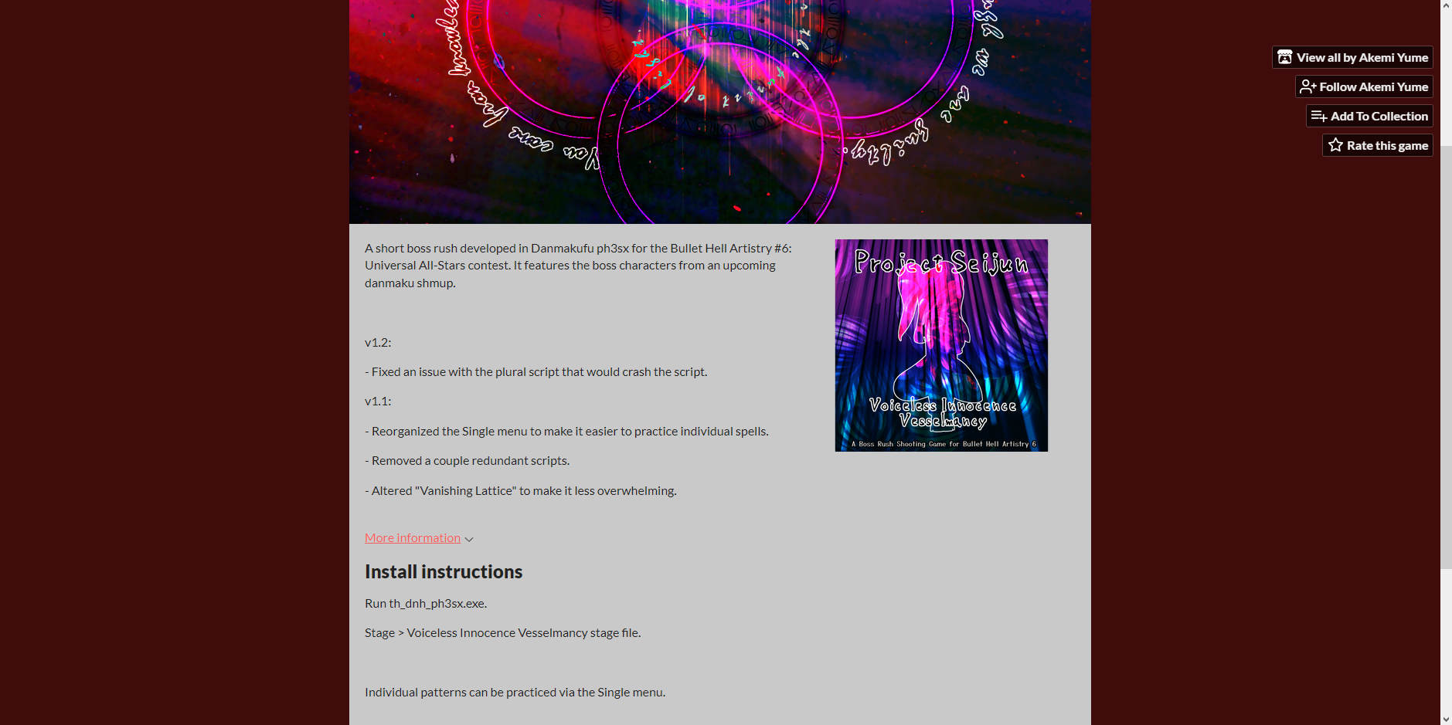

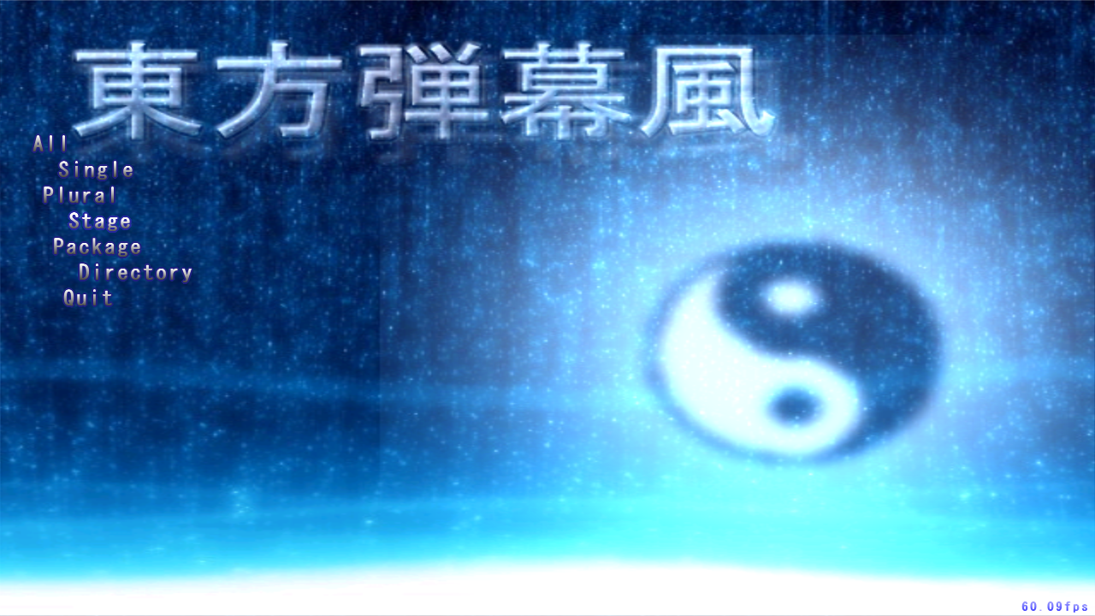

As I start out the game, I notice immediately a lack of a title screen ─ the itch.io page itself already points the user to navigate through the Danmakufu default menu to reach the game through the Stage option ─, which definitely is, as I said before, a major point of first impressions for a player. Regardless, I appreciate seeing the portrait for the playable character upon being given the chance to pick a shot type (despite there only being one).

Something I’d like to point out is that, despite this being a >contest< entry this game definitely suffers more from a characterization stand point by not having a title screen while being a game that according to the author “features the boss characters from an upcoming danmaku shmup”, AKA, characters no one has a grip on and have little to no introduction for them aside from the Bonus Omake text file included with the game. With today’s growing accessibility concerns (which is something I’m really keen on) I feel like it’s especially essential to introduce the cast for these type of things in a more friendly manner, be it a simple dialog at the beginning of the game (see: [Fan-made Virtual Autography’s intro](https://youtu.be/XLO_DNiBZHM) when booting the game for the first time) or the option to see background information on the characters in-game (see: [Dream Logical World](https://store.steampowered.com/app/1664410/__Dream_Logical_World/?snr=1_550_553__1009)’s library), because, from my perspective, when I had just entered the game for the first time, all I had to base my critics of the patterns and themes talked about in the game were by the character designs, since I can’t read japanese to get a context from the character names and I skipped the omake file (which, being honest, few players will pay attention to).

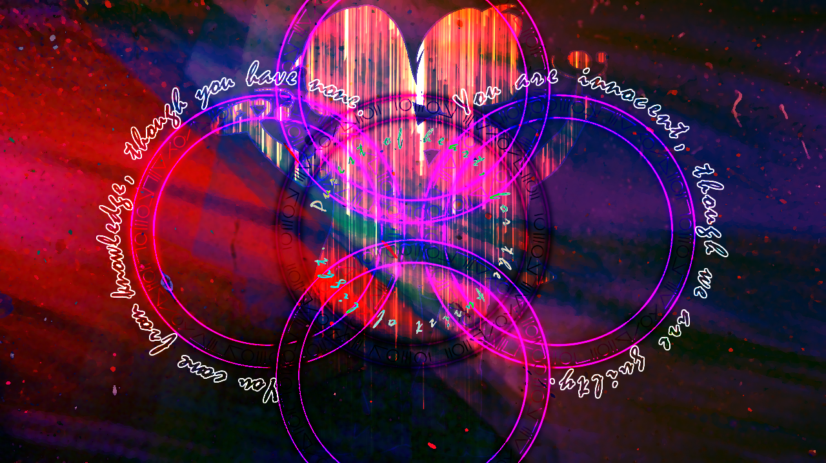

I won’t lie though, I kinda dig the aesthetic in the image. Kinda wish this style had more presence in the entry itself, though.

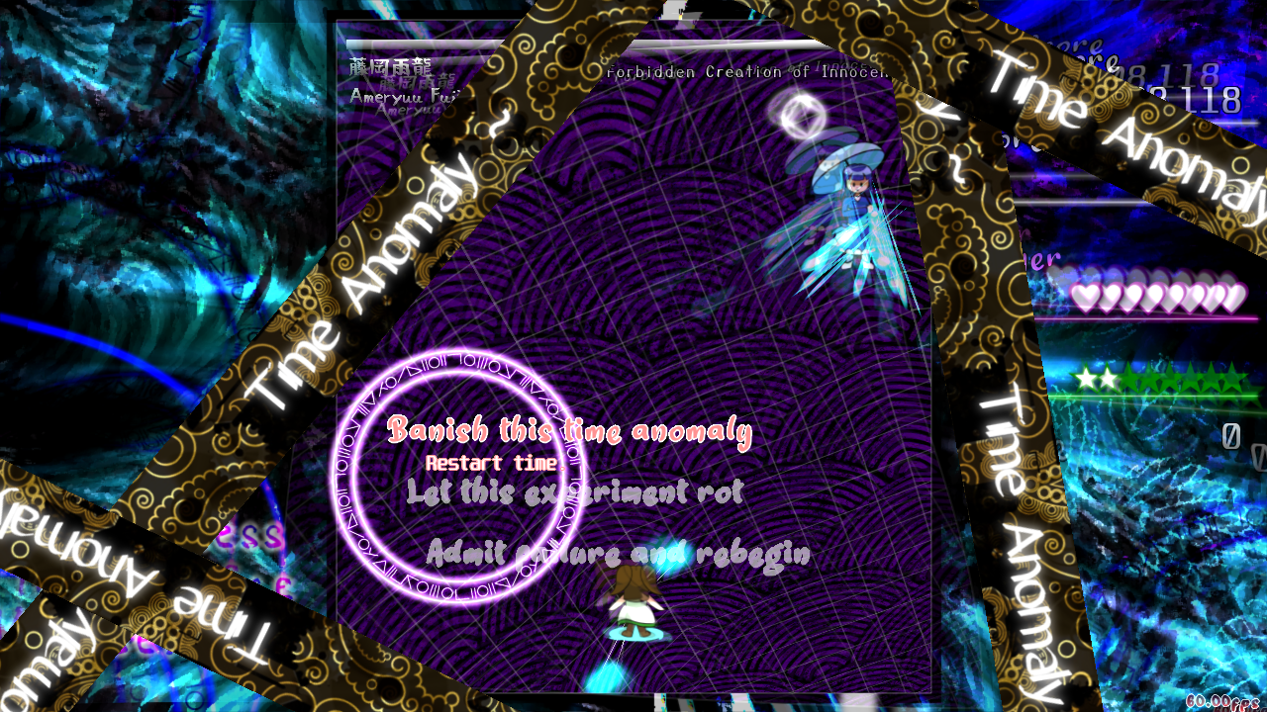

I’d also love to mention the pause screen. I really really like the concept behind it, but the visibility on the options could be a little bit better (and I’m honestly not super a fan of the font choice but it’s fine) and I wish the strips could have more of a randomized positioning. I also really dig the progress bar filling out after unpausing for the player to get a grip on the danmaku that was going on before the game was paused. You could’ve taken a stronger direction when designing this pause menu to make it a little bit more fancier while obscuring the play field to get a good use of that progress bar, but that’s okay (also, you forgot to make the progress bar a thing when unpausing with the Esc key, lol (edit: thinking about it… I actually find it very interesting to have two different unpausing mechanics. Perhaps having the Esc key to unpause faster follows the same style as using Esc + R to restart faster, so that’s still valid)). I love the distortion effect too. Esc + R could also be added, it’s always good to have a quick restart mechanic.

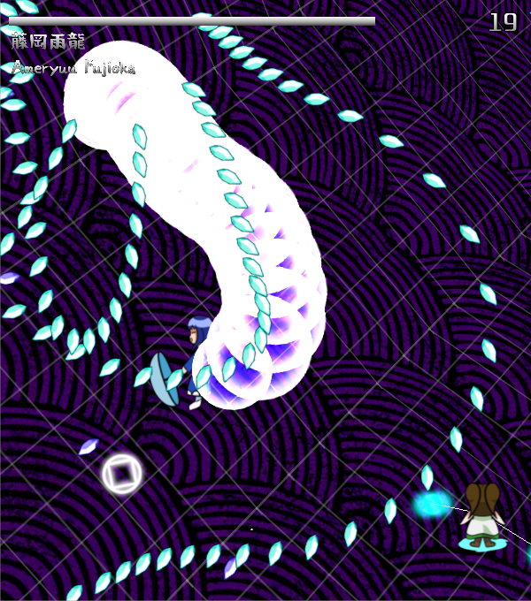

Attack 1: ***Nonspell (Ameryuu)*** | **Score: 24**

I think this is a very nice starting attack. The difficulty is very simple, while still looking a little bit threatening with the bubble bullets being mostly just a visual flair since you most probably will never get hit by them, having the dodging danmaku be the icey bullets. I think it fits well with the character’s theme of water and stuff.

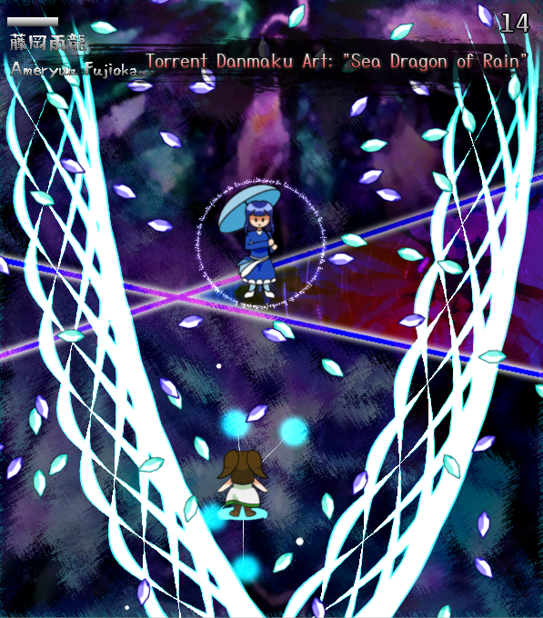

Attack 2: ***Torrent Danmaku Art: “Sea Dragon of Rain”*** | **Score: 26**

Very interesting first spell card. I love that it really does resemble a torrent of sorts and it’s kinda cute. I’d say the warning lasers should also be more transparent as I did kinda freak out thinking they’d kill me.

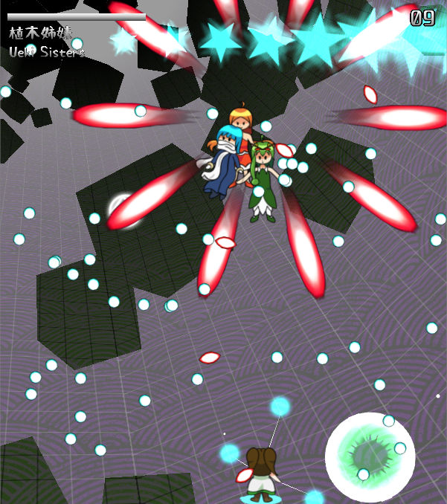

Attack 3: ***Nonspell (Ueki Sisters)*** | **Score: 23**

I really enjoy the idea of grouping characters together, though I do also like when this happens to have more individuality for each character (such as displaying their names separately instead of just Ueki Sisters). It’s nice to see characters related to nature together though I’m still debating whether mixing them all up together through danmaku in this nonspell is the best execution it could get. Though I do think the little flowers spawning from the green orbs are cute.

Attack 4: ***Sister Danmaku Art “Whirlimage”*** | **Score: 24**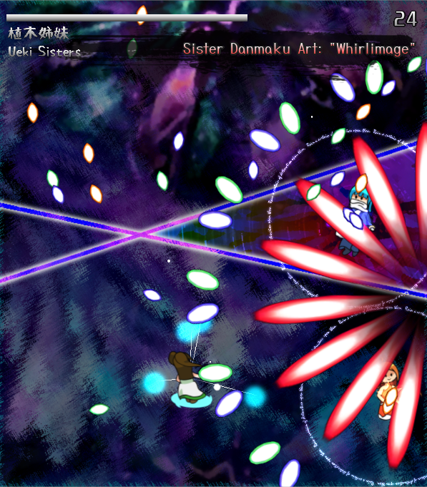

(I’m kinda pissed that holding Ctrl speeds up the game because I can’t take a proper screenshot) Feels like a very interesting continuation of the nonspell, them speeding up and charging to then rush at the player’s direction is cool. However, in the end, it’s still a pretty basic attack when taking out the visual flair on it.

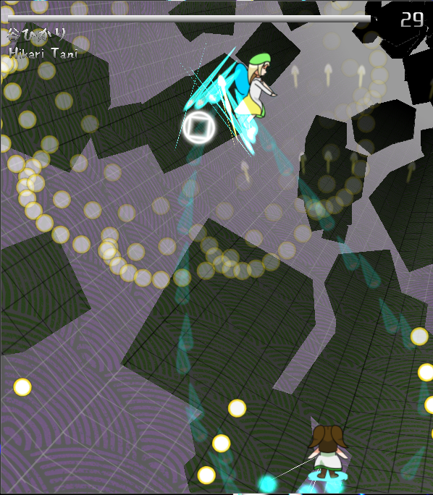

Attack 5: ***Nonspell (Hikari Tani)*** | **Score: 18**

Oh yeah, I do like my fading bullets. It’s a very simple non though. By the way, I’m sorry, but I find it super hilarious how her occupation is “Staying away from people she likes”. That’s so friggin’ tragic. Hope she gets her friends back.

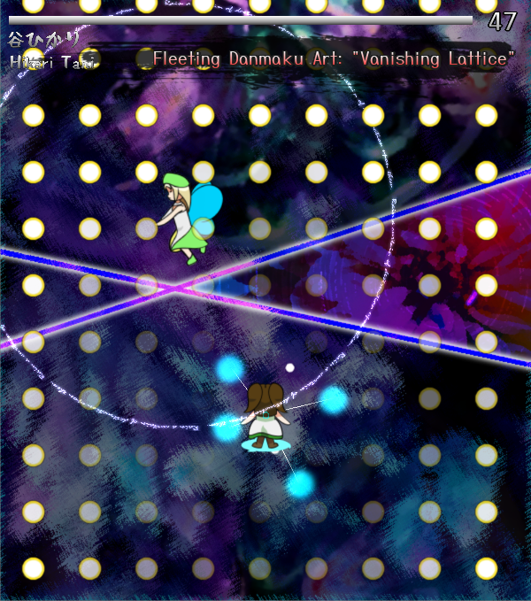

Attack 6: ***Fleeting Danmaku Art “Vanishing Lattice”*** | **Score: 20**

I’m inclined to say this is a Len’en reference. Call it what you want, some may complain but personally I kinda enjoy the basic twist it adds to this moving grid type of pattern by making the bullets less visible while near the player. Though again, I’m missing some additional components to the spell card! This is pretty basic still. Also, the telegraphing could be a little better for you to see what direction it’s gonna go. It’s understandable after two or three waves at blind play, but it could be better.

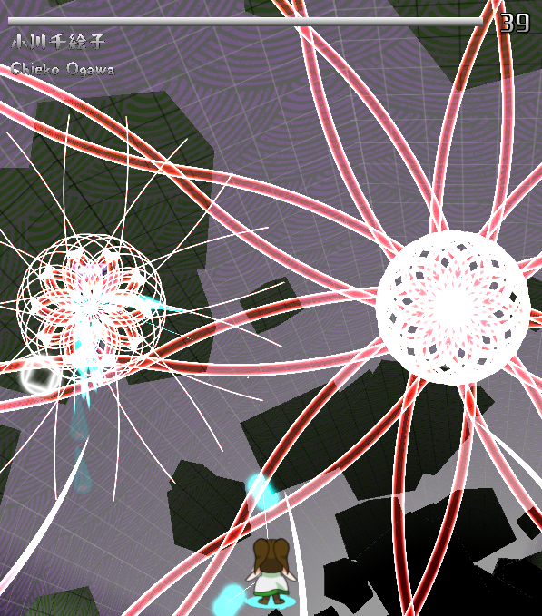

Attack 7: ***Nonspell (Chieko Ogawa)*** | **Score: 22**

This non is a little bit more interesting than the last few attacks, but now it’s suffering from just being monotonous due to how easy it really is. Maybe the flowers forming in the origin could be wider to take more screen space (cuz being compressed like they are makes them look a bit messy and not so elegant) and perhaps the falling rice bullets could be more frequent.

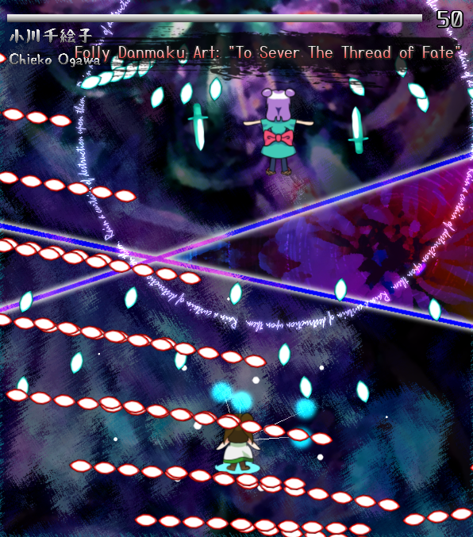

Attack 8: ***Fally Danmaku Art “To Sever The Thread of Fate”*** | **Score: 22**

Good to see some more horizontally moving danmaku. Said danmaku combined with the still-visible aspect beneath the HUD reminds me of Sakuya’s passive effect in PoFV. I like the idea of when the red bullets pass through a certain range of the boss changing, though at times it looks messy and could have a visible aspect to that range for the player to know how broad it is.

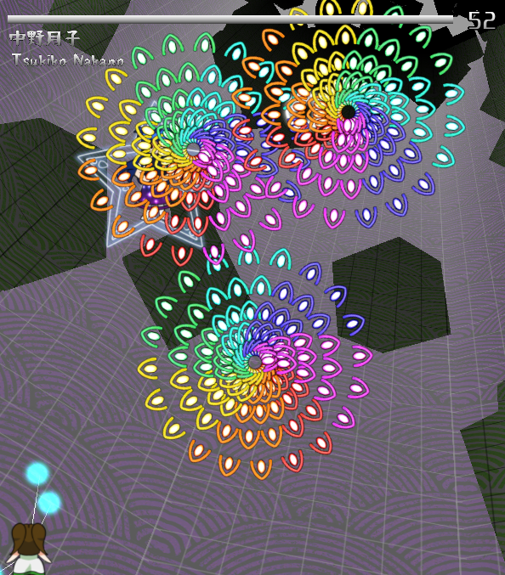

Attack 9: ***Nonspell (Tsukiko Nakano)*** | **Score: 28**

IT’S BULLET HELL ENGINES!!! Jokes apart, this colorful wheels look very pleasing. It’s definitely the most interesting nonspell, but it completely blows off the other ones in terms of difficulty. I can’t capture this for the life of me.

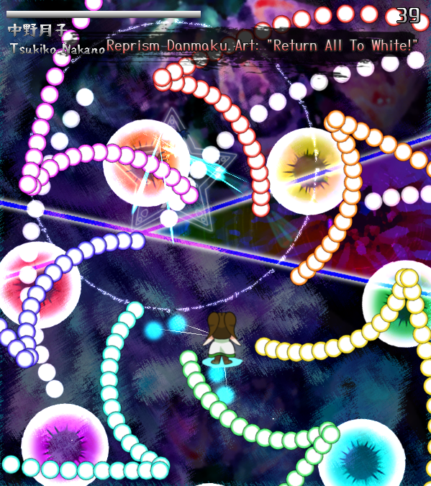

Attack 10: ***Reprism Danmaku Art: “Return All To White”*** | **Score: 28**

It looks pretty cool, but in the end it’s just the same thing over and over getting harder up until the end of it. I think it’d benefit better being this way if it was a time out card. Also, she has no cutin.

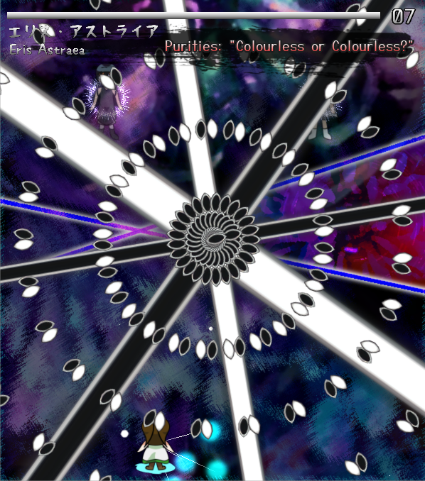

Attack 11: ***Purities: “Colourless or Colourless?”*** | **Score: 27**

You missed the opportunity to play a joke on color and colour! I can’t help but also think this one’s a Tsurubami reference. I can’t also say I haven’t seen this type of timeout being used before either.

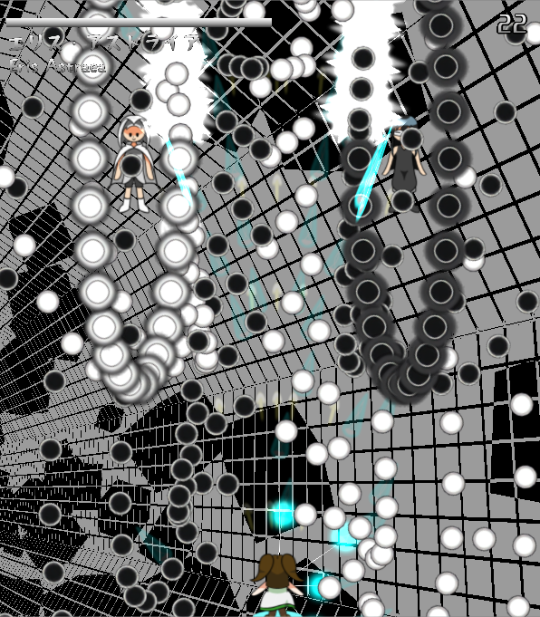

Attack 12: ***Nonspell (Eris Astraea)*** | **Score: 28**

I can’t tell if the attack order is actually really this way or if the nonspell and spell card order was swapped. Either way, I don’t mind it. Though this Twin Cranes reference (I’m sorry, this is the last time I’ll mention Len’en) is pretty fun to play, however, just by the picture on the side you can tell it’s a visibility challenge.

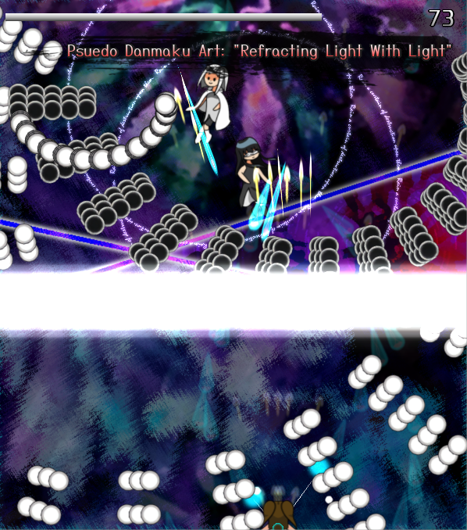

Attack 13: ***Pseudo Danmaku Art: “Refracting Light With Light”*** | **Score: 30**

I’m pretty damn sure the spell card name has a typo, lmao. Absolutely the best spell in the game to end it with. Pretty fun and I really enjoy the light barrier flipping the bullets orientation.

In general, all the attacks need a nerf in health amount or buff the player. They take way too long to finish. I can also see something balancing issues here and there as I’ve pointed out within the attacks.

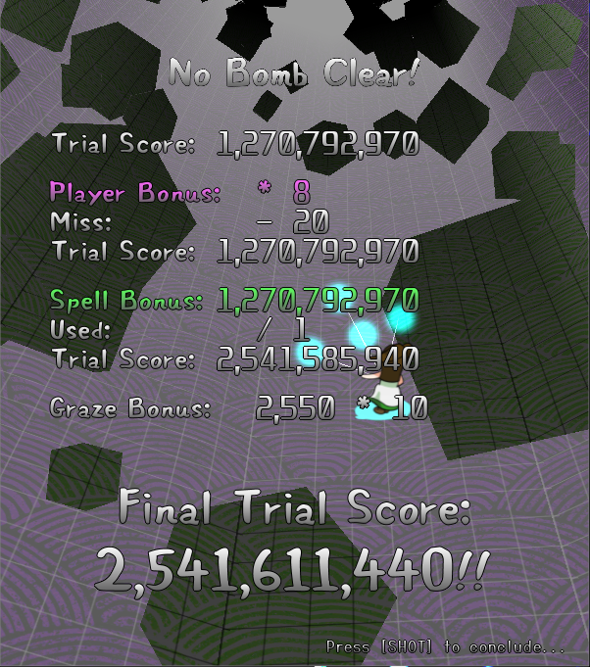

It’s cool to see a game end with score calculation!

Despite not having the best danmaku, I still think the game did a pretty good job at keeping me interested to play it till the end because of just how nice things complemented each other and felt very cohesive with the music playing.

Regarding ***beauty/atmosphere stuff***:

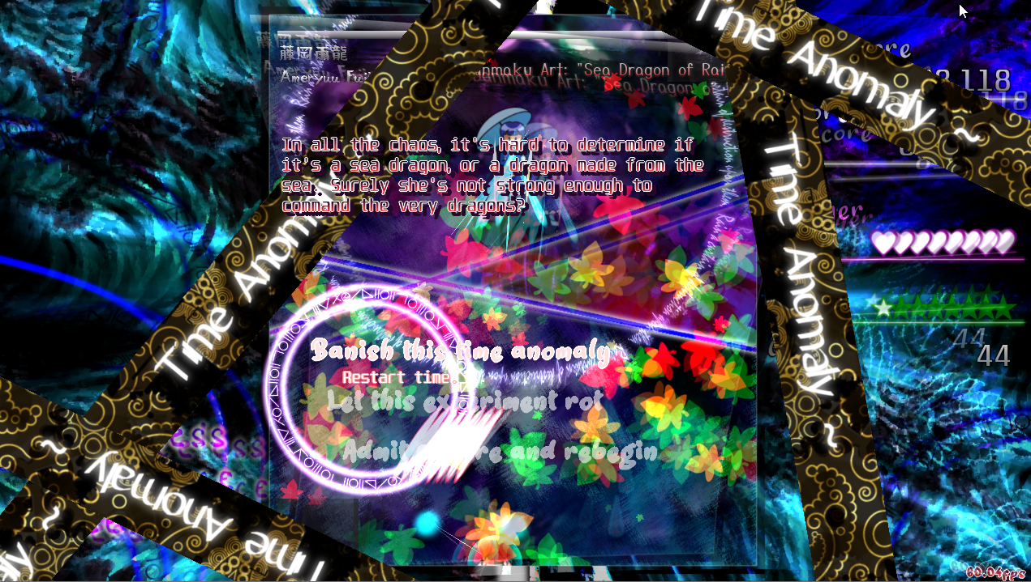

I want to start off tackling this game’s biggest offender: visual clutter. The ideas here are all pretty nice on paper: options “wheel” with flair text and exact description of selections, time stop banner clips that scroll over the whole interface, “tips” of sorts during some attacks, HUD information, etc, etc… Each of these have their own little style, but in the bigger picture, you can totally see that there is a big mismatch of these identities.

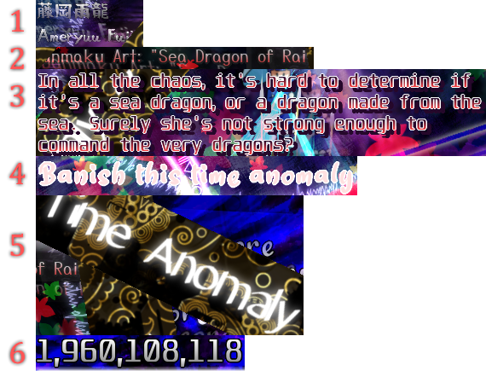

I myself can count, like, at least 6 different fonts with very wildly varying visibility, filtering and consistency. Some don’t even seem to follow the type of vibe some of the UI elements are trying to convey. I think it would definitely be better if you tried keeping the font style similar in general and had more focus on visibility than glowyness.

Other than the visibility issues within the interface, I have to say I find SO CUTE the fact that the spell and life pieces simply drop out of the HUD whenever you die 😭 that’s the coolest thing ever.

The background on the game is also pretty pleasing, never being too bright despite being pretty dynamic on the lightning when changing itself (except on the last spell a little bit). I love the color reversing 3d stuff!

I couldn’t help but notice the very subtle effect on the HUD showing that bullets beneath it still don’t get deleted once they cross the playing field edge, which is a cute detail.

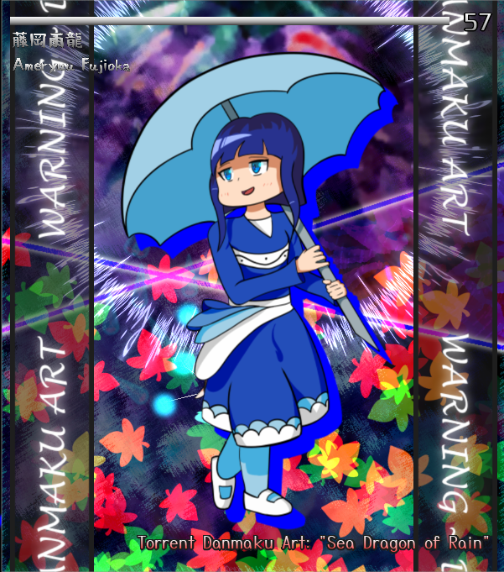

I really find the spell card cutins nice too, I love the flow they have!

Congrats on making the music be so fitting with the gameplay flow, I think it fits really well.

I swear to God the playable character sprite makes me think I’m playing with the green chipette from the chipmunk Alvin movies lmaoo.

***Score: 28***

Regarding ***miscellaneous stuff***:

This is the part things get a little bit complicated. Technically, I can see a lot of polish in the game and I can definitely perceive a very strong attempt at embellishing the game visually; however, at times, it may be a little bit overwhelming as I’ve described previously or just not very well executed. There isn’t a lot of quirkyness but I can definitely see a lot of effort in keeping the game flow alive, and despite the attacks taking a long time to finish I never really felt bored to the point I felt like the game was dragging itself: transitions were smooth, commands were responsive, etc. The messages that come along when pausing the game at certain moments are a very nice detail added. In general, I can see that the deeper you look in this game, the more cool details pop up sometimes. Which is unfortunate to say that at first glance this game didn’t really catch much of my attention.

***Score: 10***

## The Other Incident Solvers



*Developed by: Fuzzbearplush*

*Engine: Danmakufu ph3sx*

I don’t remember seeing Fuzzbearplush in the other editions of this contest, so I’m assuming they’re a debuting participant! I’m glad to see more people interested in the contest as well as the usual fair. By the way, I love the comical value of having a squishy Reimu face as the game’s image when the author submitted it. This game in particular had a lot of potential but the lack of time that was required to polish it up in the end is notable.

Information about the game came alongside the Discord post Fuzzy made submitting the entry.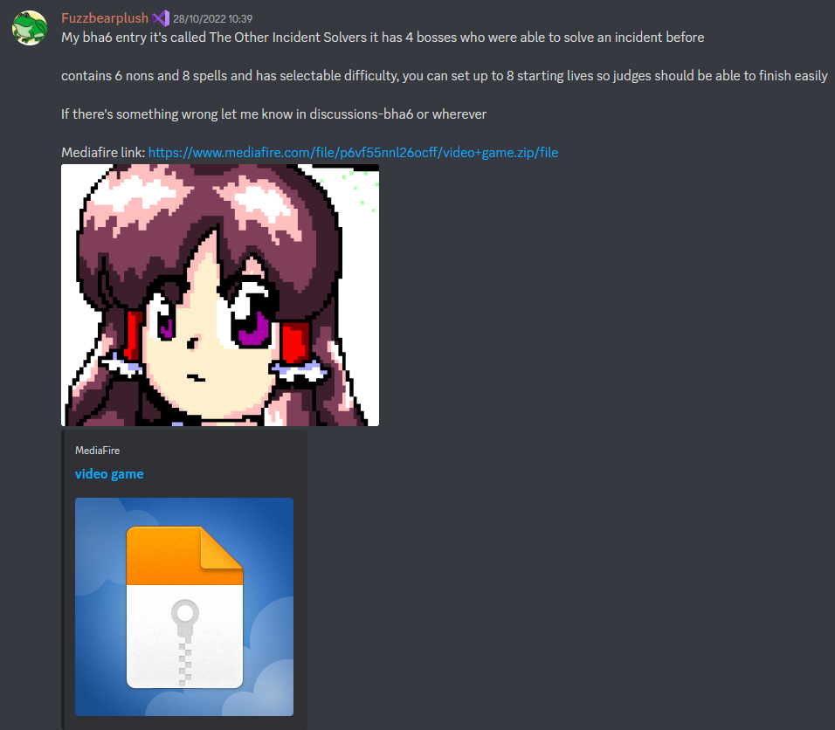

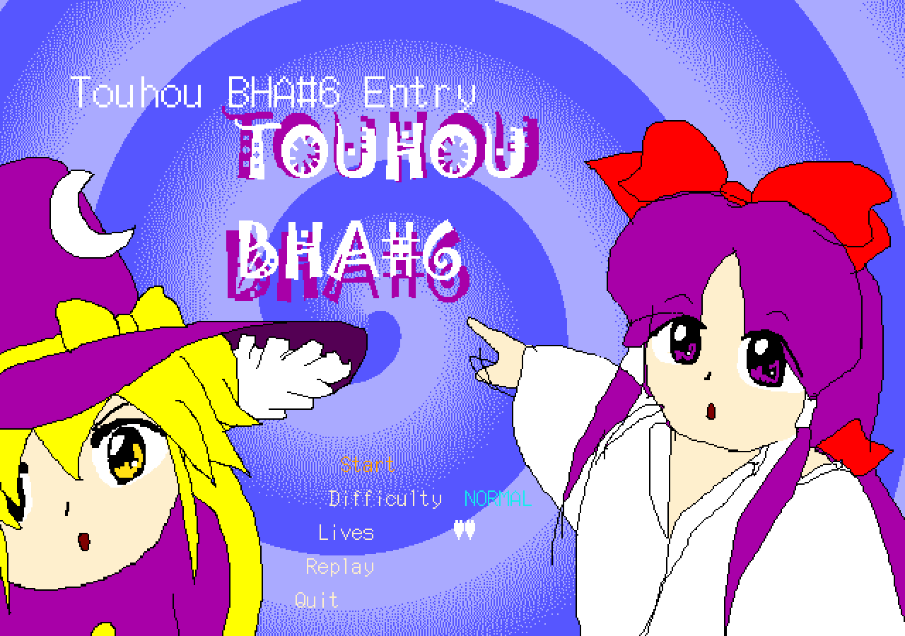

Seriously, all my expectations towards this game were turned upside down when seeing the title screen for the first time. I had been sort of accompanying the progress on the entry somewhat as the author at times posted updates on the development of it, but I seriously did not expect to be greeted to this when first booting up the game. This kind of made me confused as to whether to take this at face value or to interpret it as a meme game. Nevertheless, I’m glad it’s clear from the start that this has inspiration from the PC98 era.

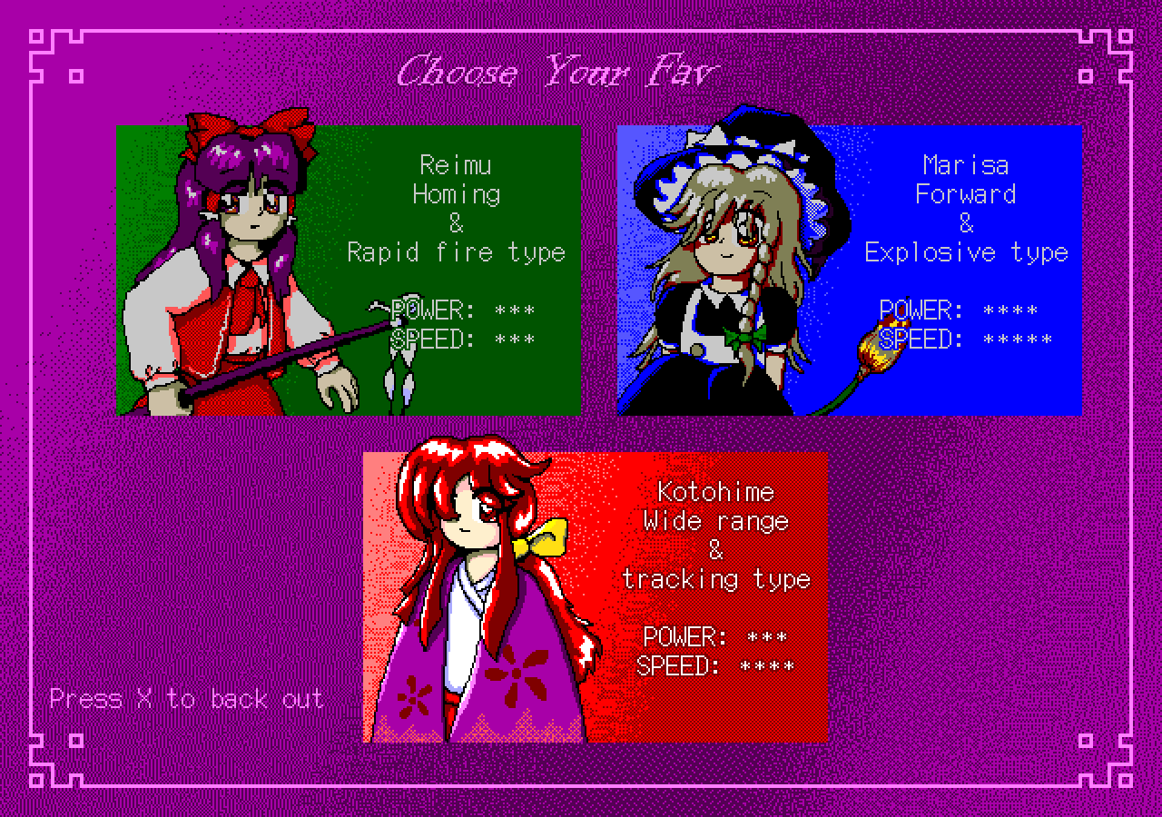

Also very much appreciated that there are multiple playable characters here. I just love this touch. Happy to see Kotohime here too, since I don’t think I’ve ever seen her as a playable character in fangames other than Fools Rush In. She’s also my favorite shot type here too.

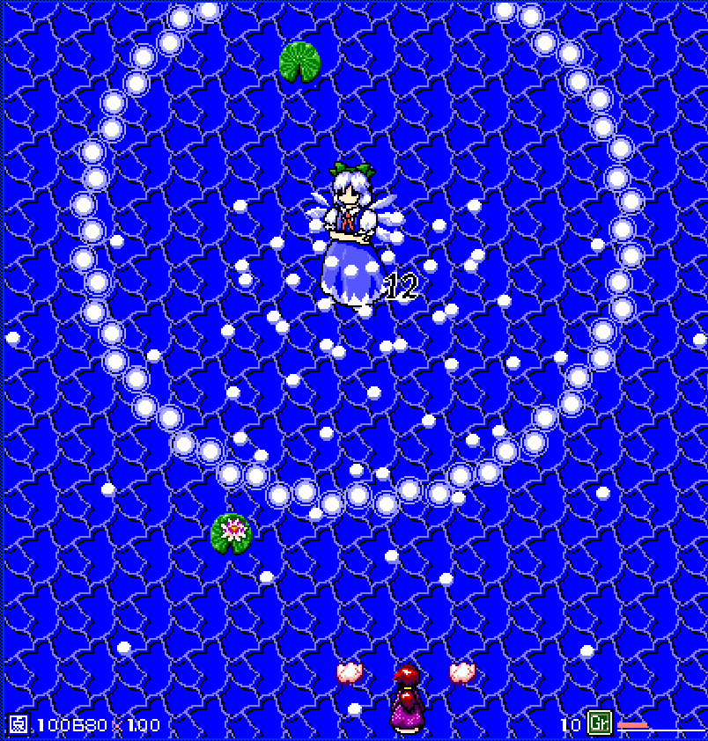

Attack 1: ***Nonspell (Cirno)*** | **Score: 22**

Cirno! It’s a fitting, simple attack for her but it’s interesting as an introduction for the game. Not much to say here.

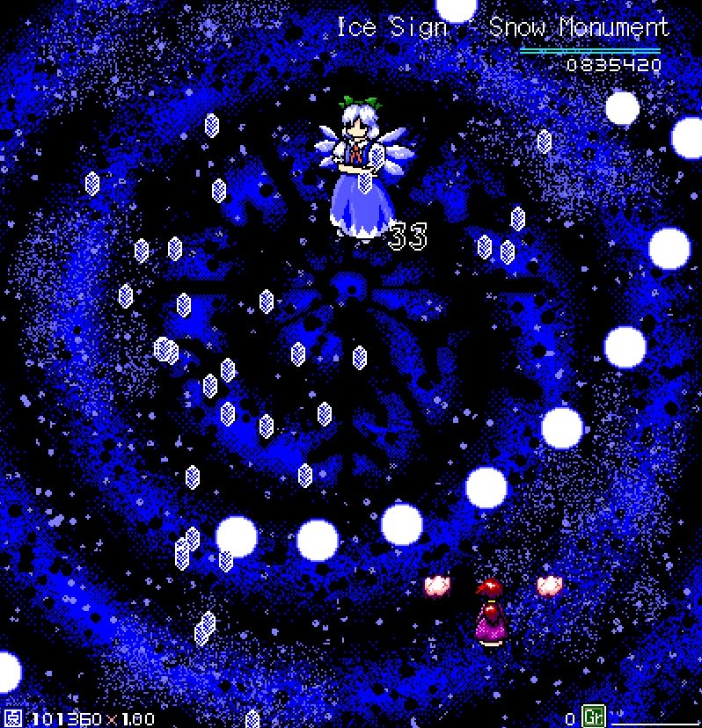

Attack 2: ***Ice Sign ~ Snow Monument*** | **Score: 20**

Tildes on spell card naaaaaaaaamesssssssss. Sorry, it’s a big pet peeve of mine. Regardless, it’s a bit repetitive and simple. Though the bullets look cool. Though I ain’t seeing no monument here.

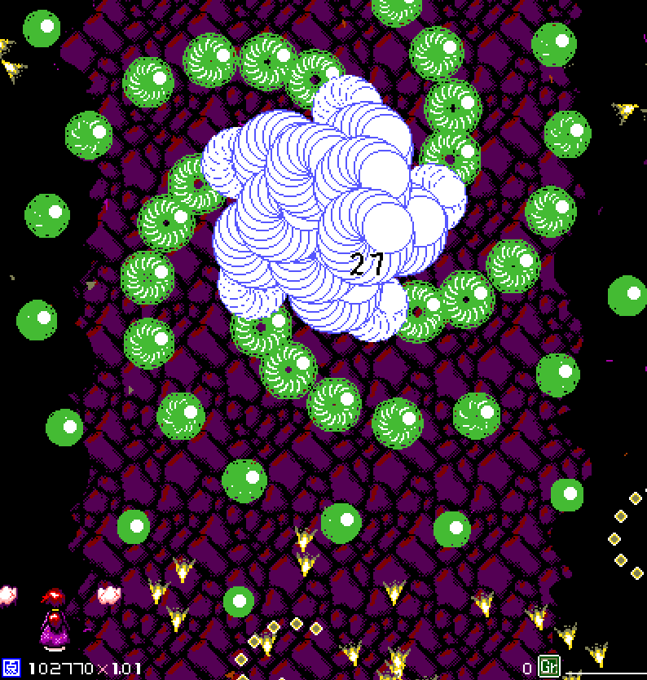

Attack 3: ***Nonspell (Aya)*** | **Score: 22**

It’s the usual fanfare of Aya nonspells, not many twists of it, but I do enjoy the yellow layers it has.

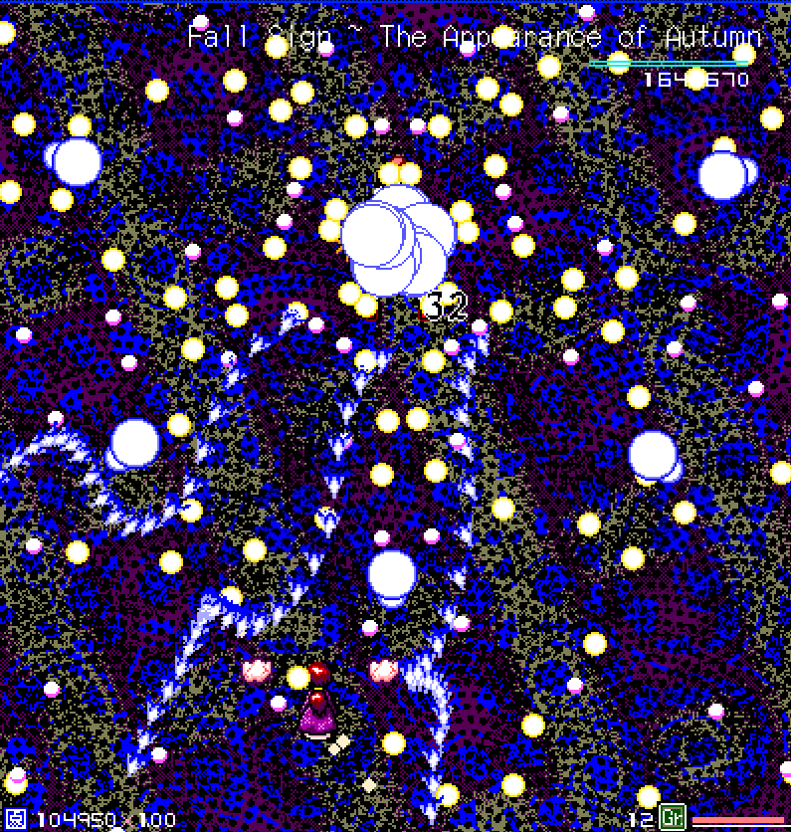

Attack 4: ***Fall Sign ~ The Appearance of Autumn*** | **Score: 21**

Not much creativity in the spell card names, and I don’t see it very much reflected in the danmaku either. This one kind of looks like a mixture of Yuuka and Minoriko danmaku. Honestly, easier than the previous nonspell.

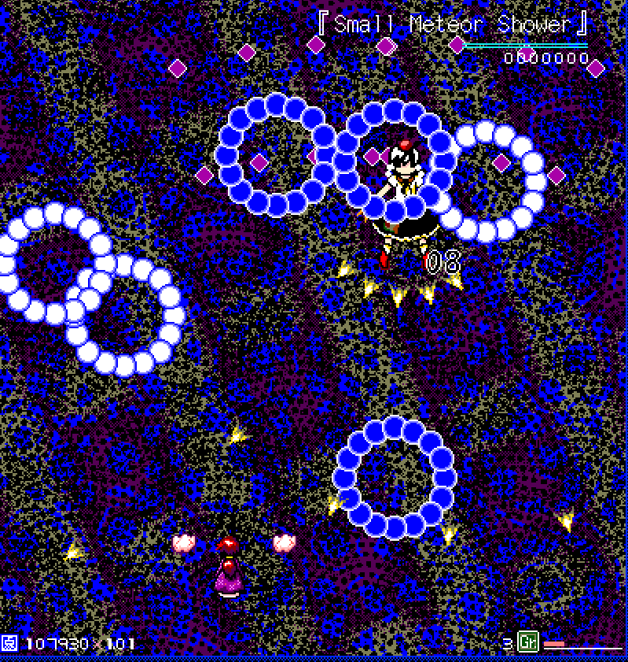

Attack 5: ***『Small Meteor Shower』*** | **Score: 20**

What’s up with the inconsistency in the spell name now using japanese quotation marks? Lol. It’s kind of a random timeout too. Very simple to dodge. Though I kinda like these types of patterns.

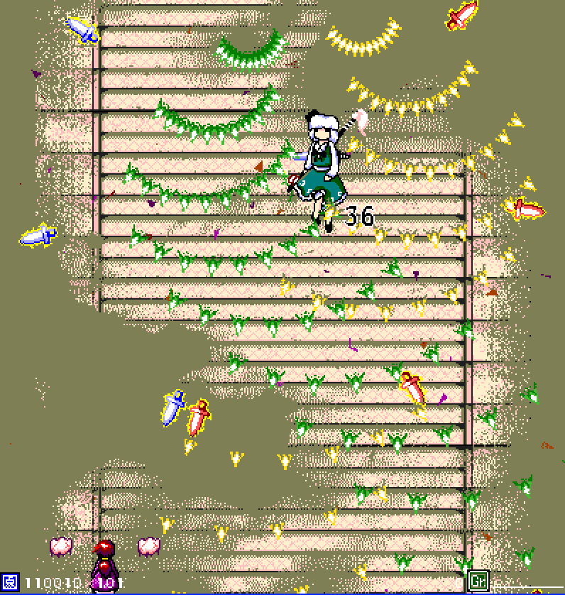

Attack 6: ***Nonspell (Youmu)*** | **Score: 23**

The visibility in this stage is very complicated. This non also has way too much health. I’ve noticed the nons in this game have some interesting variety, but grouping up just a few styles of patterns instead of having a single one being refined is perhaps an issue. The connections between the styles could be a lot more organic, as they’re way too spaced out in intervals and kinda monotonous alone.

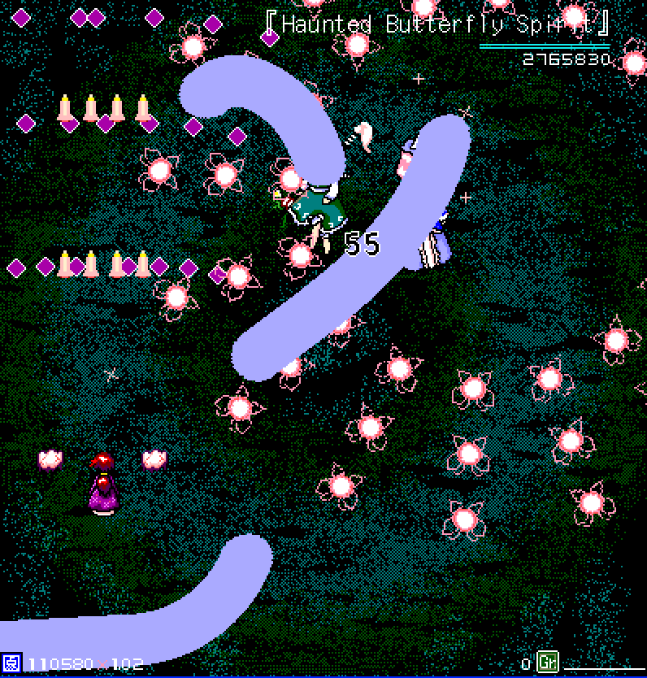

Attack 7: ***『Haunted Butterfly Spirit』*** | **Score: 22**

Cheeto lasers! I… think. I forgot if that’s really what these curvy PC98 lasers are called. Either way, I kinda like this spell. It has a lot more of moving around. It’s kinda funny Yuyuko can die first and then have Youmu just shoot around these snakes alone after. Not sure how much it vibes with the spell card name.

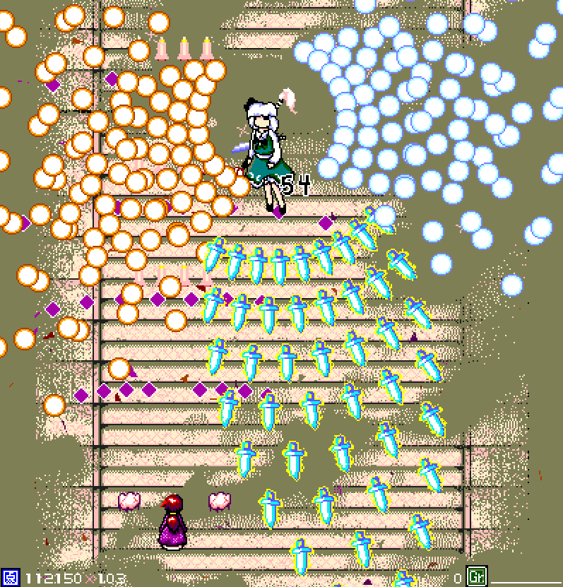

Attack 8: ***Nonspell (Youmu, again)*** | **Score: 24**

This one is one of the more complex nons, I like it. I feel like the organicity that I talked about before is starting to catch up. However I’d still like to see more unique things done with these characters instead of mostly rehashing the patterns we’ve already seen them shoot countless times.

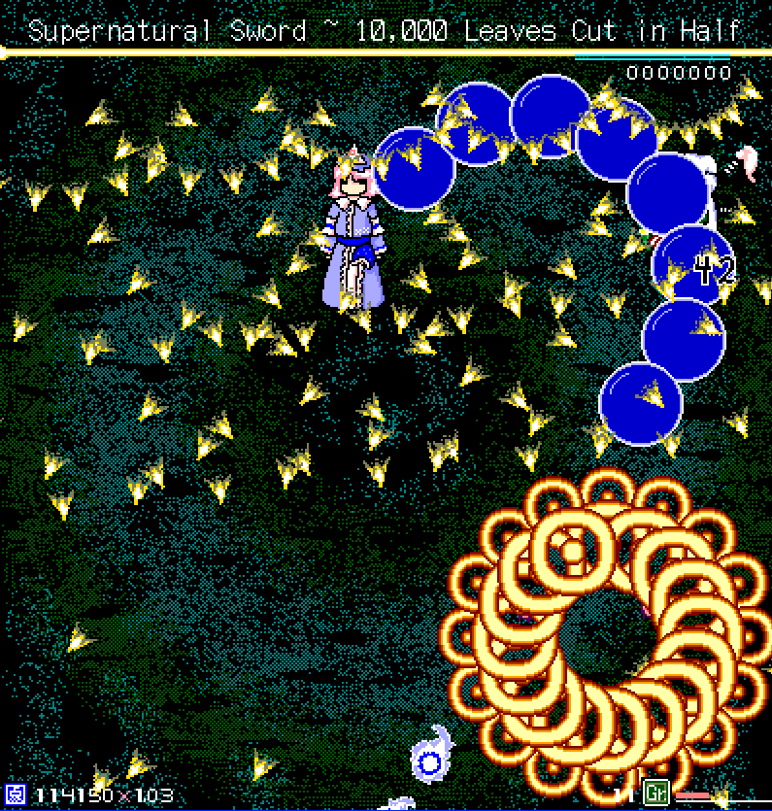

Attack 9: ***Supernatural Sword ~ 10,000 Leaves Cut in Half*** | **Score: 21**

Those blue balls look kinda off for Yuyuko, and I feel like she’s mostly not doing much here. I like the way the first arrows are spawned, but when Youmu executes the laser thing, it looks kinda weird. This pattern just feels kinda weird in general. I like the intensity of it increasing after a while though.

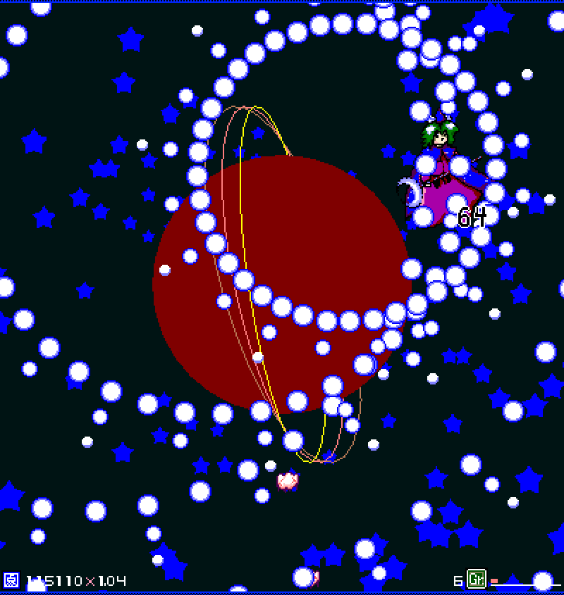

Attack 10: ***Nonspell (Mima)*** | **Score: 27**

Hell yeah, that was a cool Mima introduction! However you completely broke the atmosphere it created when the extremely compressed (and spliced?) music started playing 😭😭 wtf I giggled. But I really enjoy the atmosphere here. The vibe of this pattern is cool and sounds fitting for her.

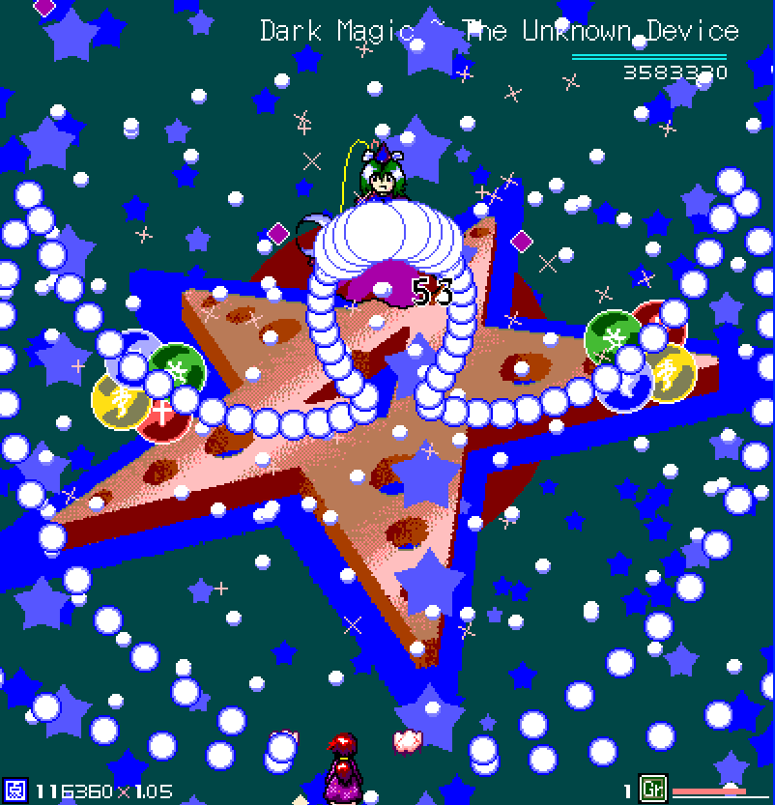

Attack 11: ***Dark Magic ~ The Unknown Device*** | **Score: 27**

It’s not such a complex spell, but the mechanisms it employs to make it look grand make it pretty fun, and the increasing intensity helps that too. This really does give out a final boss tension. This fight definitely has the best atmosphere this script has to offer. Just looking at the little picture on the left makes me wanna play it again.

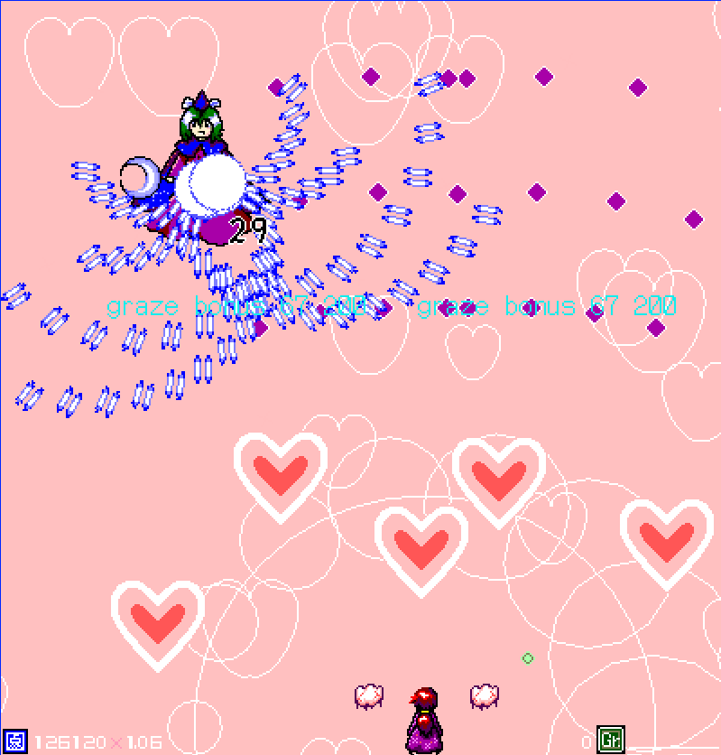

Attack 12: ***Nonspell (Mima!!!)*** | **Score: 27**

There’s a lot of components here. Somehow, it doesn’t feel tedious like Youmu did, perhaps the danmaku intensity really helped make it look more organic than the previous patterns. It really gives out the PC98 vibe. Yes I bombed.

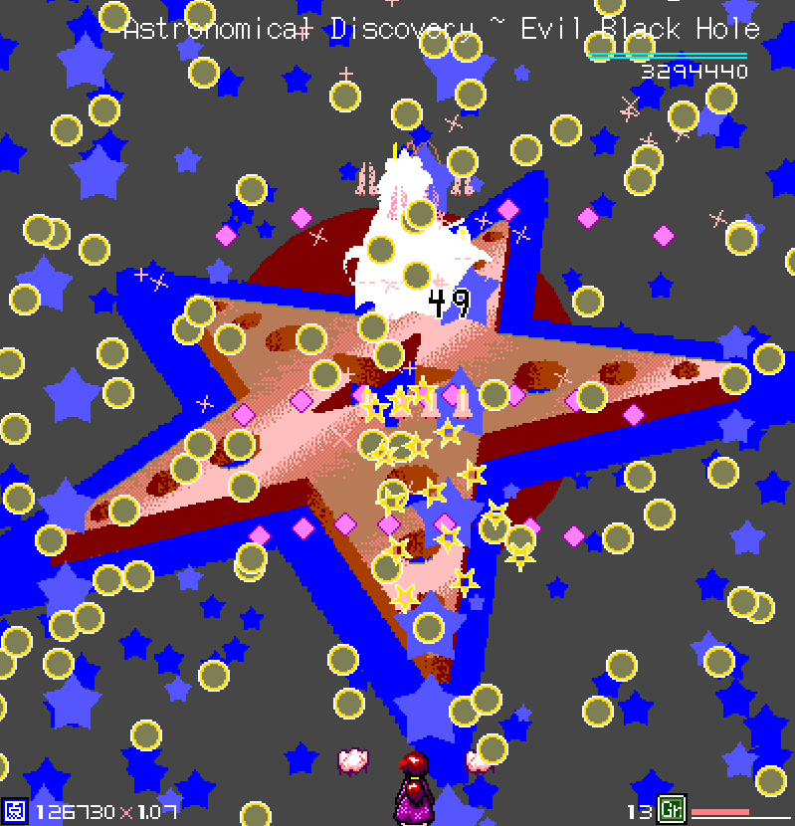

Attack 13: ***Astronomical Discovery ~ Evil Black Hole*** | **Score: 22**

This one kinda breaks the immersion into the fight as it’s probably her most plain pattern. But despite that, I still felt in depth. It probably has complex maths that I’m not noticing though, because the way bullets shift look pretty interesting.

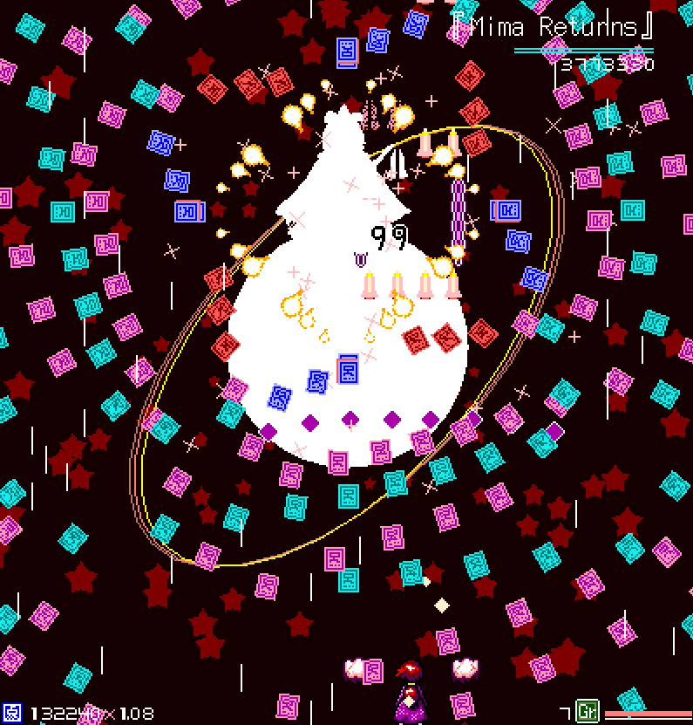

Attack 14: ***『Mima Returns』*** | **Score: 28**

A cool looking micrododging spell card to end the game. Not much complex, but you could say the same for climatic finals such as Flandre’s ending. It does kinda remind me of Kanako and Chimata. Let’s hope Mima does return! I love the aesthetics of this one.

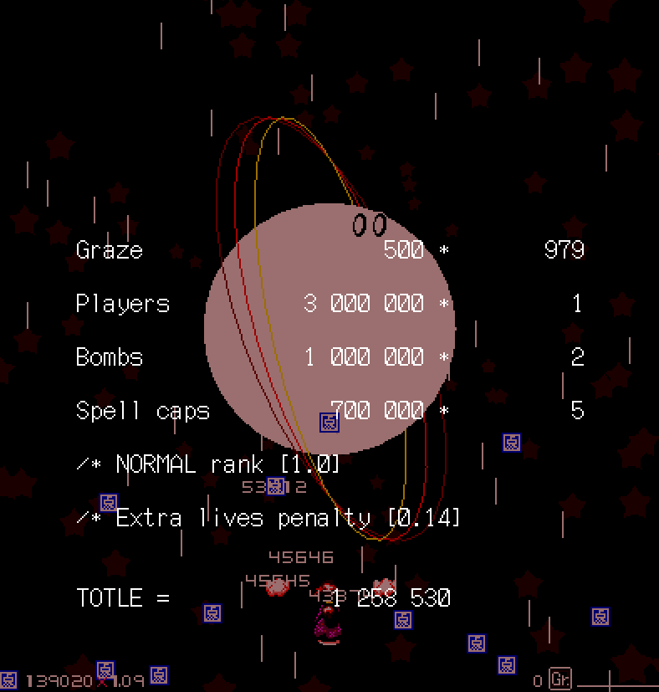

Again, rejoice in the score calculation endings!

I think the transitions between stages are kinda abrupt, so I wish it was a little bit smoother (and had more time since I want to collect the items the bosses drop!!).

I don’t know what’s up with the occasional graze bonus that pops at times, or the mechanics at the bottom of the screen, since they’re never introduced.

Another problem I noticed is that if I end the stage at the top of the playing field, the next boss spawning will just ram into me and kill me. Which is definitely an aggravated issue considering I will go to the top of the playing field in instinct to reach for the PoC to collect all the items before the stage switches.

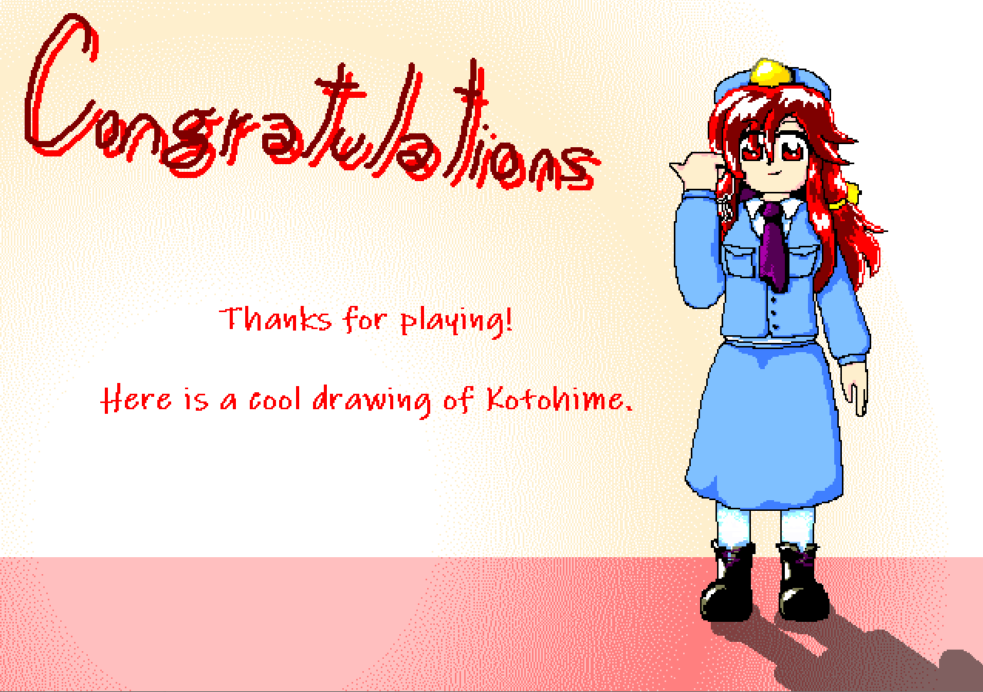

Love the drawings it gives out to you when you finish the game.

Regarding ***beauty/atmosphere stuff***:

First thing that I thought about writing regarding this was the music, I really wish it also followed the PC98 style! Also, Mima’s theme was so annoying to hear because of the compression it had. Nonetheless, the intensity the themes portray do fit the game.

Though I’m also really bothered by the lack of sound effects in the danmaku in this game. I understand sometimes people get inspired by the likes of Marine Benefit in that aspect but I really believe that it adds a lot of depth to the game.

I was never a fan of the PC98 games, so I can’t really judge how precise the replication of the aspects from that era are here, but from a surface viewpoint, I believe it’s really awesome. From the effects, to the graphics, to font usage, etc, it all looks pretty cohesive for the most part.

However, the visibility at times is pretty poor, especially at the Youmu stage.

I’m not sure if the boss sprites were original, but considering they’re not mentioned in the assets credits file bundled together with the game, I’m assuming they are, but they look very nice.

This game could definitely be improved upon, and perhaps match the same standards as the last Mima fight stood out to be. That’s definitely my favorite part of the game, but a lot of it being strange to me is due to how it’s presented. At the submission post, everything seems to point out for it to be a normal entry, but the way you’re greeted by the title screen says otherwise, but the game itself doesn’t seem to follow that direction in the end. It could be a pretty solid boss rush if polished!

I didn’t feel much taken in by the game up until the Mima fight, which is where I feel the real thing begins and where I believe the most time was spent on.

***Score: 22***

Regarding ***miscellaneous stuff***:

And lastly, about the rest of the things. Not sure how much I could comment here, since I mostly accidentally described things I’d discuss here within the other categories, lol. Either way, I appreciate the different difficulties the game offers as well as starting lives, and also how it seems to mostly keep itself grounded within the PC98 style boundaries. I don’t think you’re obligated to follow the style to a T, but just enough to get the player immersed within the game and what the style can mostly offer, and I think this game did that pretty well, it sold me to that vibe.

***Score: 11***

## Hell Sink Her

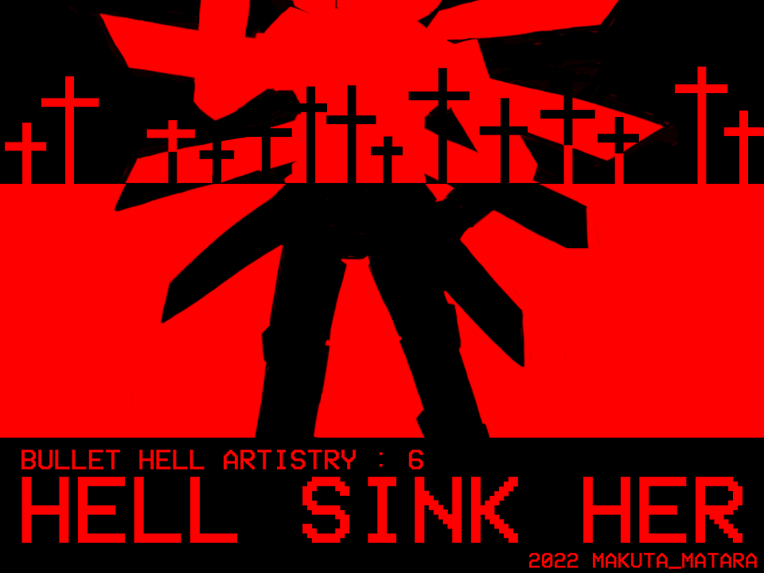

*Developed by: Makuta Matara*

*Engine: Danmakufu ph3sx*

From the brilliant minds of Touhou Fortnite, we got Hell Sink Her. Which, by the way, has a kickass cover. I’ve never played or seen Hellsinker, so I probably won’t get much of the references to that here.

Information about the game came alongside the Discord post Makuta made submitting the entry, as well as the BulletForge page for it.

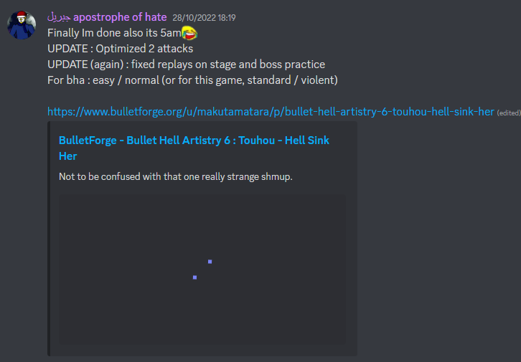

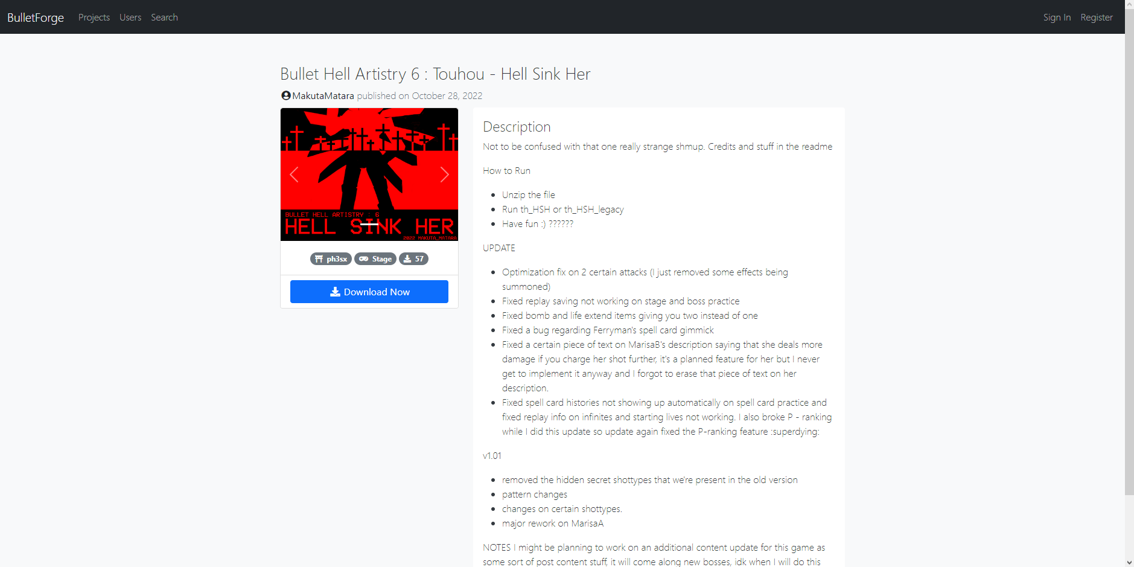

The beginning of this one is pretty cool, sets up a very cinematic feeling of the game! 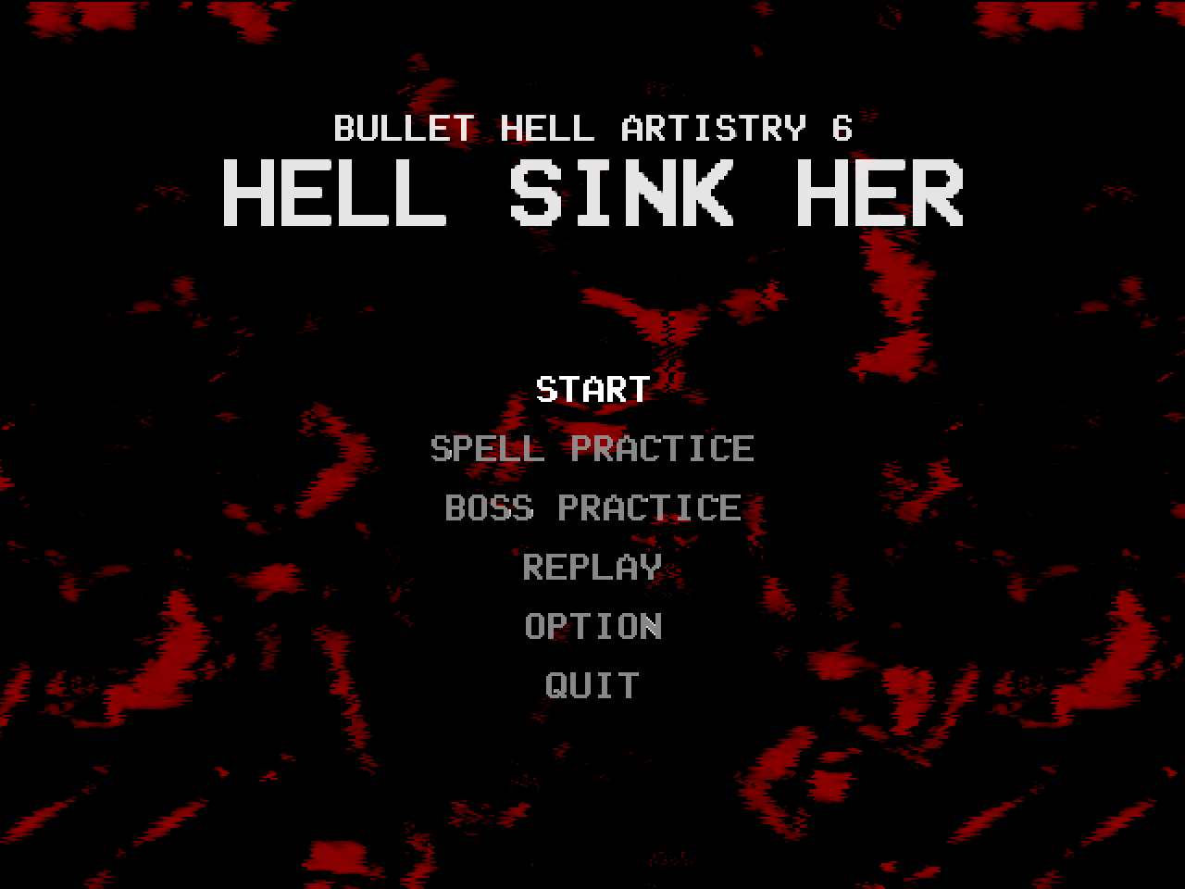

The title screen itself isn’t all that complex, but follows the mood pretty well.



By the way, the game icon is so cute. I feel like eating it.

I couldn’t help but notice that the volume options on the settings reset every time I access it, though. That’s something to be solved.

I don’t know why, but everything just *clicked* for me in this entry, so I’m kind of left speechless introducing it here. It just feels nice and direct.

This is the first entry I see with dialog, too. ~~Finally!!!!!!!!~~

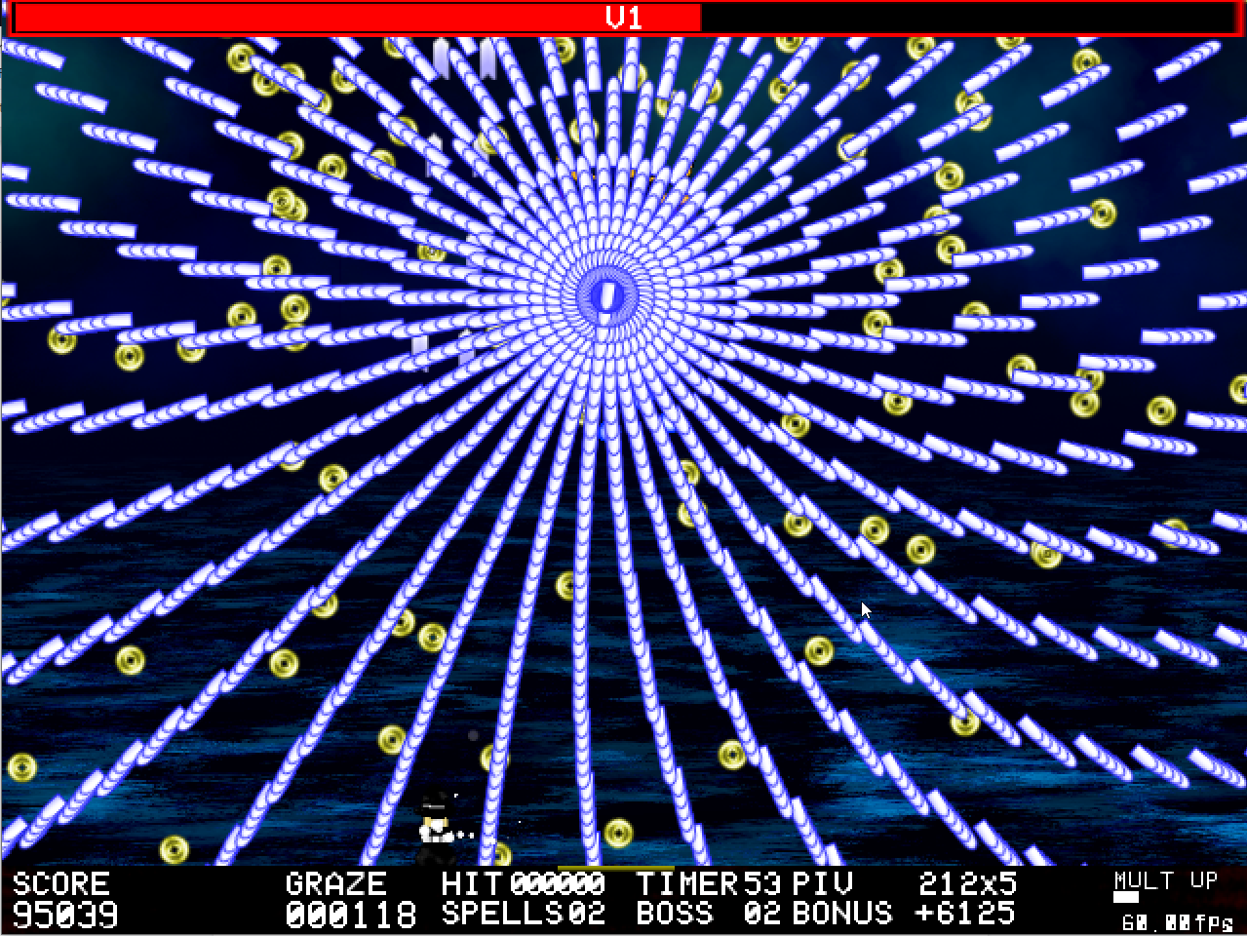

Attack 1: ***Nonspell (V1)*** | **Score: 25**

This one sets the style pretty well for me to expect more arcade style patterns from now on. A bit challenging and scary, but very learnable. Cool as an introduction.

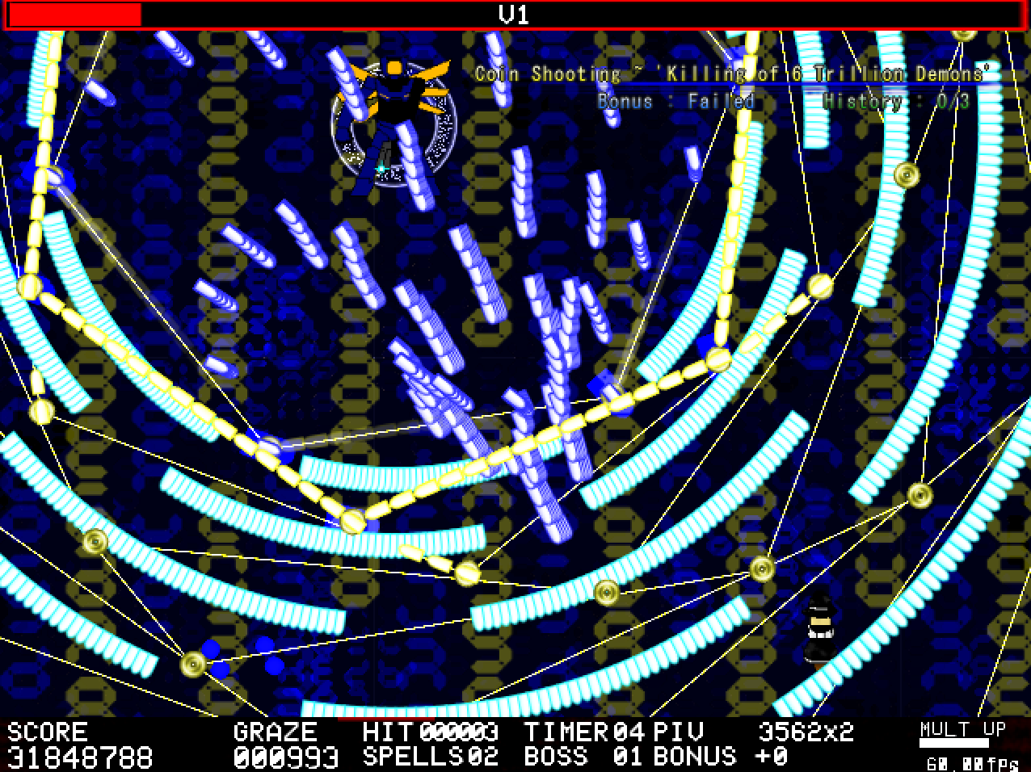

Attack 2: ***Coin Shooting ~ ‘Killing of 16 Trillion Demons’*** | **Score: 28**

~~I swear I’m going INSANE with these tildes on the spell names.~~ I’m loving that we’re starting out already with some pretty interesting movement strategies here, in general you’ll have to be pretty decent at pathfinding to get a good grasp on how to dodge this and also speed to run back to safety for the next wave. I like this one a lot.

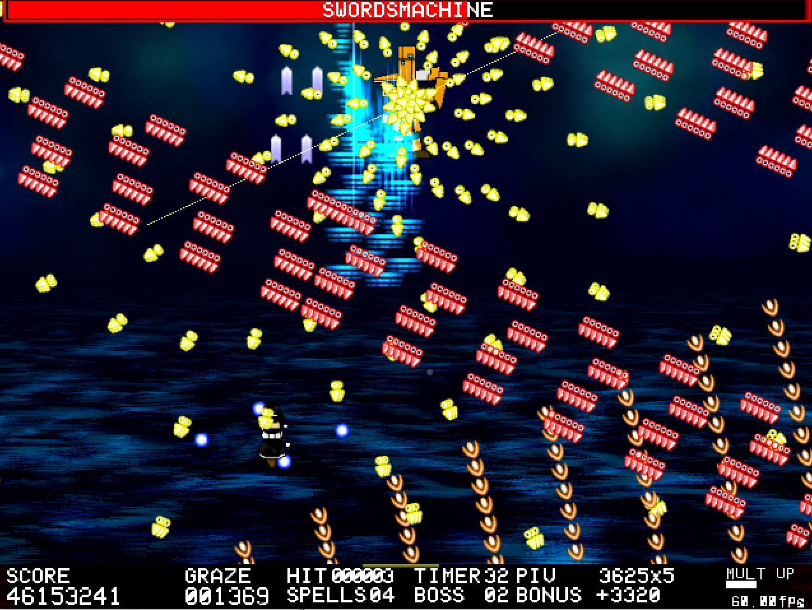

Attack 3: ***Nonspell (Swordsmachine)*** | **Score: 27**

Just plain fun dodging. I’m kind of out of words because the game just keeps me very engaged all the way through so far. Perhaps I’d say to add a little bit more breathing between the things going on, but I don’t feel like it’s a necessary thing.

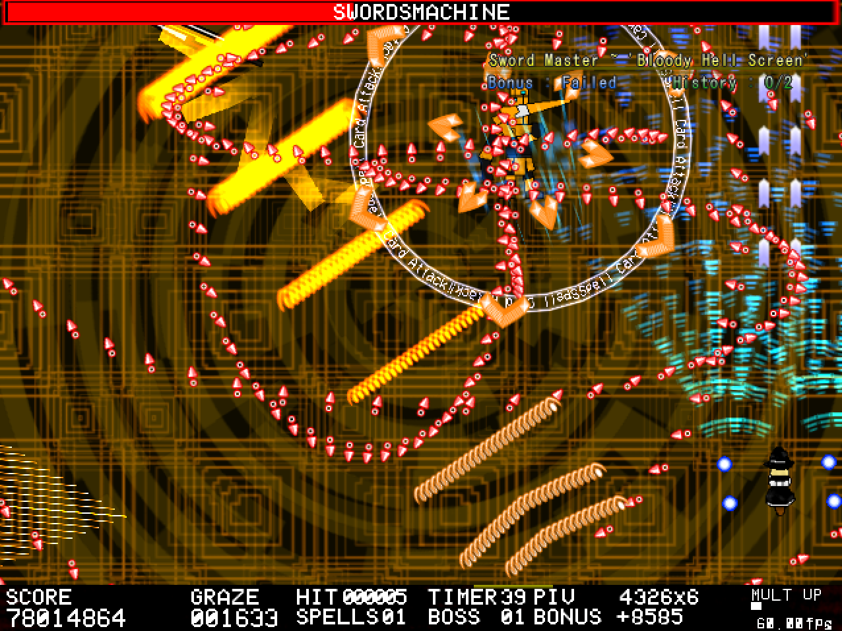

Attack 4: ***Sword Master ~ ‘Bloody Hell Screen’*** | **Score: 26**

This one I had a little bit of a visibility problem. Also, it feels like stuff occurs way too fast, but visually it’s pretty fun. Also, the sword hitboxes are kinda scary and unclear. This game is definitely on the harder side of the games.

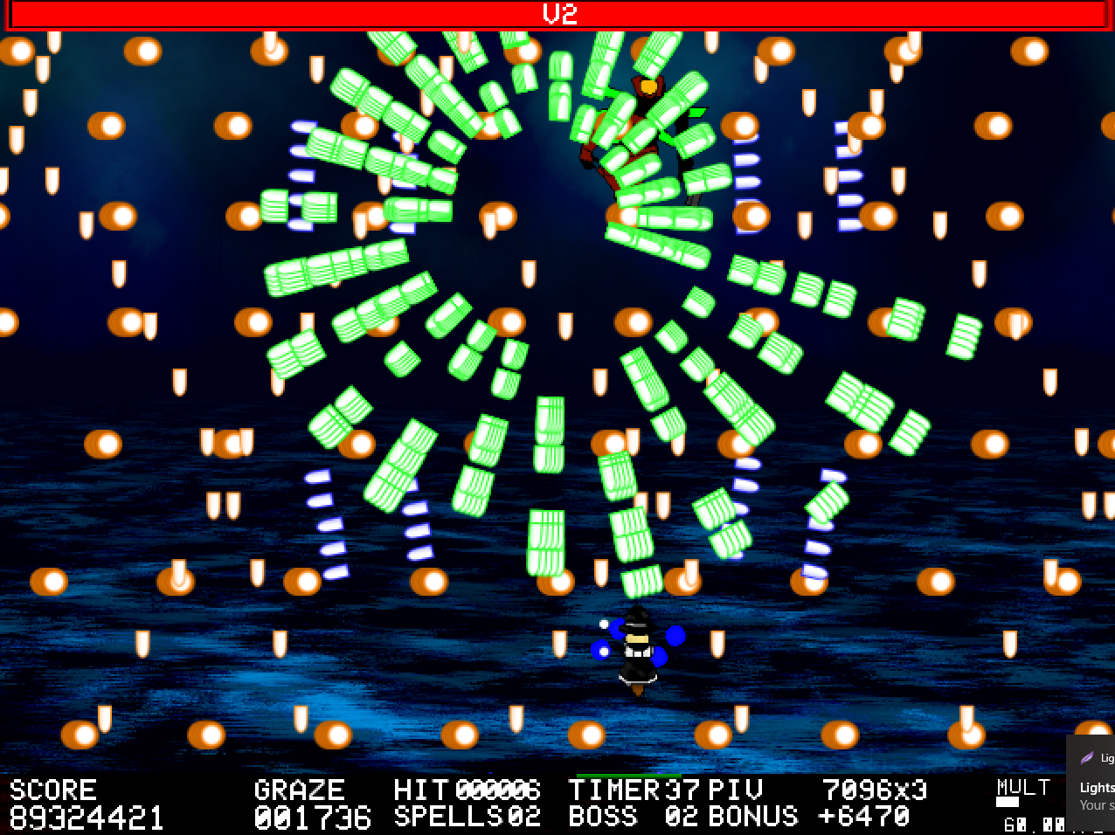

Attack 5: ***Nonspell (V2)*** | **Score: 24**

I won’t lie, the beginning of the song playing here kind of reminds me of dating games, lmao. Regardless, this one is super fast.

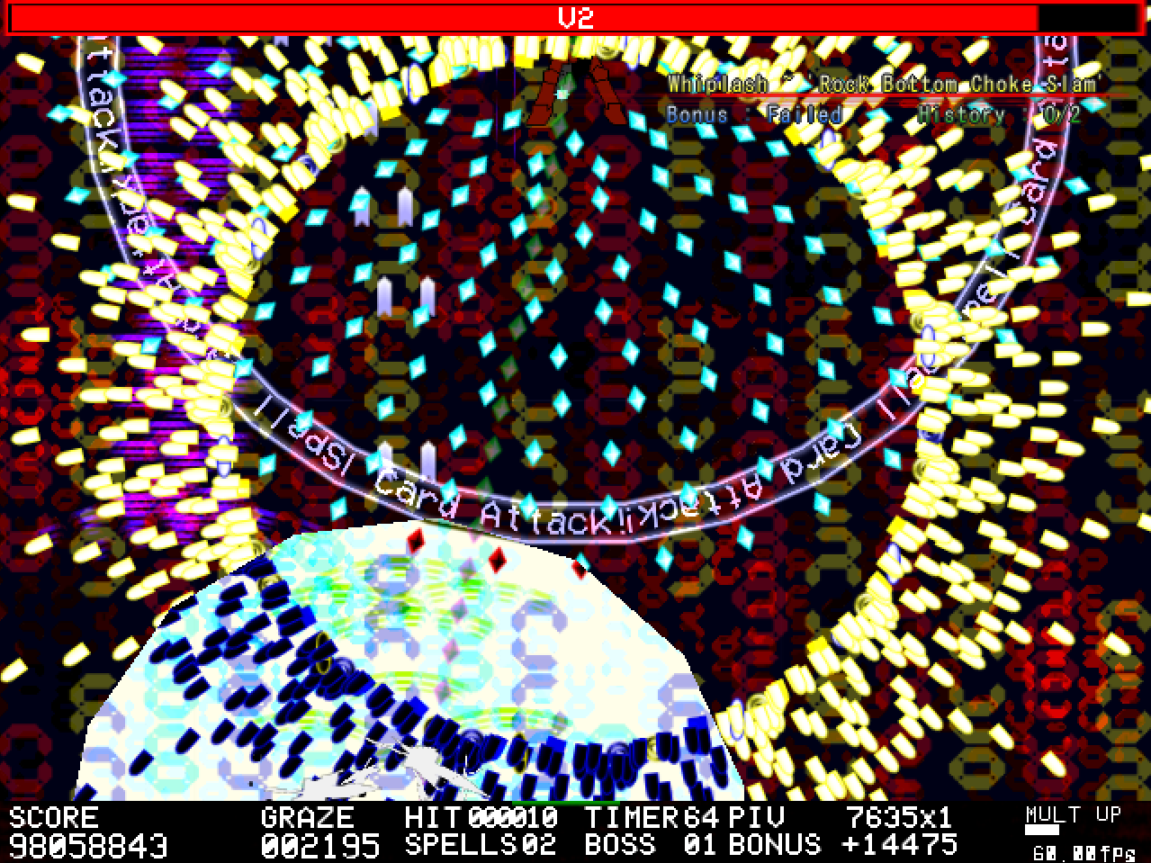

Attack 6: ***Whiplash ~ ‘Rock Bottom Choke Slam’*** | **Score: 28**

This screenshot of me dying is totally what happens every time. The mechanic of this spell is cool, but totally unpredictable and blind killing. So it kinda backfires. In general this spell is very blind killing with little to no telegraphing. It’s a shame, since it could be a very awesome card.

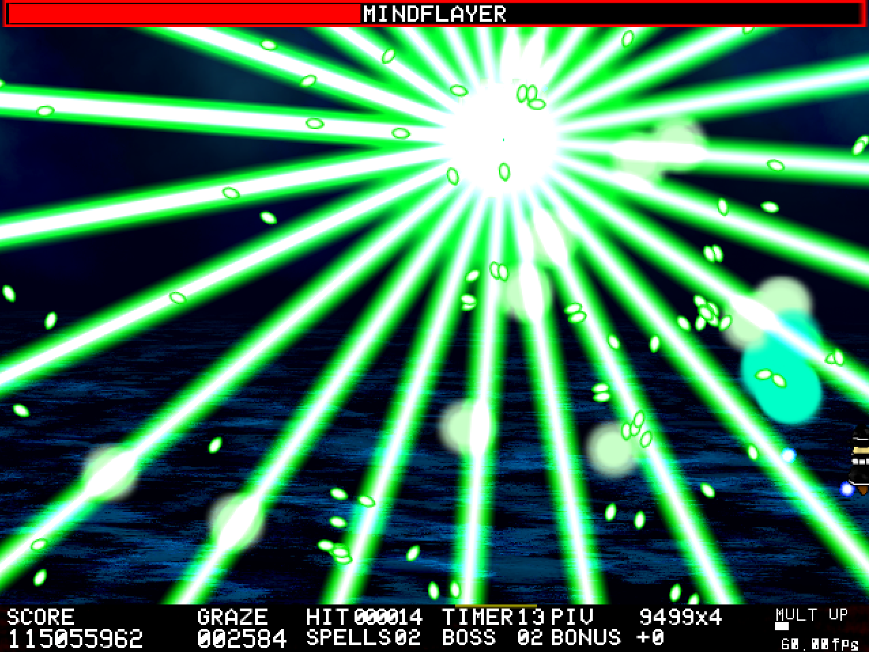

Attack 7: ***Nonspell (Mindflayer)*** | **Score: 23**

Stranger Things hello? This one’s a real conundrum to me. I haven’t figured out the best strategy to deal with this one, but the pursuing orbs are a real pain in the ass.

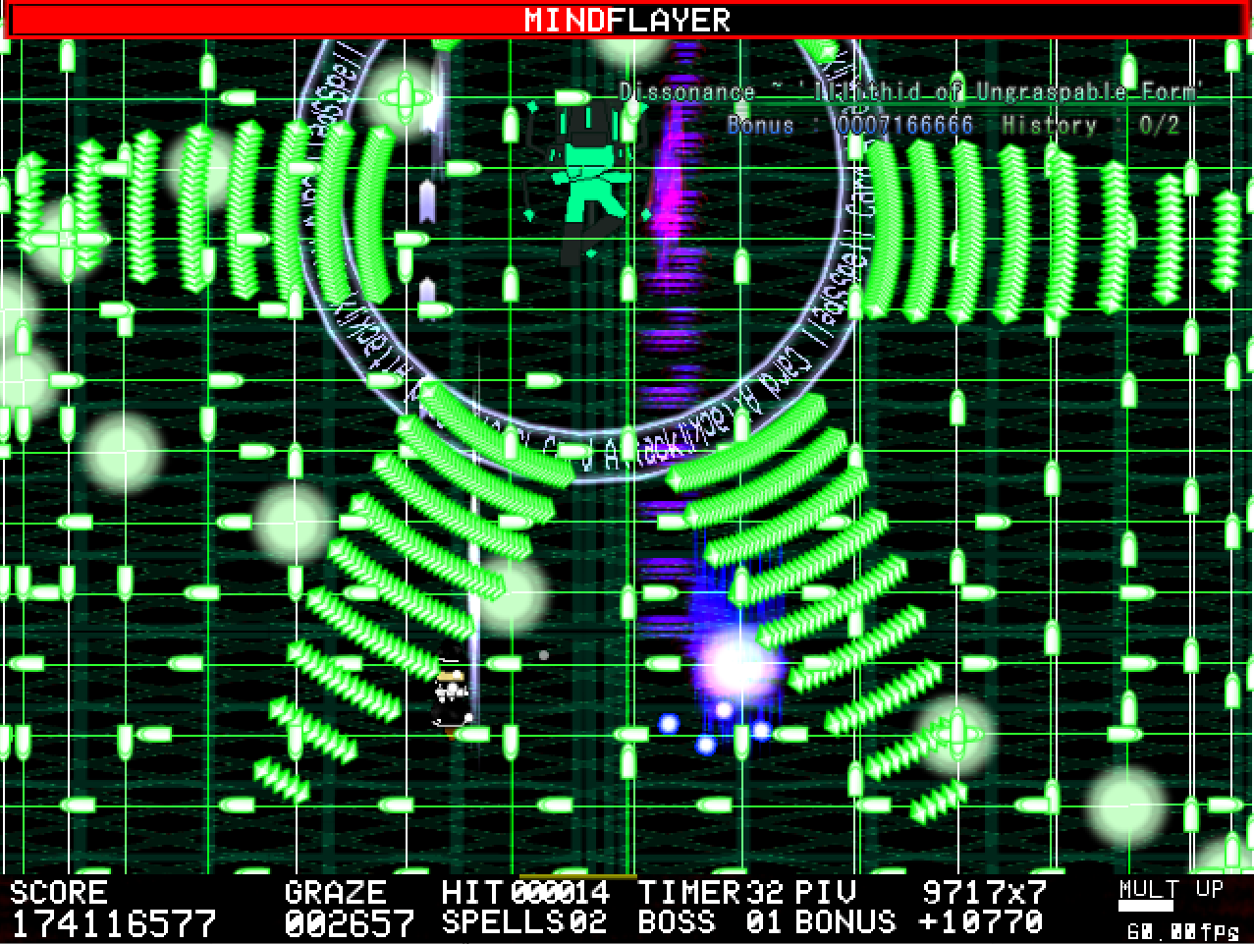

Attack 8: ***Dissonance ~ ‘Illithid of Ungraspable Form’*** | **Score: 26**

This card's a real trippy one. But I felt so immersed! Following the lanes feel threatening but it’s actually pretty simple to dodge, despite being pretty hard.

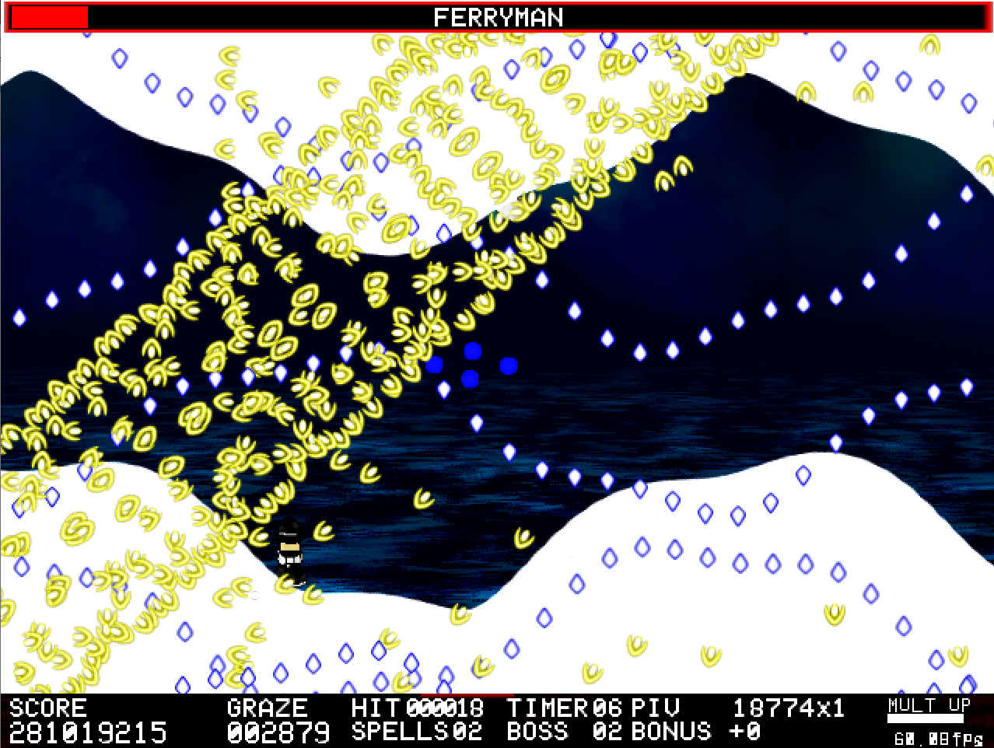

Attack 9: ***Nonspell (The Ferryman)*** | **Score: 27**

Now this start is an asshole, I had no idea it would spawn up a bunch’o bullets in the middle. Also, this attack definitely fits better in a spell card, it’s so complex! I felt some Undertale/Mrs. Estacion vibes here, so I’m pretty satisfied with this one. I can’t capture it for the life of me, though, it’s way too hard.

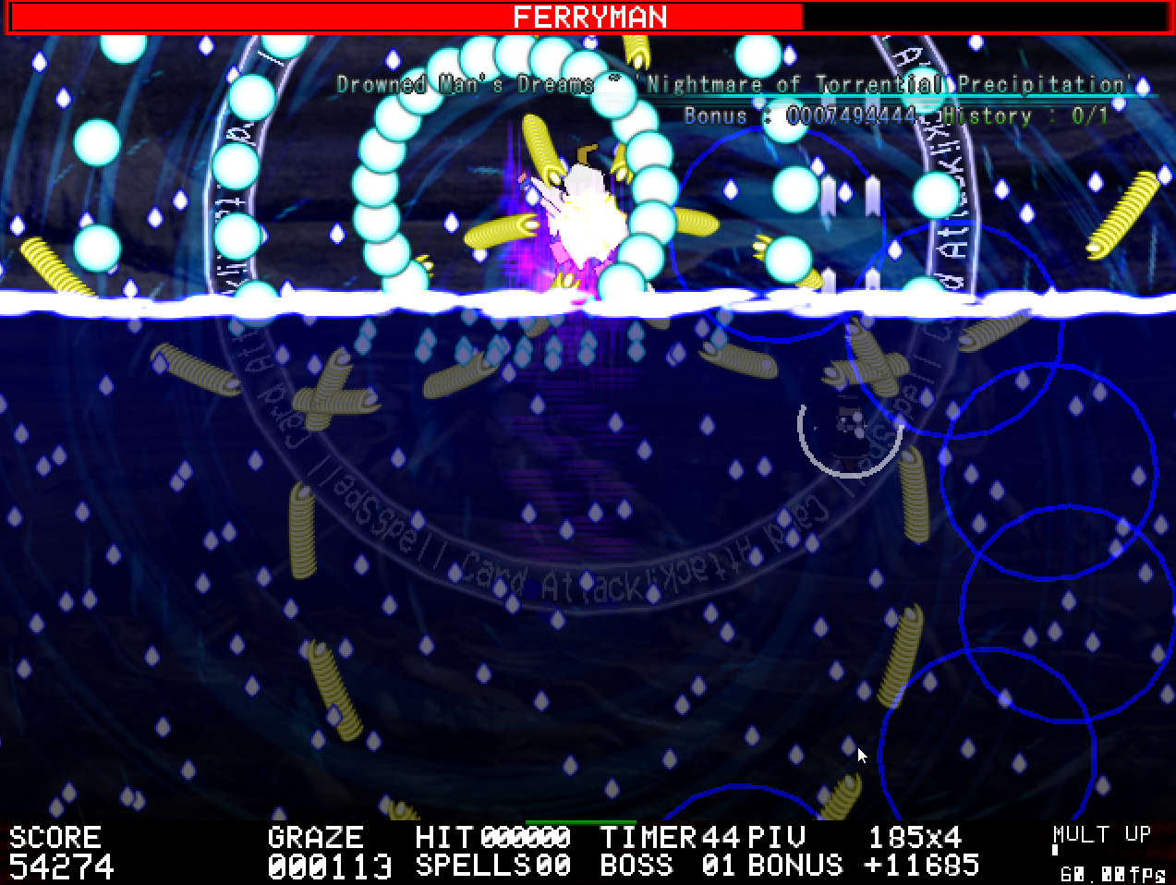

Attack 10: ***Drowned Man’s Dreams ~ ‘Nightmare of Torrential Precipitation’*** | **Score: 29**

Yeah, despite this attack’s cool introduction, it did waste a bomb unnecessary due to shock. You also did not just name this spell like that. I super vibed with the MB-inspired breathing mechanic, but the bullet opacity didn’t have to be so scuffed during the attack. Pretty fun, but definitely hard. In general, I’m seeing that this game’s alleged “normal” mode is definitely not the same normal Touhou has, and I wish it was clearer.

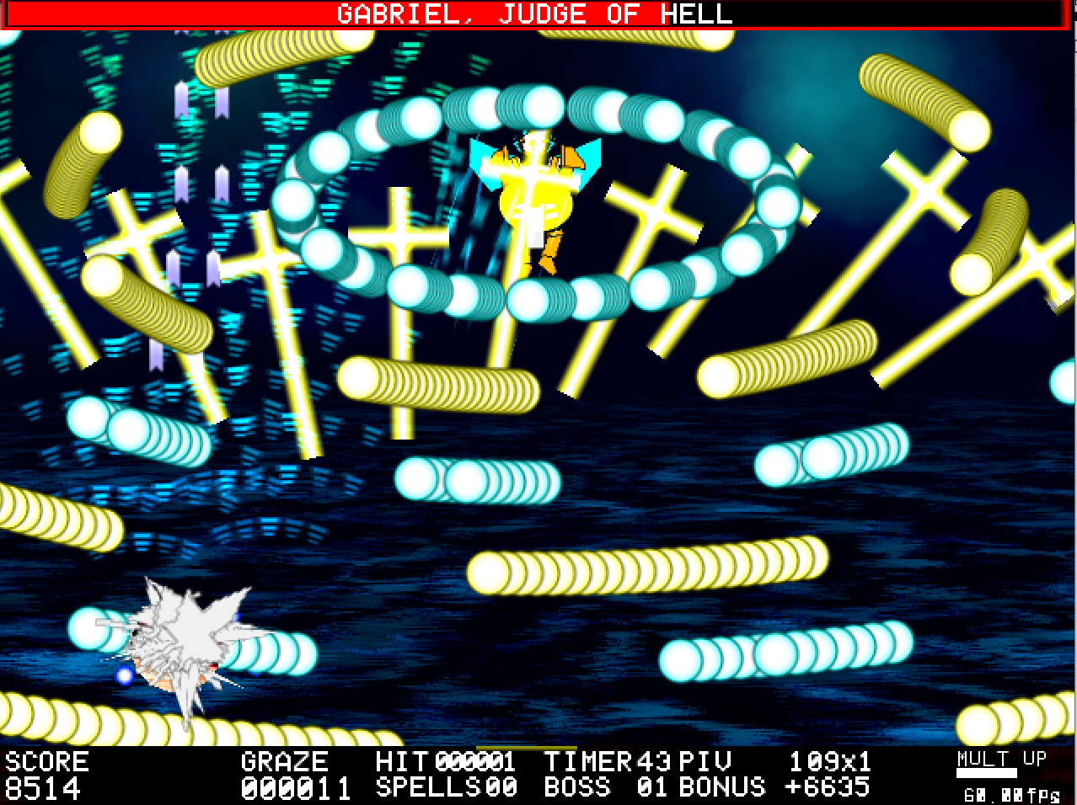

Attack 11: ***Nonspell (Gabriel)*** | **Score: 25**

At first glance, it seems like the start of the attack just features aimed crosses and mentos ellipsis, but the movement they have is pretty funky. A simple attack though for what was a very flashy introduction for the character.

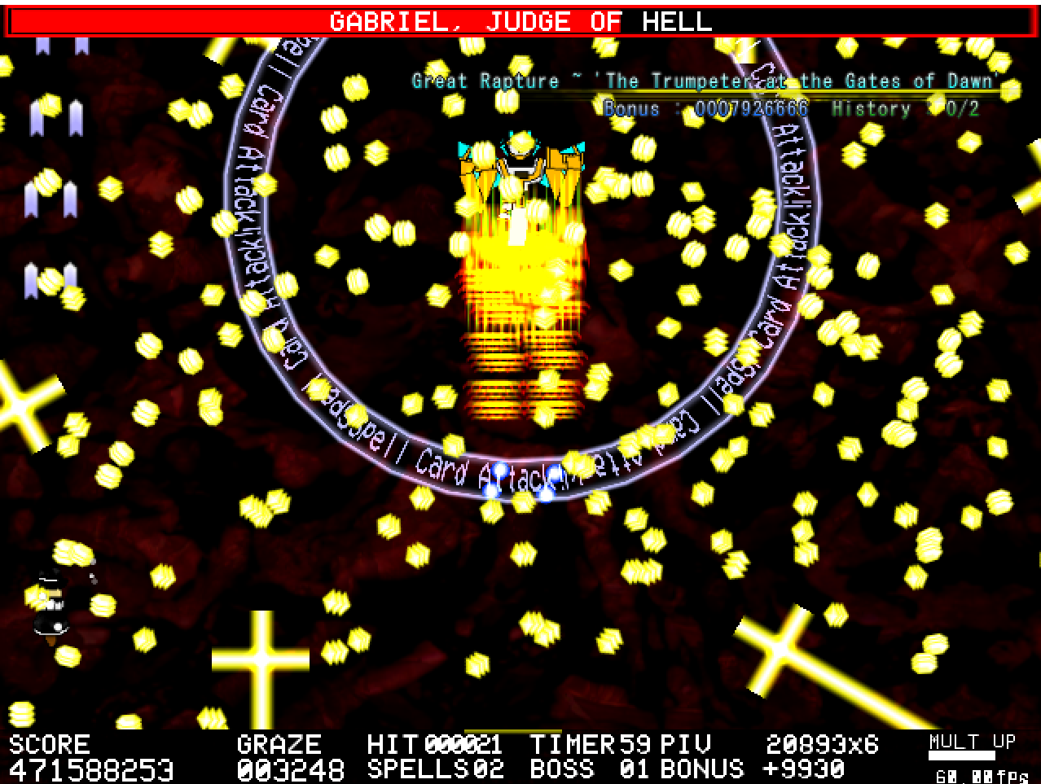

Attack 12: ***Great Rapture ~ ‘The Trumpeter at the Gates of Dawn’*** | **Score: 25**

Not much to comment here, it’s a cool spell, but perhaps not on par with the rest of the attacks shown so far.

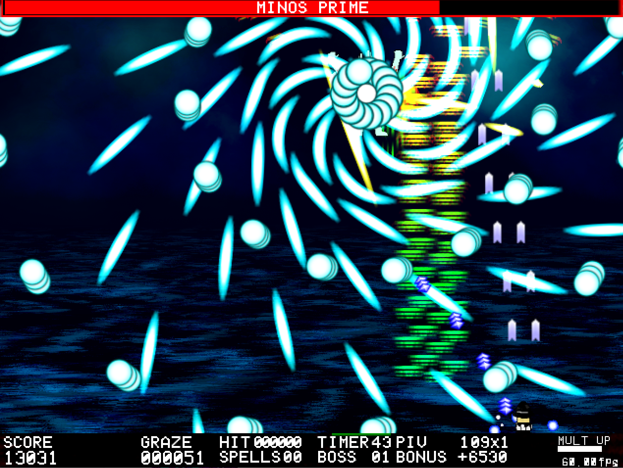

Attack 13: ***Nonspell (Minos Prime)*** | **Score: 26**

The blue kunais kinda tripped me out, overlaid on top of this dark background, they could be a little bit brighter considering they stack on top of each other and are way too fast to dodge efficiently without being able to see their dynamic trajectory very well. I do like my curvy lasers though. Wish the yellow laser waves were shorter, too.

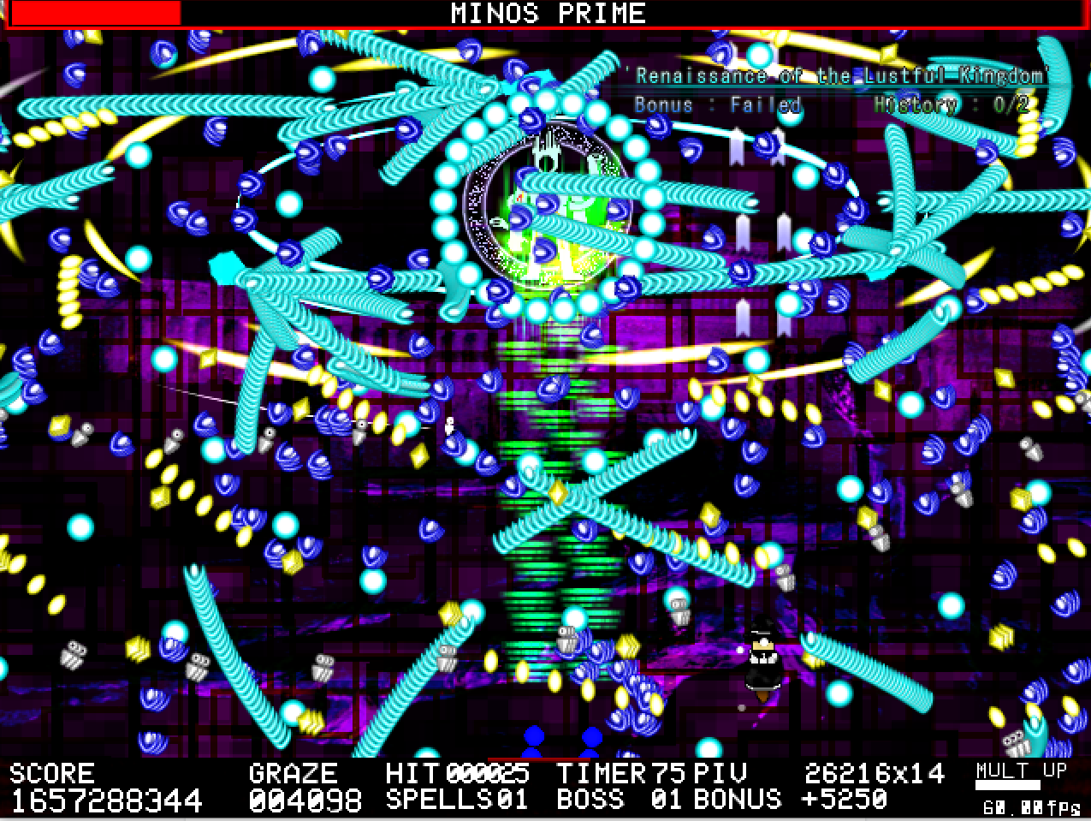

Attack 14: ***‘Renaissance of the Lustful Kingdom’*** | **Score: 27**

As a finisher, it feels pretty standard, an attack with a bunch of modules that stack on top each other that seem simple standalone but a big thread combined.

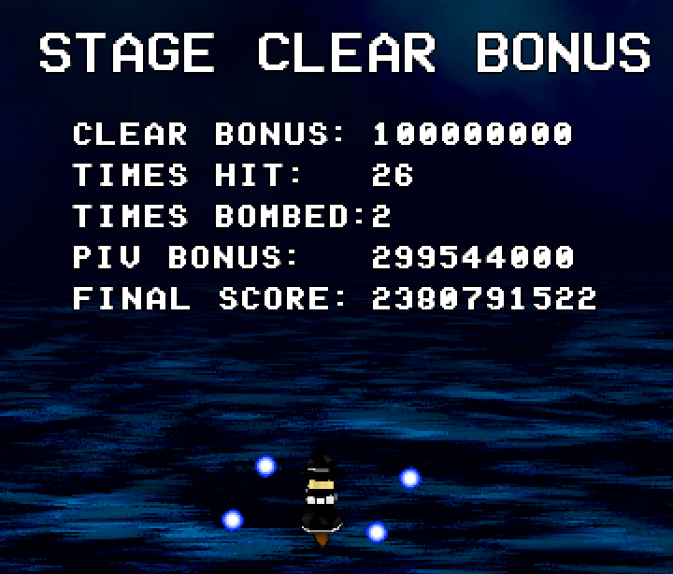

So glad to see a bunch of games having score calculations!

I noticed that during dialog, if you charge MarisaB’s missile it kind of just freaks out with the sound. MarisaB is weird. MarisaA is probably the best shot in my opinion. And the coolest looking one too.

In general, my biggest problem with the game is the difficulty. Sure, the difficulty name is “violent” but the description specifies it’s the substitute for normal mode, alongside pointing out this is the difficulty intended for the contest, but it definitely doesn’t seem that way. The patterns are very fun all around, but I can definitely say my experience was a little bit impaired by that.

Regarding ***beauty/atmosphere stuff***:

I’d like to mention that the style here is pretty interesting! It doesn’t necessarily reek of Touhou, but the atmosphere is very concise and pulled me in very easily, and I think it fits very well with the robotic stuff the game pulls later on.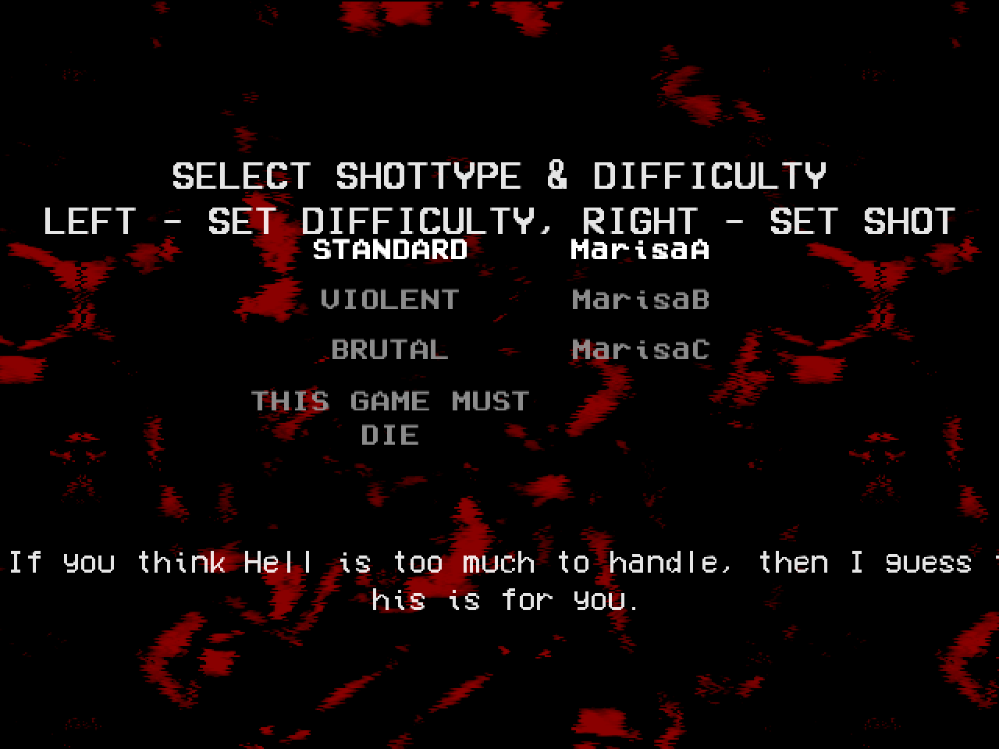

The title screen is pretty nice, the transitions feel fluid and all, but the game start screen is kinda scuffed, I wish the alignment was different and that the text cropping was better too.

Regarding visibility, this game has a pretty good grasp at having it clear, except in some specific cases.

The music utilized in it was also pretty nice, I felt like it matched well with the attacks that were occurring during it.

It’s a pretty bold move to do an entry like this, deviating so much from the usual Touhou fanfare. I appreciate this courage a lot, though I believe it’s about time I expect stuff like this from the author.

Kinda related to the last point, I missed a little bit of characterization and fleshing out on the characters dropped here.

***Score: 30***

Regarding ***miscellaneous stuff***:

What can I say? This game set out to do something and it did it well. The options provided for the player are pretty decent (except for that small bug I described earlier) and I’m very glad there were options to practice boss the boss fights and the individual cards, which is super cool. The little intro at the beginning of the game is also super nice, it definitely amps up the expectation for the game when seeing it. To me, I think that was mostly delivered well. The variety present both in difficulty selection and player shot type is also very much appreciated. I think it's nicely polished all around, the construction of the game is pretty solid and concise. I absolutely loved the amount of diversity in terms of gameplay mechanics it had, which kept me interested all the way through.

***Score: 14***

## Dealing with Doppel Characters

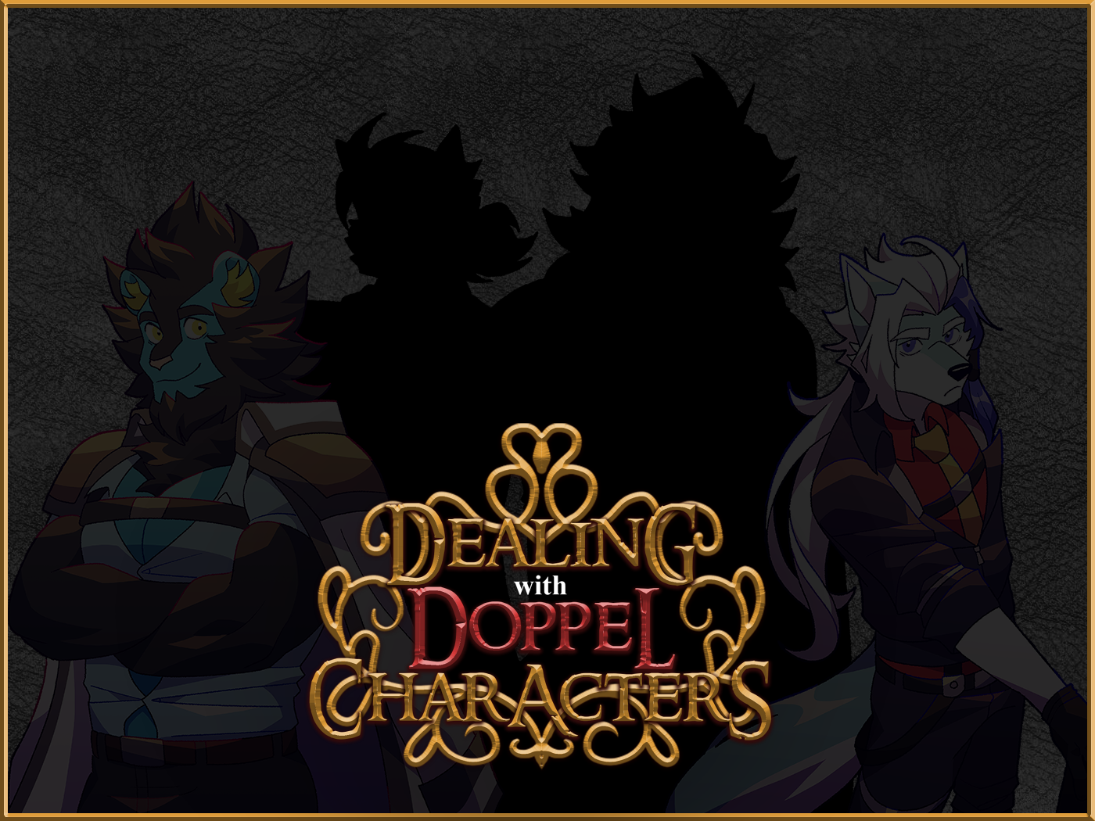

*Developed by: Syoudre*

*Engine: Danmakufu ph3sx*

This one’s a storm of creativity that heavily surprised me when I first played it, I cannot fathom the absolute intensity of an upgrade that Syoudre had comparing this entry to his previous one in a previous BHA edition.

Information about the game came alongside the Discord post Syoudre made submitting the entry, as well as the itch.io page for it.

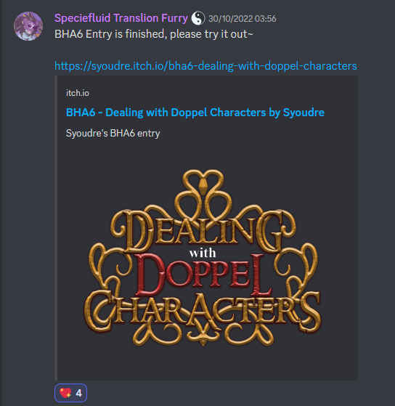

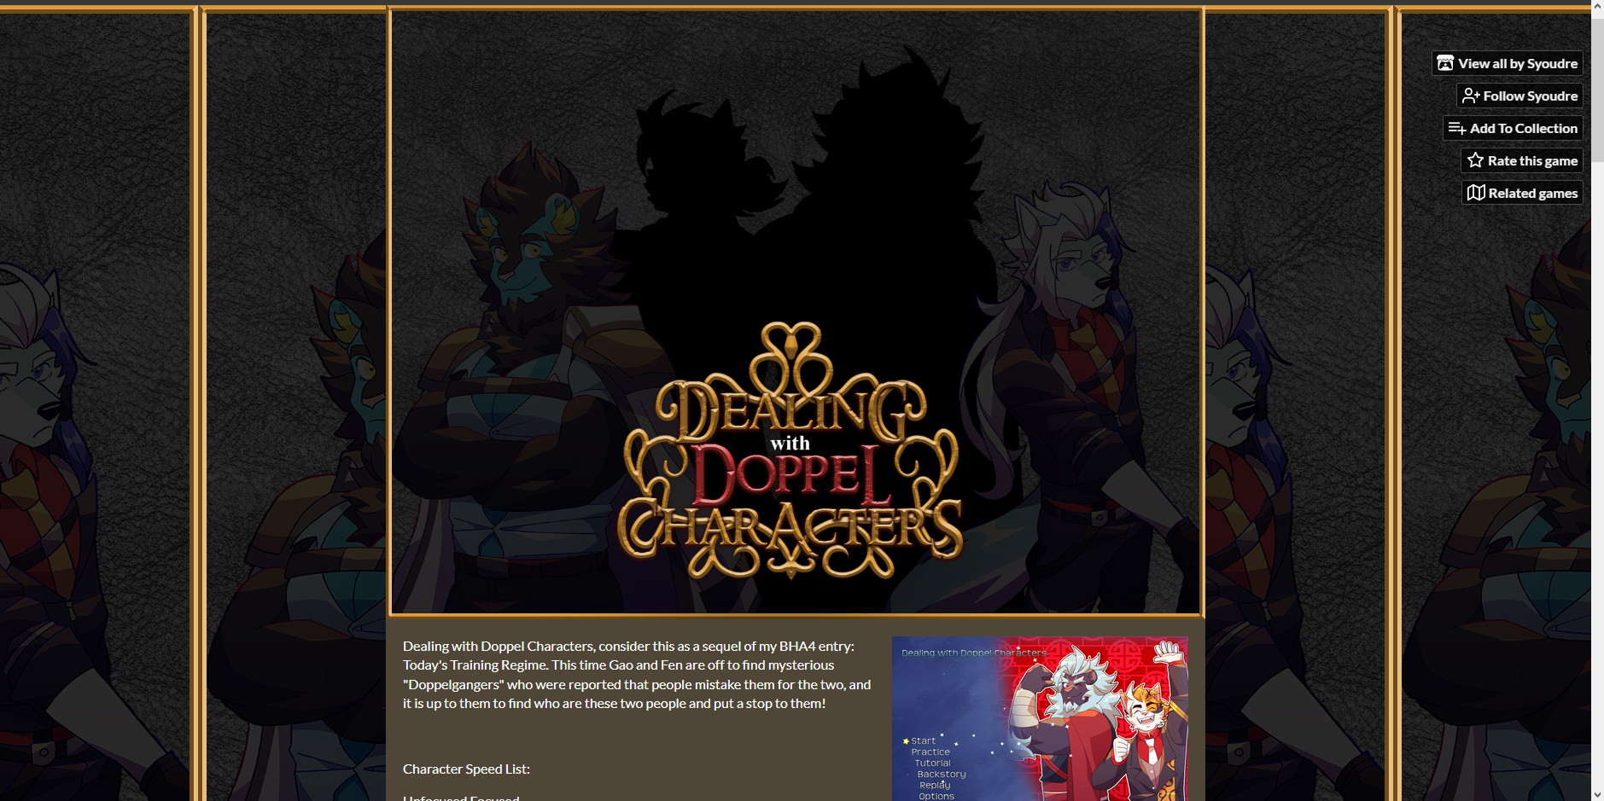

To start off, the system here is impressive, it accounts for a lot of possibilities the user may want and it honestly was helpful even for judging.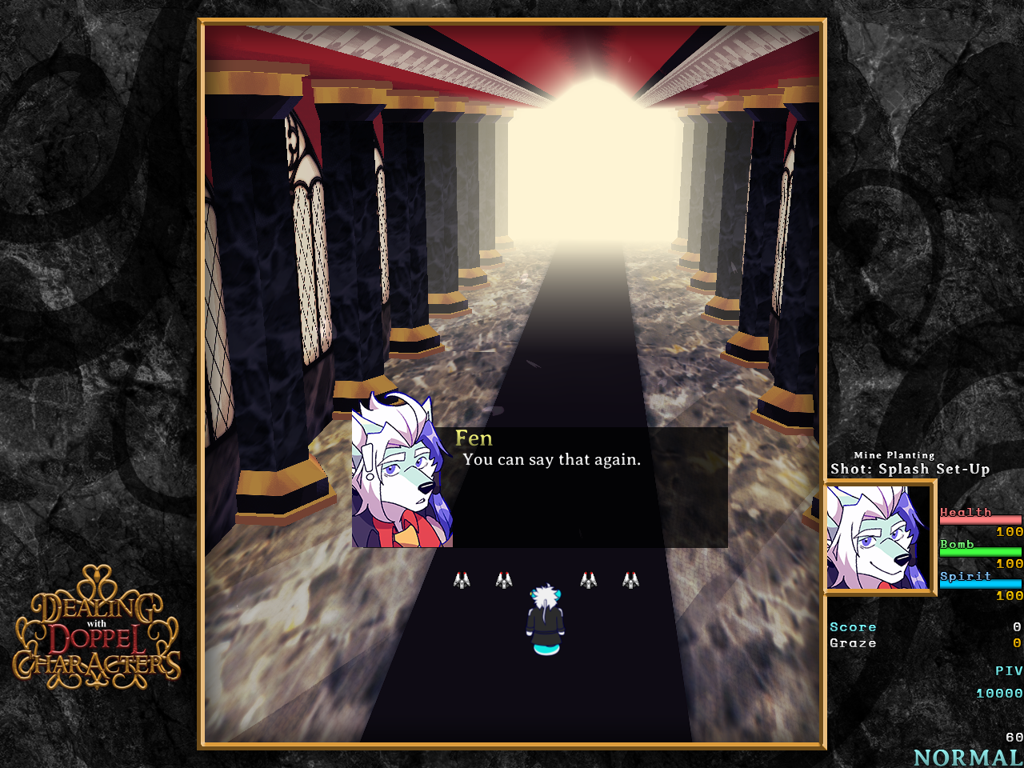

Starting off the game, the flow of the dialog and cutely unique way of portraying it is very satisfying, even if I’m not such a huge fan of how quickly it skips to the next one without player input. The way the dialog boxes actually do follow both the player and the speaking boss is pretty impressive too, and I’ve never seen anything like that. I will say that the music accompanying this really helped the feeling of grandiosity this whole exchange gives.

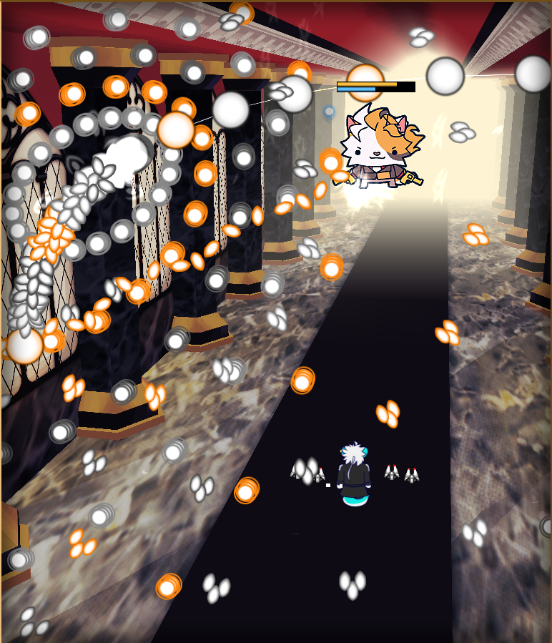

Attack 1: ***Nonspell (Leif)*** | **Score: 24**

An easy, but cute introduction. I can’t handle how unthreatening the boss sprites are, I guess it fits a lot on how this game’s humor operates. Furry! It’s interesting to see how the arch formed turns into these sort of flower things.

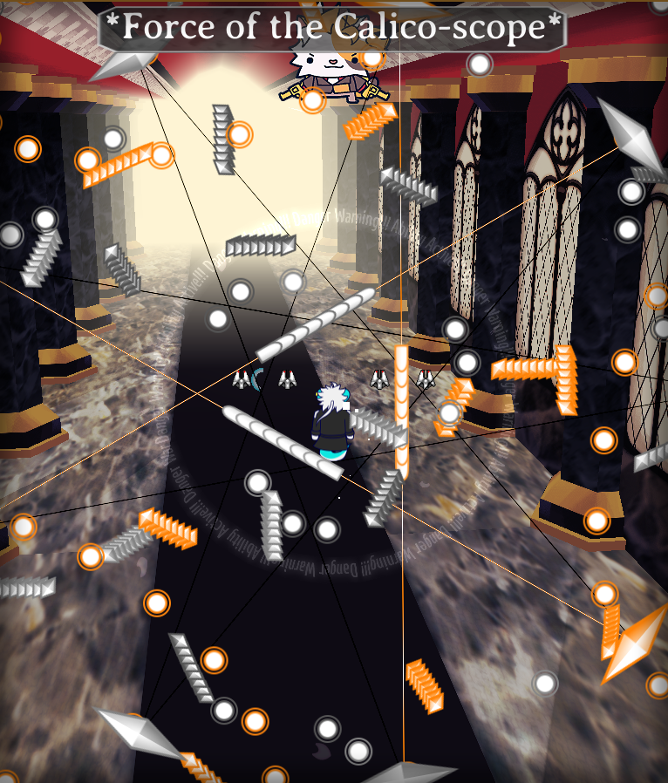

Attack 2: ***\*Force of the Calico-scope\**** | **Score: 25**

This one’s a pretty different implementation of a first spell card. You’d usually see something leaning more to the simpler side but I can see a lot of components present in this card. Regarding the danmaku itself, I’m pleased to see that the bullets actually do follow the line paths that are rotating instead of just being shot at the current angle. That’s a pretty cool detail.

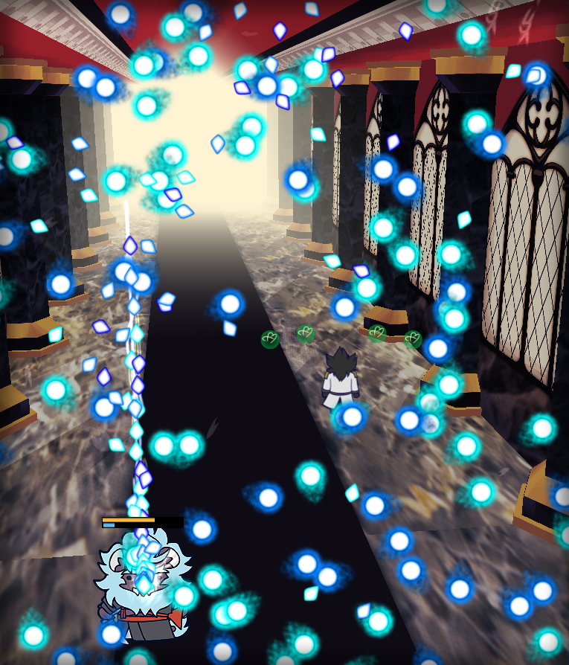

Attack 3: ***Nonspell (Zhan)*** | **Score: 25**

I appreciate the little breathing time for the player to reposition themselves after the previous attack going into this one, and the quick attack frenzy is kinda nice, though the sound effect repetition is kind of obnoxious. The warning lines to simbolize the boss rushing in at you is cool too. An odd nonspell, but I like it.

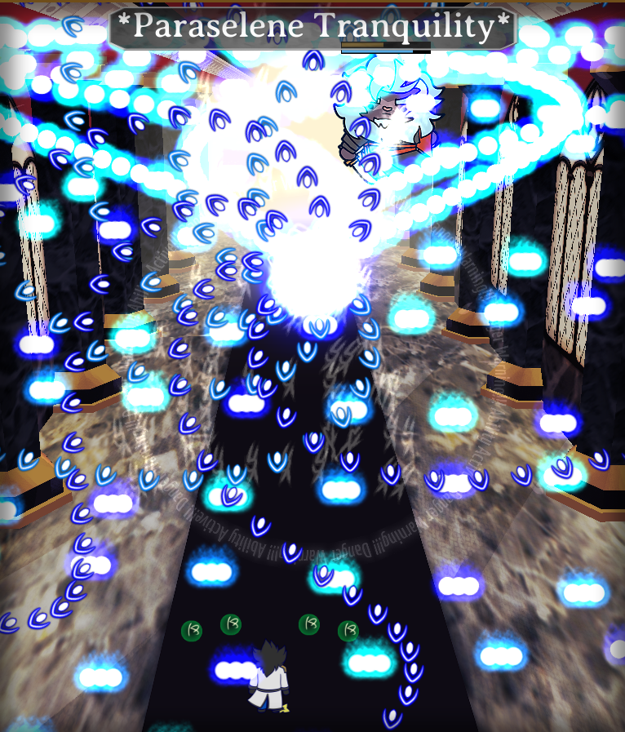

Attack 4: ***\*Paraselene Tranquility\**** | **Score: 24**

This kind of reminds me of Belle from IFoCW. I like that it’s not just an infinite repetition of these tide waves but that after a while the boss cuts out the central spawning point of the bullets and turns it into a star. I wish that explosion was a little bit more dense, though. Is this an improved BoWaP experience?

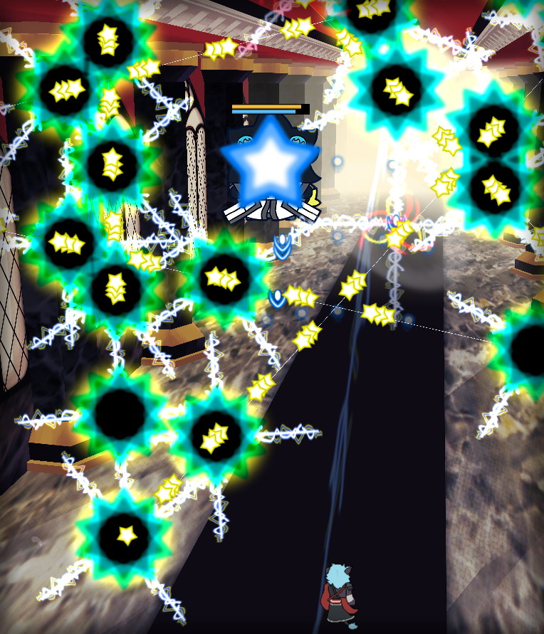

Attack 5: ***Nonspell (Gao)*** | **Score: 26**

Switching sides now! I really love this sort of thing. I know Syoudre has done this in the past before, but I don’t feel like it’s a bad thing. This danmaku looks pretty threatening, and definitely is one of the most deadly in the game, it took me a few tries to capture it.

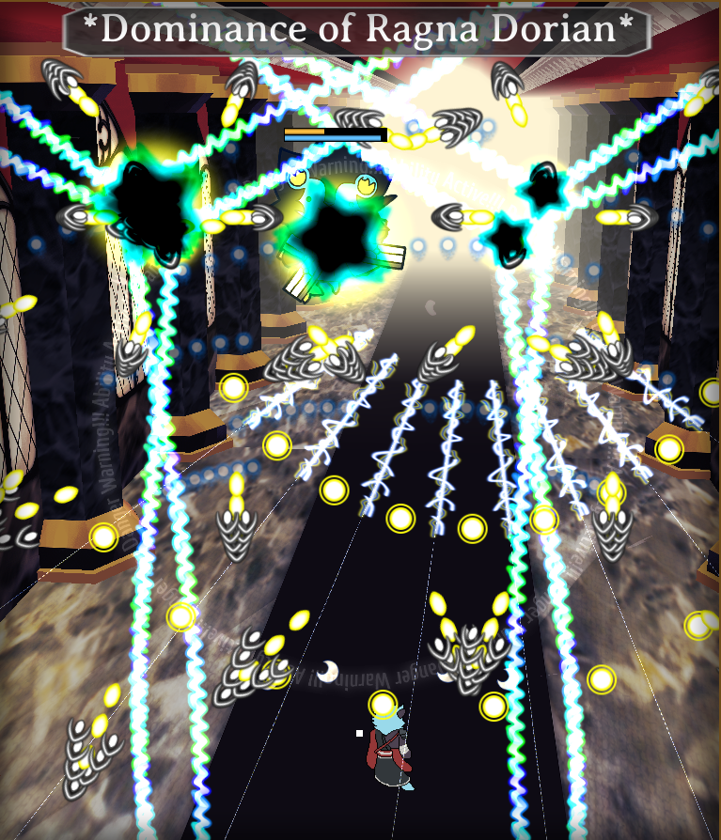

Attack 6: ***\*Dominance of Ragna Dorian\**** | **Score: 26**

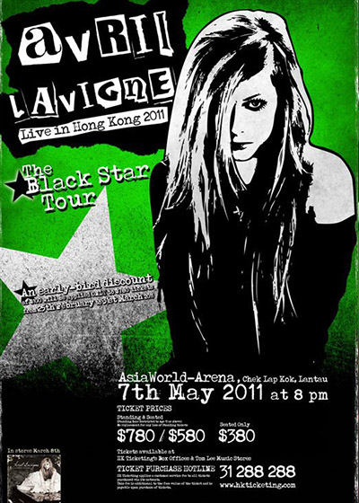

You can’t tell me this one wasn’t inspired by Devil’s Recitation. Dunno who Ragna Dorian is, but I’m sure Shinki would like a word with’em. The author is very nasty with this one, swapping to a playable character whose shot is so wide you can easily destroy the black stars, causing more lasers to appear. Also, I can’t help but notice a similarity to Avril Lavigne’s Black Star tour. (Edit: replaying it, now I noticed the little warning in the corner that breaking the stars reduces Gao’s defense. I didn’t notice it through my first 3 playthroughs so I wish it was clearer, too)

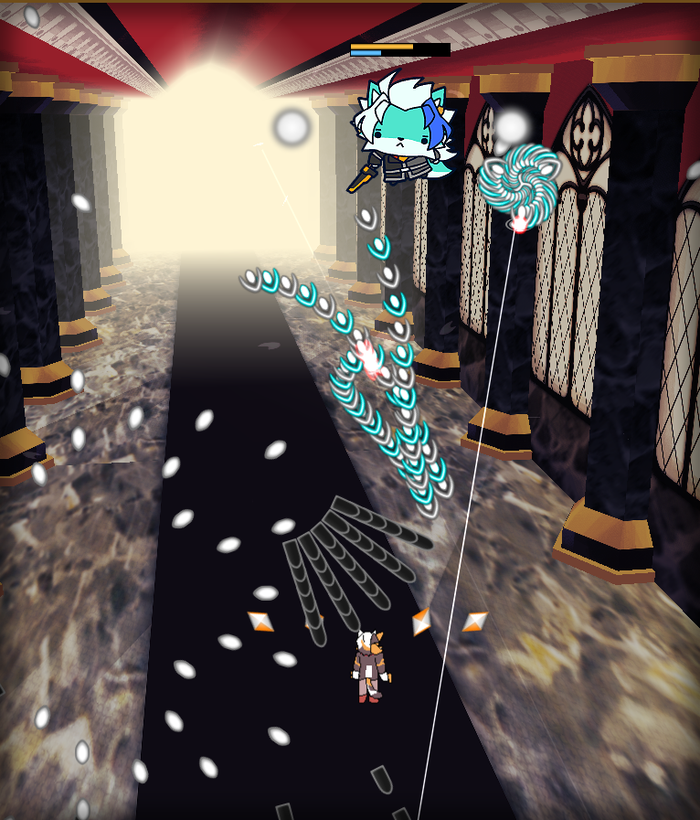

Attack 7: ***Nonspell (Fenrir)*** | **Score: 20**

This one’s probably the oddest one out of the game. I don’t particularly get this attack and it’s mechanisms are kind of unclear. Dunno what much to say about it.

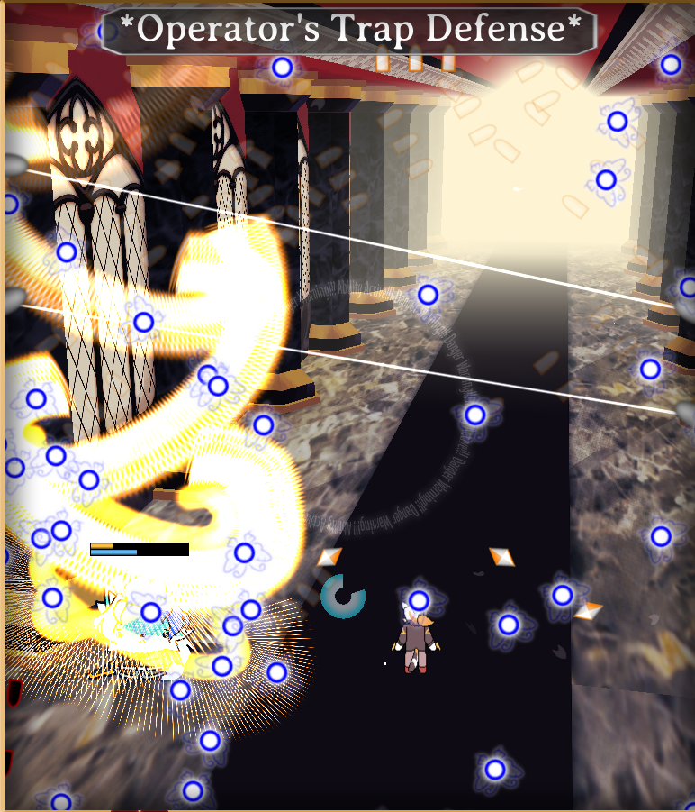

Attack 8: ***\*Operator’s Trap Defense\**** | **Score: 30**

Thankfully, this one’s a really good attack for Fenrir. I really enjoy the dynamics of it and how much movement you’re required to do here. The explosions feel super satisfying (best sound work in the game in my opinion) and it feels really fitting for the character.

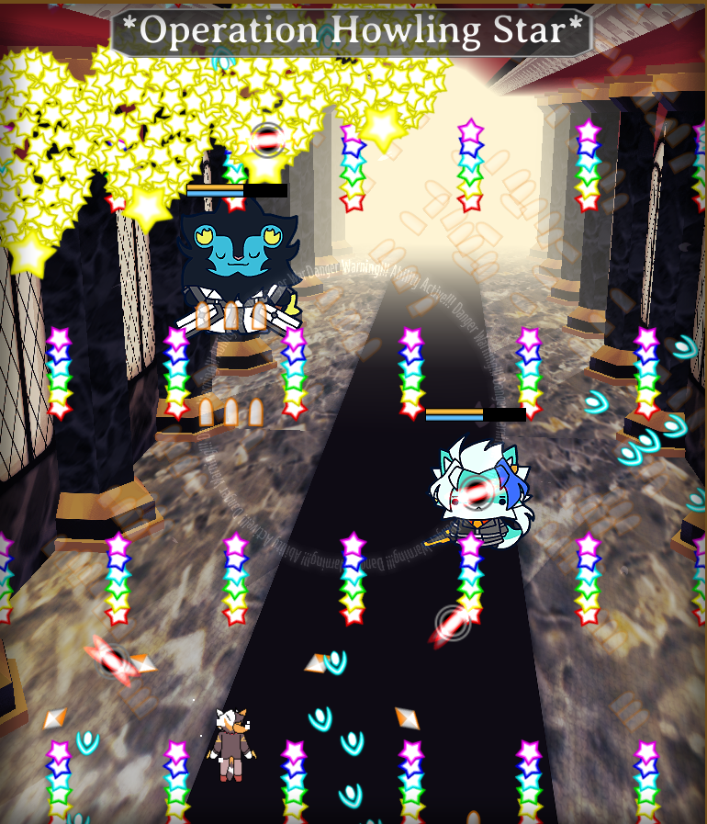

Attack 9: ***\*Operation Howling Star\**** | **Score: 28**

Teaming up time! I really like the Subway Surfers vibe this one gives me, a pretty fun attack to dodge and despite not being my favorite, I believe it represents them both well.

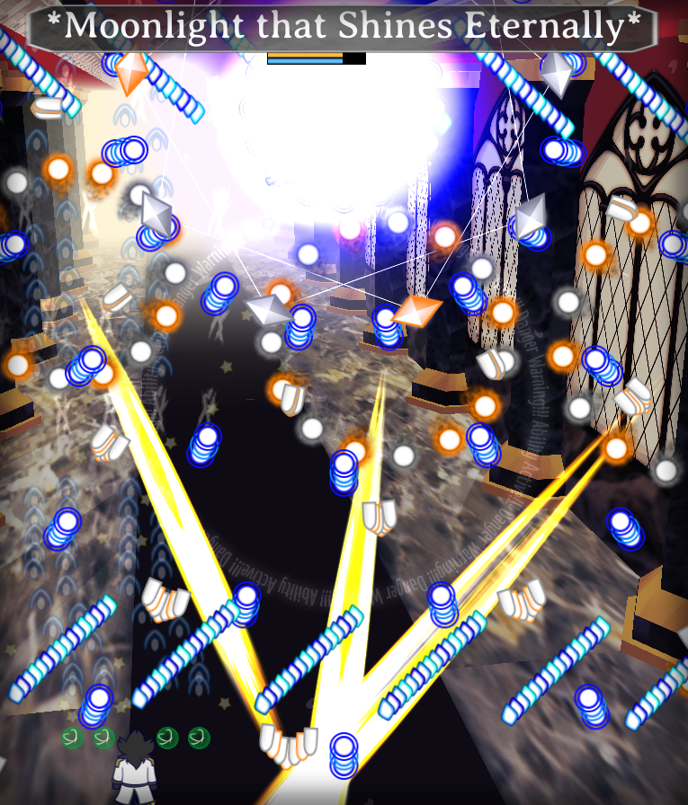

Attack 10: ***\*Moonlight that Shines Eternally\**** | **Score: 29**

Swapping sides again for the other team to team up now. This one does feel more interesting than the previous one but aesthetically wise, I think the previous one employed better coloring, though I will say this one keeps it consistent with what we’ve seen previously.

In terms of balancing, I felt that the game is very forgiving, and that’s coming from a perspective of someone who barely even used all of the tools at disposal that the game offers. I really enjoy the presence of a special ability that’s separate from the bomb amount, but perhaps it didn’t have as much of a presence in the game that I wish it had. The variety of different playing mechanisms especially coming from the switching playable characters is also commendable. However, I will have to note that all characters bombs feel kinda underwhelming. I don’t feel weight in them. Perhaps mostly due to the sound effects used and them being too simple visually. Overall, I wish there was more impact to the players' offenses.

The game has a very eclectic manner of utilizing the attacks, I feel like a lot of them don’t follow the usual convention you see in fangames and such and the distinction of a nonspell to a spell card here is way broader in terms of complexity, some of the attacks I felt like could well be a spell card in some contexts while being nonspells and in general they’re all pretty fun. The fact that spell cards don’t have any additional background effects help cement the feeling of that.

I also wish you had to confirm to leave the game during the pause menu, cuz I accidentally quit a pretty good run of it pressing the wrong button lmao.

Regarding ***beauty/atmosphere stuff***:

By far, the consistency and stylish take on the game was incredible compared to what you usually see in a game jam.

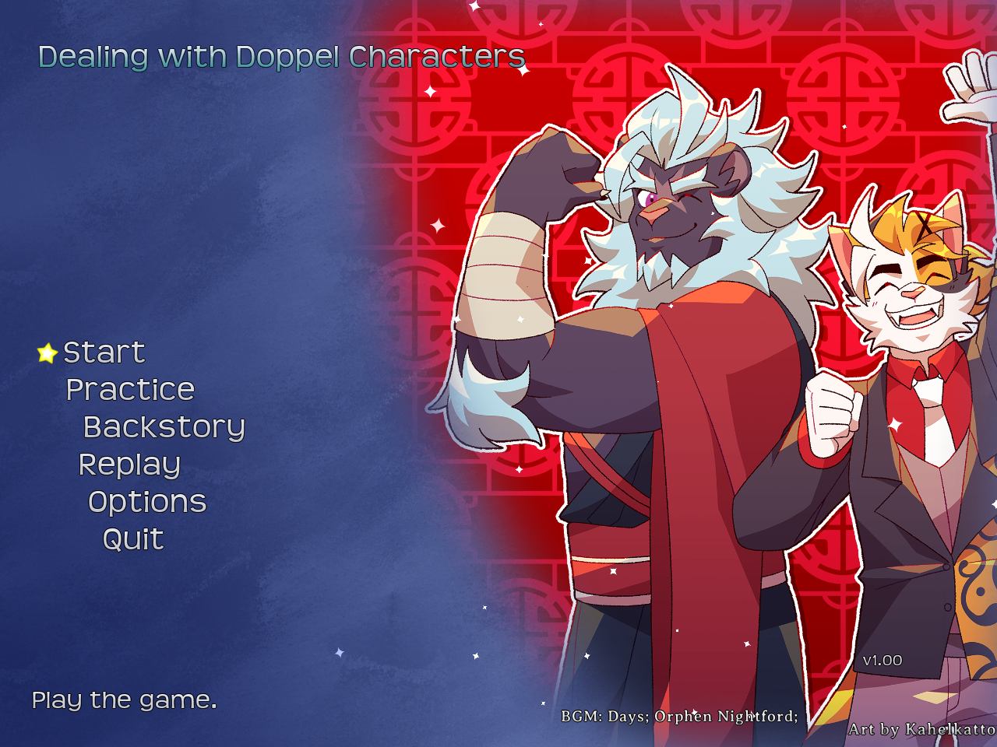

The title screen is already pretty impressive with the cute little effects it has, alongside the randomly picked background image. Though I don’t get why the game’s logo isn’t featured in the title screen…? I’m kinda concerned by one of the images featuring Gao in a particularly suspicious viewpoint and clothing.

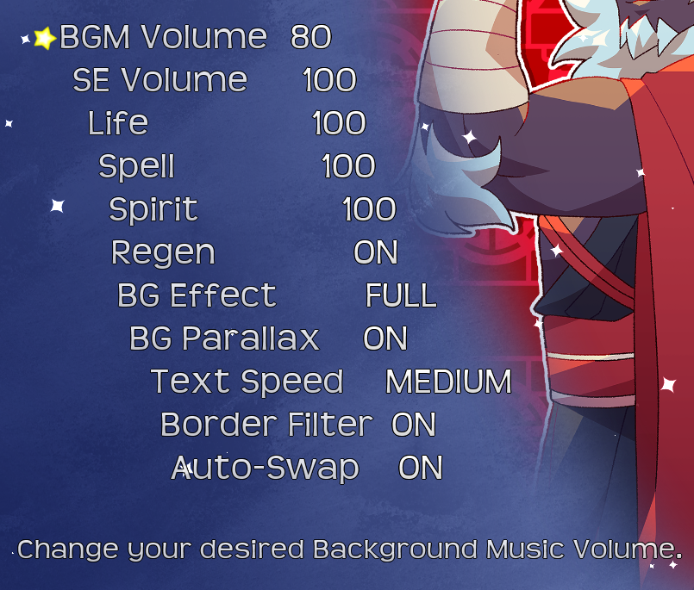

It’s pretty nice to see a bunch of accessibility options here too, as always. Good to see a description of each option, too. Similarly, as I’ve talked before, I’m very, very glad to see a menu section dedicated to the game’s backstory. Again, it’s important to let me get to know the characters featured organically in case they’re not of public knowledge (like a canon Touhou character, famous fangame characters, etc). The only suggestion I’d have for that menu in specific is letting people know there are more pages, cuz I thought the first page was the only one and quit out of it until Syoudre himself told me there were more during my first impressions stream chat.

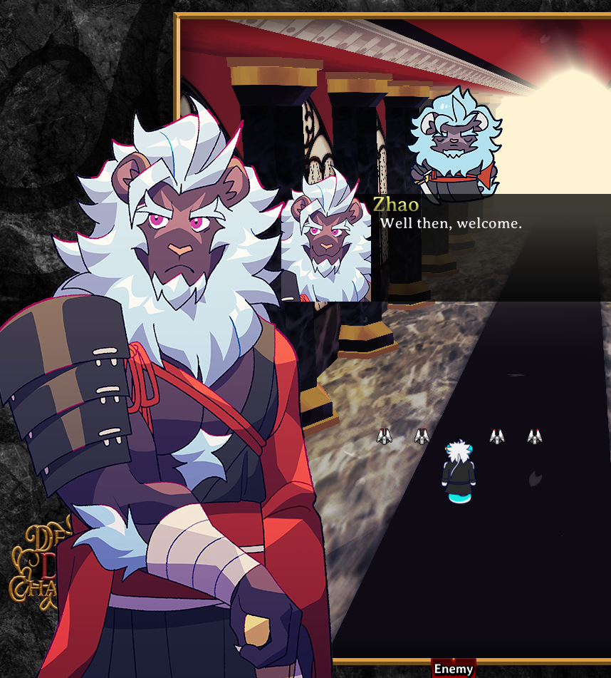

The background and overall visibility of the game is excellent, I really do love the effort I can see put into it and it’s lovely. The portrait art is very nice looking too. The dialog itself is kinda cringe, but I appreciate the whole lore construction. I especially find it really fitting that the border of the player field looks like a painting frame. The boss sprites look very cute, which I guess is a valid style to go to since this game’s vibe feels very casual. Talking about that, I have to commend how nicely the identity of these characters were built. I could totally recognize their danmaku and assign it to one of the furries here just by the way they mechanically feel and by the way they look.

The choice of using a remix of Hatsuna’s theme as the battle theme is something that perplexes me still to this day, but it’s alright, I guess.

I am also extremely perplexed as to why the author keeps using this weird banner to display spell cards. It’s one of the very few things that don’t feel fitting with the rest of the game and it’s such a weird decision to keep using it after so many previous games. The death effect is also very crude, in my opinion, and could be improved upon.

The logo itself is also another good thing to analyze: I really enjoy how complex it is, and definitely is a highlight in this context by itself, but I can’t help but feel that the word visibility is kind of impaired by the tangled pattern beneath it. Perhaps that pattern could be changed to make it less visible, or perhaps a different/darker color to it.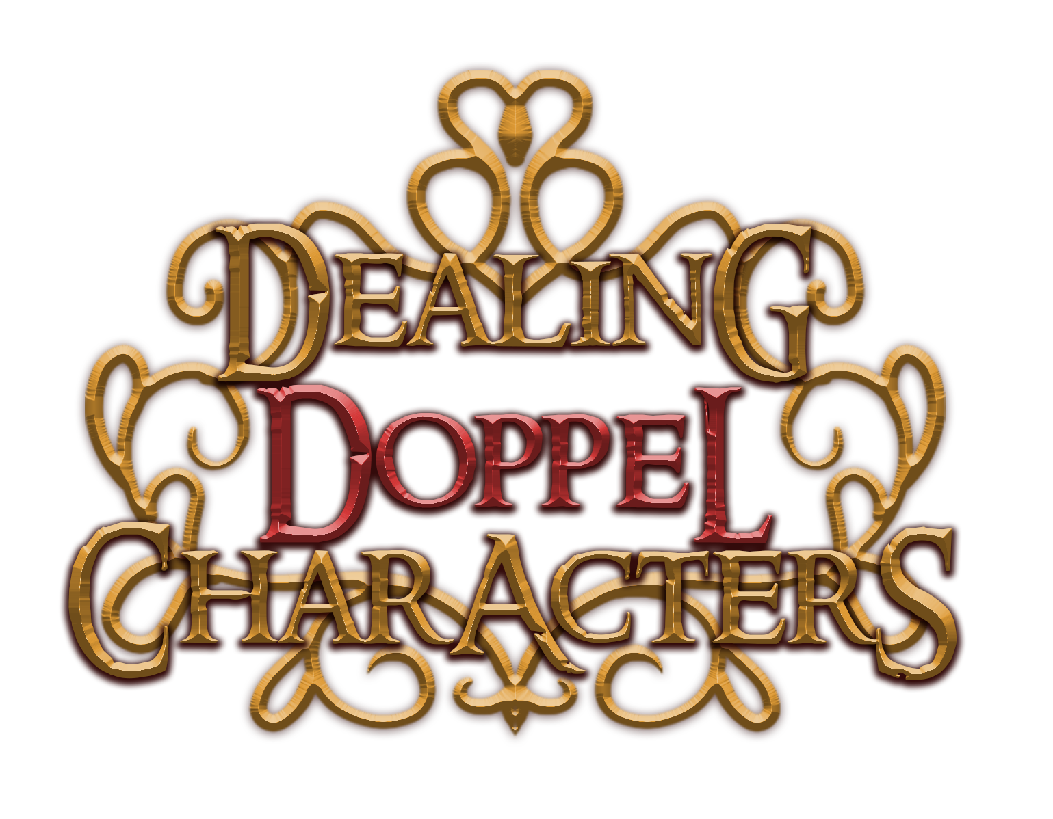

***Score: 35***

Regarding ***miscellaneous stuff***:

I technically have already accidentally described again most of my thoughts during the rest of the analysis itself, so I’ll just reiterate here that the polish in this game is impressive. The graphic quality is really amazing and despite seemingly being outsourced, I still applaud for the style consistency and the way everything was applied seamlessly. And for once, this game actually has stuff that deem pretty gimmicky to me, such as the player swap mid-game and others.

***Score: 17***

## BHA6 (epicgame3)

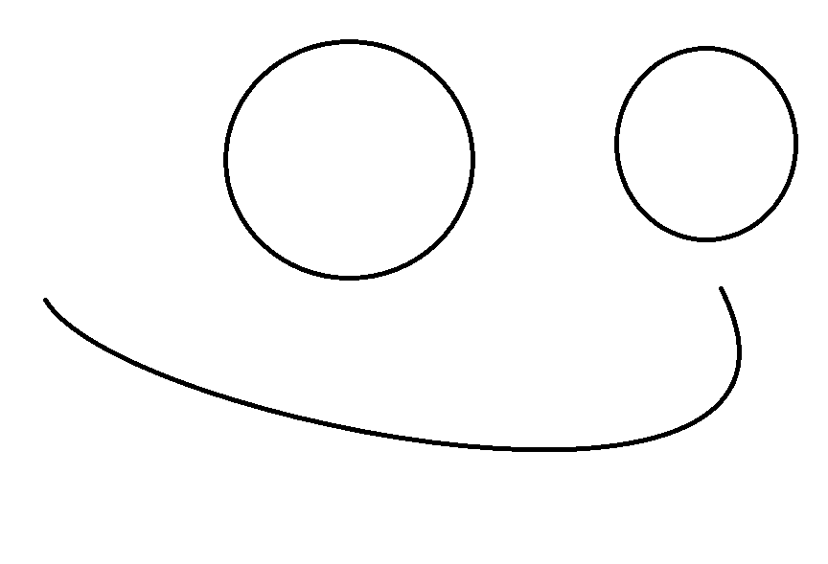

*Developed by: Pickled Cow*

*Engine: Godot*

I’m increasingly concerned about how Pickled’s brain state is. Their previous entries were quite peculiar but this one takes the cake for my worries.

Information about the game came alongside the Discord post (if you could call that information) Pickled made submitting the entry, as well as the itch.io page for it.

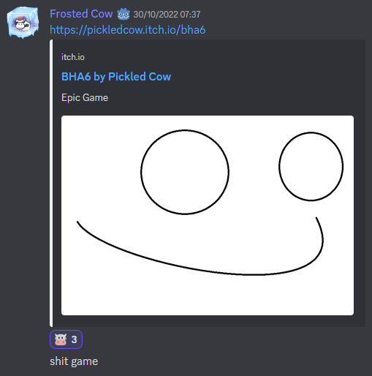

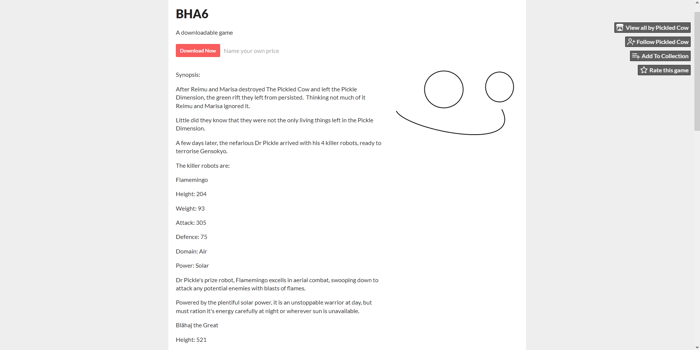

Quite an… um… simplistic take eh? I appreciate the courage to put your work out in the world publicly but this is definitely quite a highlight here.

The title screen is also quite a glimmer to perceive.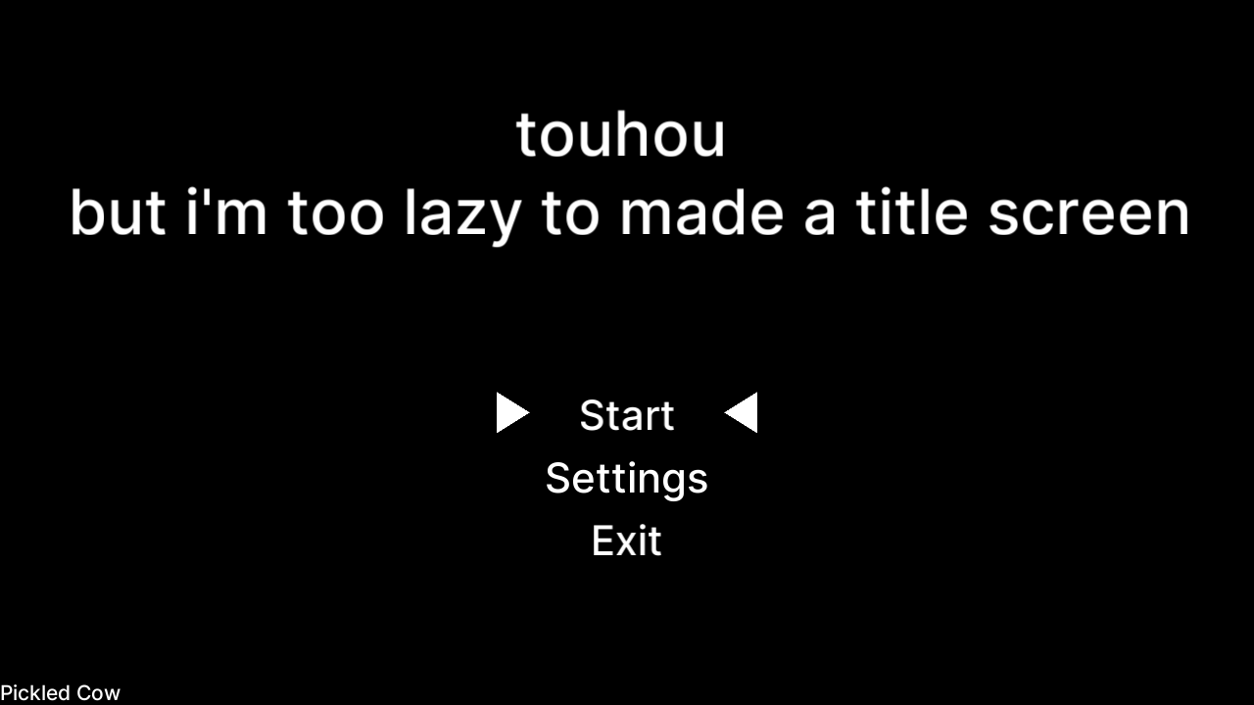

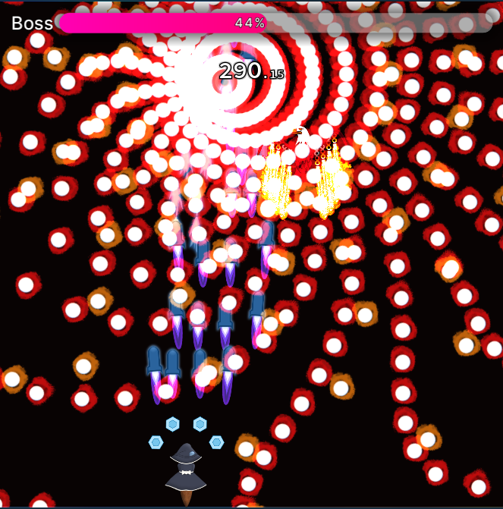

Attack 1: ***Nonspell (Eagle)*** | **Score: 16**

Despite being a pretty comical beginning, I think fire suits eagles a lot.

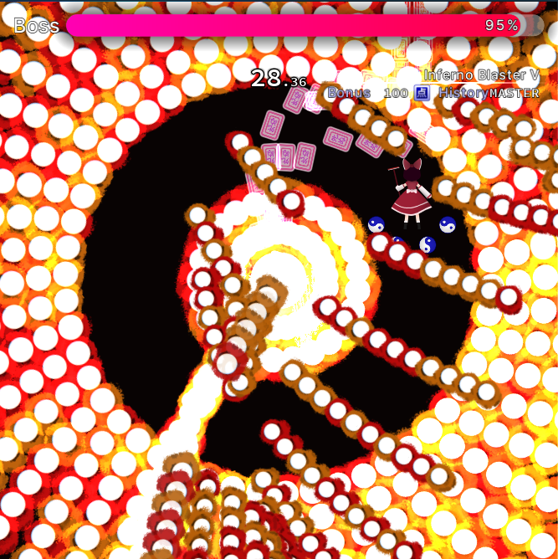

Attack 2: ***“Inferno Blaster V”*** | **Score: 21**

This is an interesting fire wheel attack. At first, I thought it was impossible, but I didn’t think of backtracking to dodge the incoming waves. Overall, I think this is a quite fun attack. A little bit different from the usual first cards.

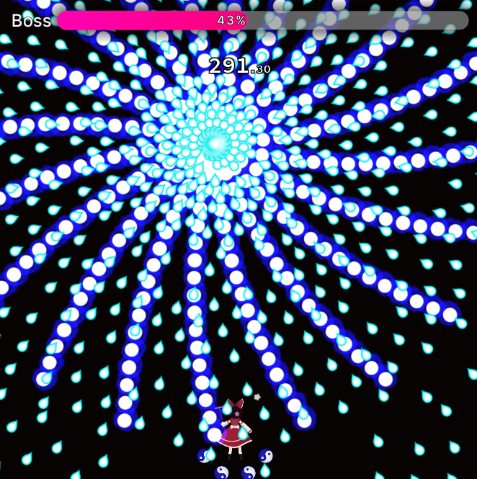

Attack 3: ***Nonspell (Shark)*** | **Score: 15**

Very similar to the first non. Quite simple, too. I’m kinda dying at these characters.

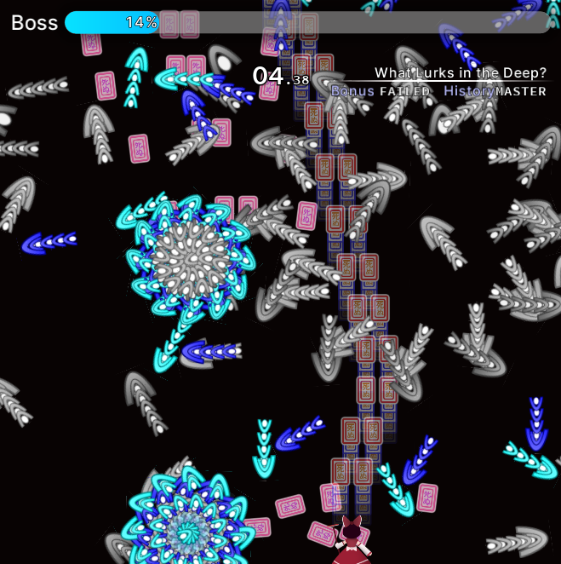

Attack 4: ***“What Lurks in the Deep?”*** | **Score: 20**

This attack isn’t very much developed, but I really like the core idea of it. The shark’s visibility is kind of hampered by being in this black background while also being pretty dark, so I kept getting surprised by it’s position relative to me. The waves spawning are kinda cool, but perhaps if they were faster and less dense it would make for a more intense pattern, more fun.

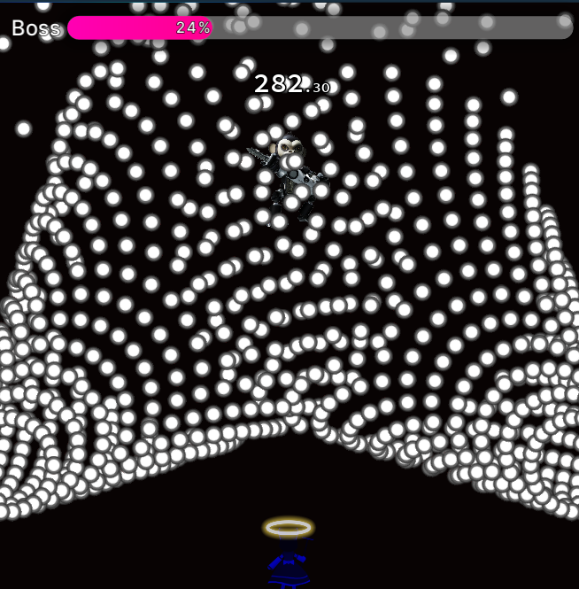

Attack 5: ***Nonspell (Minotaur and Unidentified Creature)*** | **Score: 4**

This is uh… impossible.

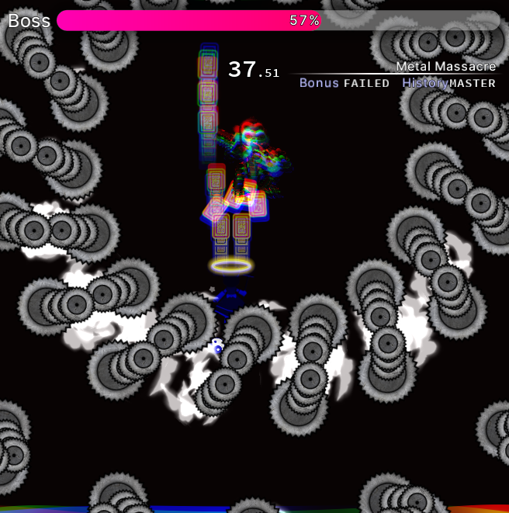

Attack 6: ***“Metal Massacre”*** | **Score: 14**

This isn’t all that but the idea of it is just so hilarious to me.

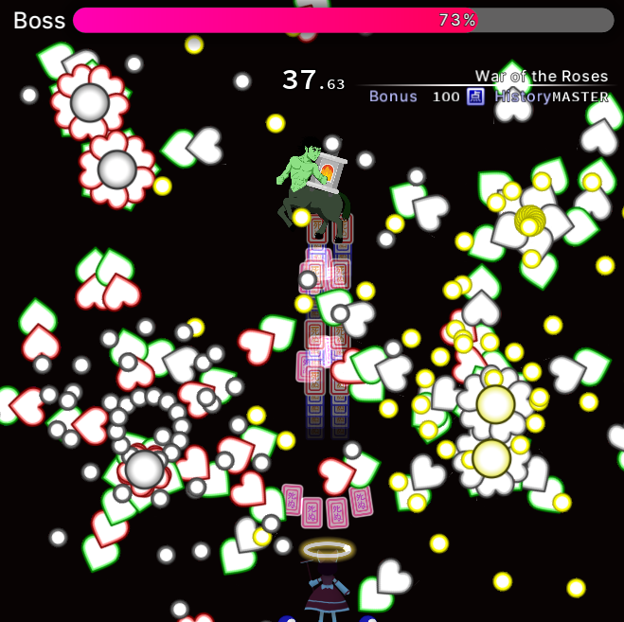

Attack 7: ***“War of the Roses”*** | **Score: 16**

I probably wouldn’t associate roses to a green minotaur with a chimney glued to their back but to each their own.

And then the game never ends.

Regarding ***beauty/atmosphere stuff***:

I do think the death effect is kinda cool, it clears bullets on the screen but only within a certain range around the player, and the little distortion it does is quite nice. In general, the smoothness of the interface, despite being void of much construction, is pleasing.

The spell card cleared (well, failed) toast falling down like a loose plank is pretty cool, too.

***Score: 9***

Regarding ***miscellaneous stuff***:

Despite, uh, the game itself, it’s still notable to mention the existence of a settings menu that lets you change up some game options. That’s cool. The fact you can still change settings during gameplay is also very nice. Even though changing the BG crashes the game, lmao. I quite like how compact the game folder is too, only having 3 files.

One aspect of the game I’m not really fond of is hiding the bullets from the playing field during pause. It most surely will surprise the player in case they don’t remember where the bullets are.

***Score: 6***

## Random Boss Rush

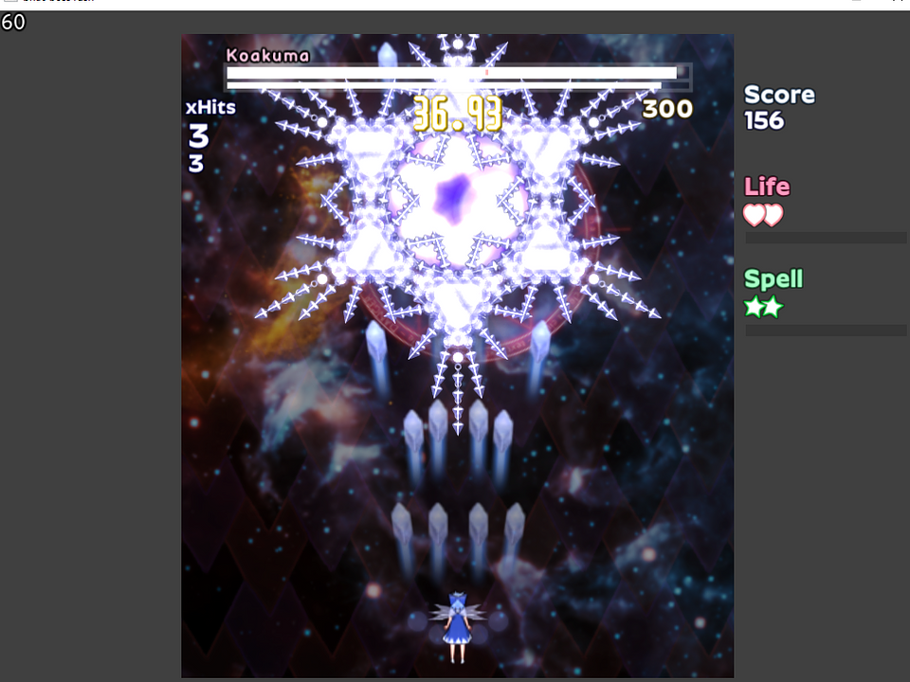

*Developed by: razzy*

*Engine: Custom*

This game had a peculiar combination of things that made me go “wow that’s so cool” but at the same got me perplexed by the design choices taken. Nonetheless, it was a pretty pleasing experience.

Information about the game came alongside the Discord post raz made submitting the entry, as well as the BulletForge page for it.

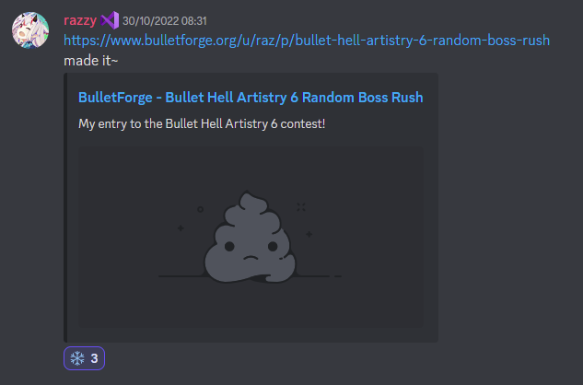

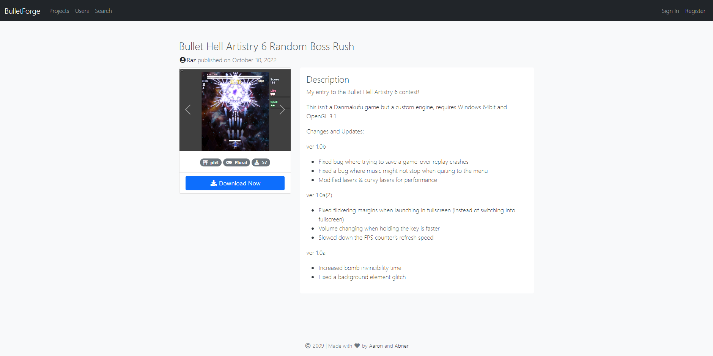

Well, let’s head right into it.

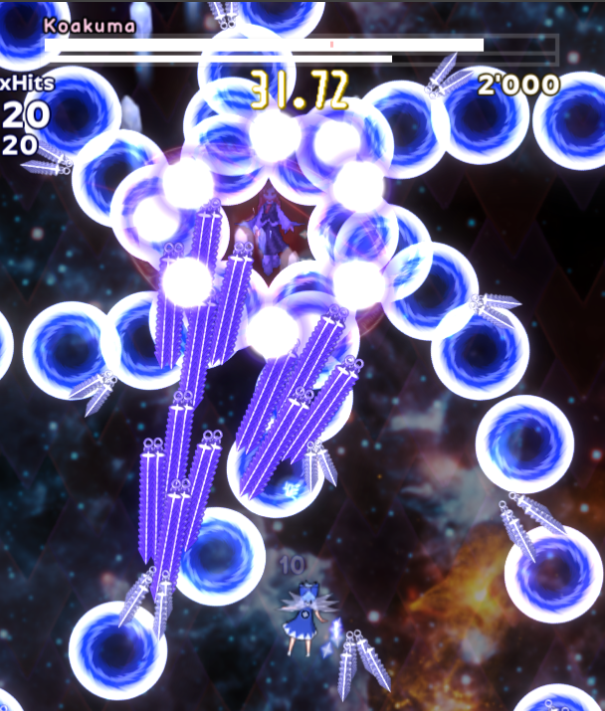

Attack 1: ***Nonspell (Koakuma)*** | **Score: 26**

Very in character for Koakuma. I’m definitely impressed by the graphical effects here, I think they’re quite stunning to say the least. I believe it’s a good introduction to the game. By the way, I really enjoy the quirkiness this game has with the seemingly wider playfield cropped by your current position.

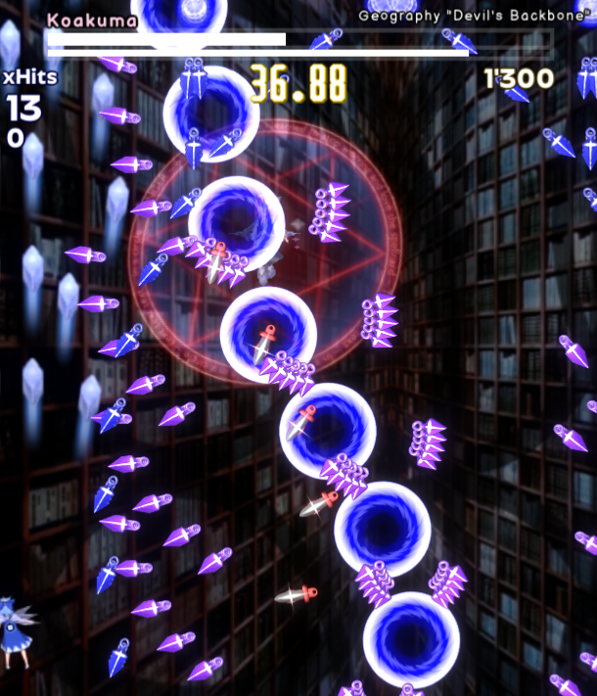

Attack 2: ***Geography “Devil’s Backbone”*** | **Score: 25**

This is quite a quirky spell, I enjoy it. Perhaps leaning it a little bit more to the harder side, but regardless. I actually quite like the pick on Koakuma here, she really is a character that can be expanded upon pretty well, and I think this is a pretty nice execution on that.

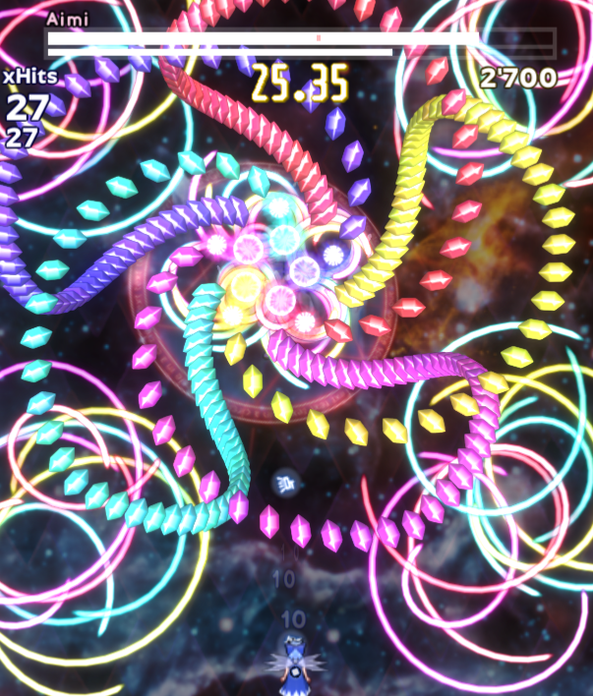

Attack 3: ***Nonspell (Aimi)*** | **Score: 30**

Aimi here is just stunning. I love the danmaku glow here and it’s truly impressive. Very representative of her original danmaku, and it looks quite nice. A very fun danmaku to dodge, too.

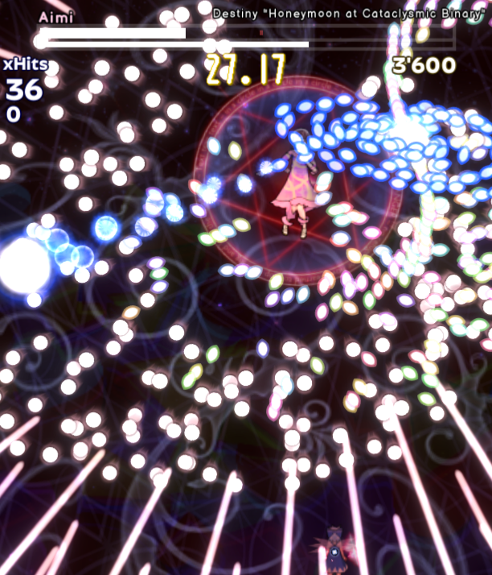

Attack 4: ***Destiny “Honeymoon at Cataclysmic Binary”*** | **Score: 29**

The cyclone thing spinning around is pretty fancy, I have to say. The danmaku is pretty tight, but cool to dodge. I’m not sure what much to say about this, but I vibed with it.

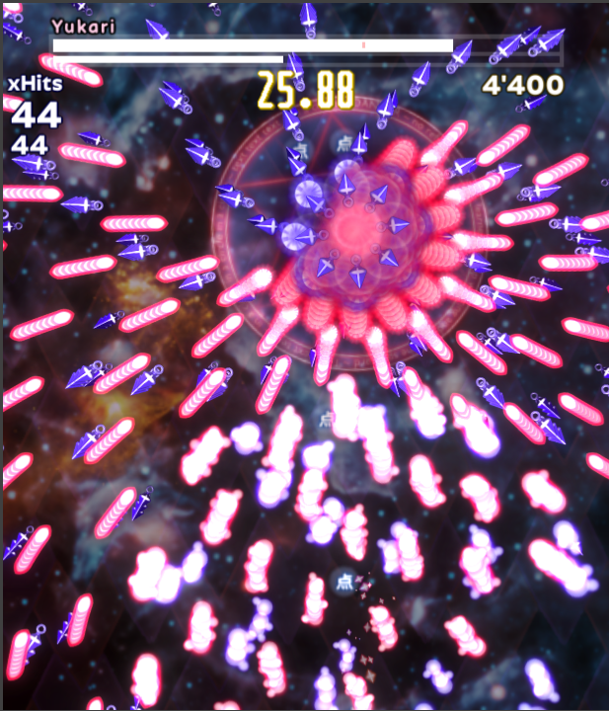

Attack 5: ***Nonspell (Yukari)*** | **Score: 28**

It’s basically BoWaP with an extra layer to it. I guess I can’t say much considering this is Yukari after all.

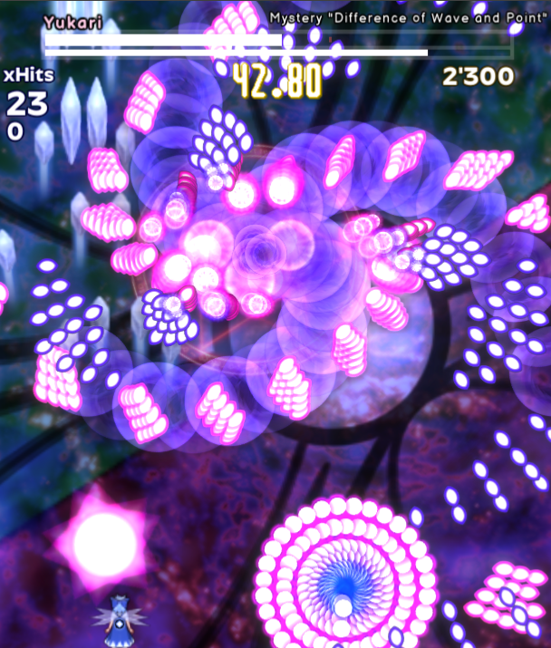

Attack 6: ***Mystery “Difference of Wave and Point”*** | **Score: 36**

Wow, this pattern is definitely a highlight, absolutely. Incredibly fun, the mechanic within it is super fun and I loved it.

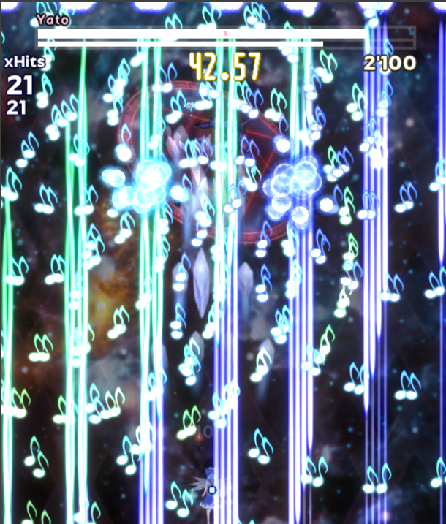

Attack 7: ***Nonspell (Yato)*** | **Score: 30**

This is a very visually pleasing nonspell, I love this color combination. Quite a fast paced non, I really enjoy it. Reminds me a little bit of Taira no Fumikado. I like the speeding up note bullets, this frenzy sort of pattern where you have to quickly position yourself in a specific lane or so is uber cool to me.

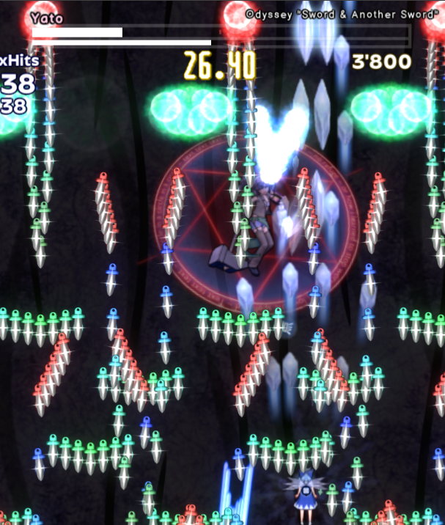

Attack 8: ***Odyssey “Sword & Another Sword”*** | **Score: 26**

A very finisher kind of vibe spell, adding more and more components to it as time goes on. It’s not very fancy compared to the previous stuff we’ve faced, but it’s nonetheless an interesting pattern.

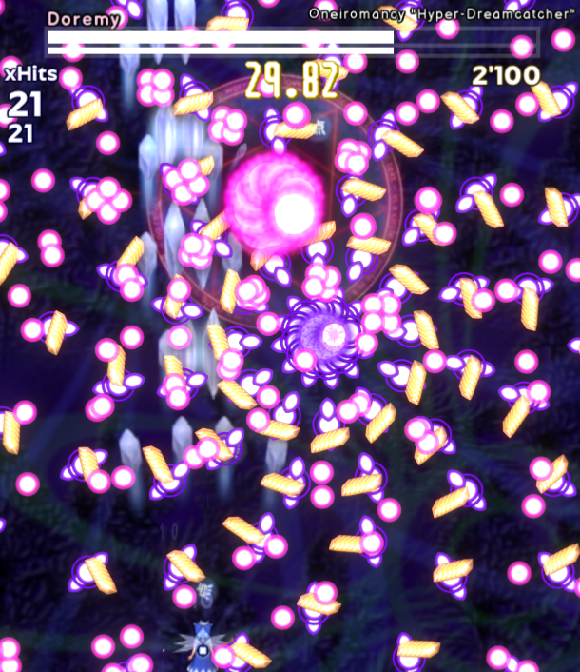

Attack 9: ***Oneiromancy “Hyper-Dreamcatcher”*** | **Score: 28**

Certainly a cool multi-phase kind of attack. I love the section where the bullets kind of seem to be heating up before spawning orange bullets, that looks cool. Honestly, I kind of expected something more grandiose judging from Doremy’s last dialog line, but it’s still interesting.

Overall, to say this game holds up mostly based on the danmaku it offers is quite an euphemism. I’d say it entirely on it, and honestly, I guess that’s a personal preference whether that’s good or not. Despite not being able to finish this game without continues, I think the difficulty is always mostly consistent between patterns. I especially applaud how nice the thumbnails I’ve included for the patterns look here, perhaps due to their density mostly, but it shows how nice the danmaku looks in general.

Regarding ***beauty/atmosphere stuff***:

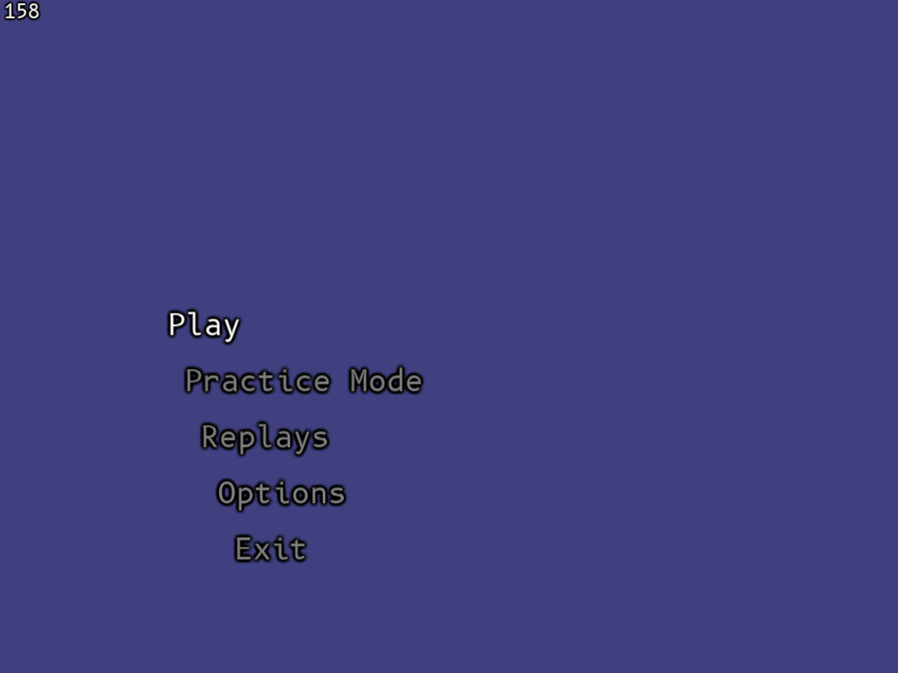

One of the first things that I was expecting from the author was at least a partial glow up in terms of presentation. I think literally every game I’ve played from them featured this same style of title screen: MS Gothic (pardon for my font recognition skills) over a flat colored background. I understand a lot of the development perhaps went into refining the engine the game is built upon, since it is a custom made one, but for the end player, it just looks bland. It doesn’t help the fact that a command prompt window opens alongside the game that kinda gives the feeling of “this is a debug build” instead of a released project. And you can’t even close it without also shutting the game down. The lack of any feedback (audio cues, further vfx) other than seeing the option alter when pressing the moving keys is also disappointing.

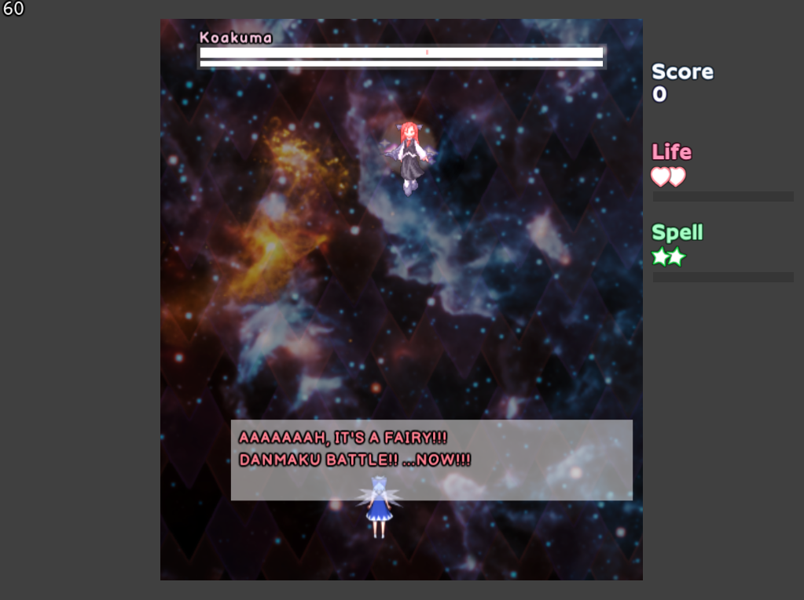

The HUD also looks very dull and empty. Which is very surprising considering there is a HUD board image included with the game inside the resources (which are open for the user to toy with), even if I’m still not a big fan of it.

The dialog system is also just as crude, unfortunately. I can’t help but also notice a lack of executable icon. Sorry that I’m pointing out all of these things without addressing points that I’m liking so far, but these are things that strike me really hard when I’m looking for things to analyze in the games. There is cool stuff that I spot here! It’s honestly just easier to spot things that I deem lacking and talk about them missing.

First of all, being up for the debate or not, regardless, I really like the effort put into the danmaku effects. They truly look gorgeous. Some could say they’re a bit distracting, but honestly, it’s this game’s best effort in terms of gripping into something neatly designed. The danmaku images themselves are also pretty good looking. Even their destruction effect looks good and organic. I think the danmaku in this entry truly represents the feeling of “magic” that this art entails.

The boss explosion effect is very flashy, and the player death animation, despite being a little bit too slow in flow for my taste, is also pretty nice looking. Talking about the player, I’ll also applaud the sprite itself. It looks 3D modeled exported in a 2D sheet, but the animation is really good and the model itself looks great. I also extend this to the boss sprites that are from this same source, they’re great. However I will point out how awkward it is to mix in CtC sprites alongside them.

Sound wise, I kinda liked the sound effects and I felt like the music suited it a lot.

***Score: 19***

Regarding ***miscellaneous stuff***:

Regardless of a simple title screen, I cannot omit the fact that practice options are available and that the settings menu is quite robust. It’s good to see that you can also change input settings, which I don’t remember seeing here. Very good to see that being included within the pause menu, too! It’s a shame the music volume doesn’t work (why is this being a trend in the entries?).

In general, I just wish this game had a lot, lot more polish visually and I’d definitely rank it up way higher if some development had gone into it. There’s just a big lack of identity here coming head first simply by the game title: Random Boss Rush. There’s no… flesh to it, it feels like a disposable game, even though the gameplay itself is lots of fun. I just wish it felt more “prideful”, in a way, of being a cool game.

***Score: 10***

## Elegant Quintessence - All-Star Artistry -

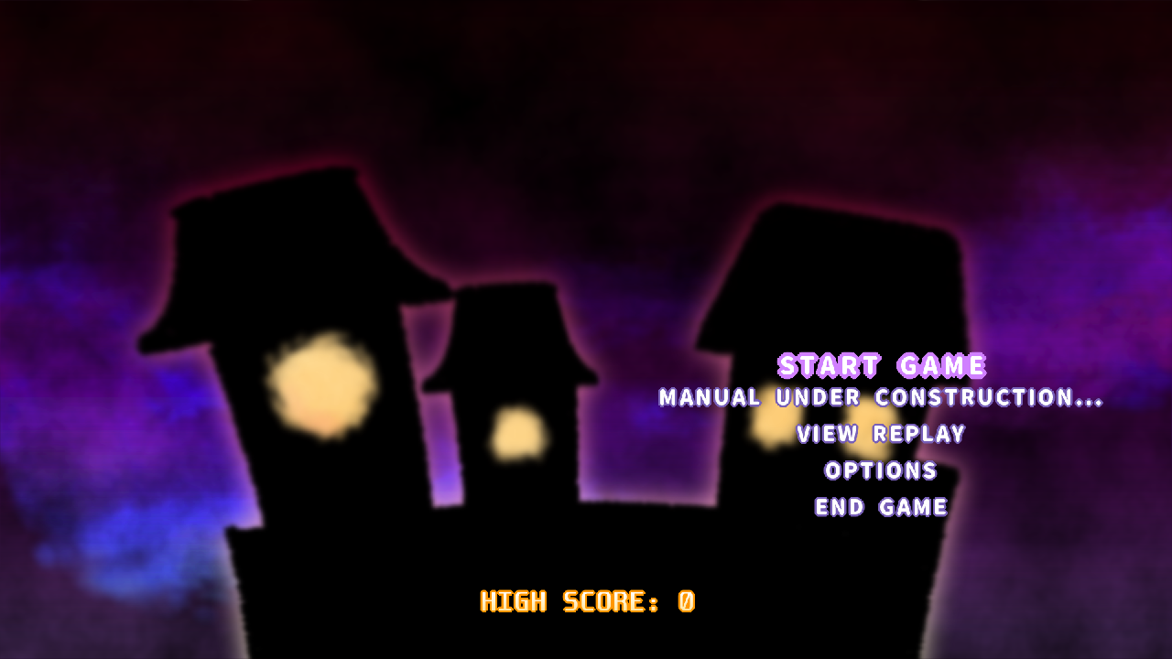

*Developed by: Kevin Minh*

*Engine: Danmakufu ph3sx*

This one strangely didn’t have any cover image for it, so I used the title screen for the main banner for it here. I had some expectations for this one, considering Kevin was the grand winner of one of the editions of BHA. I also have to mention the presence of a text file with some useful tips for the judges of the contest about their entry. Thanks!

Information about the game came alongside the Discord post Kevin made submitting the entry, as well as the itch.io page for it.

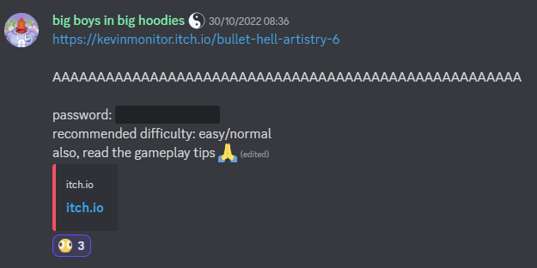

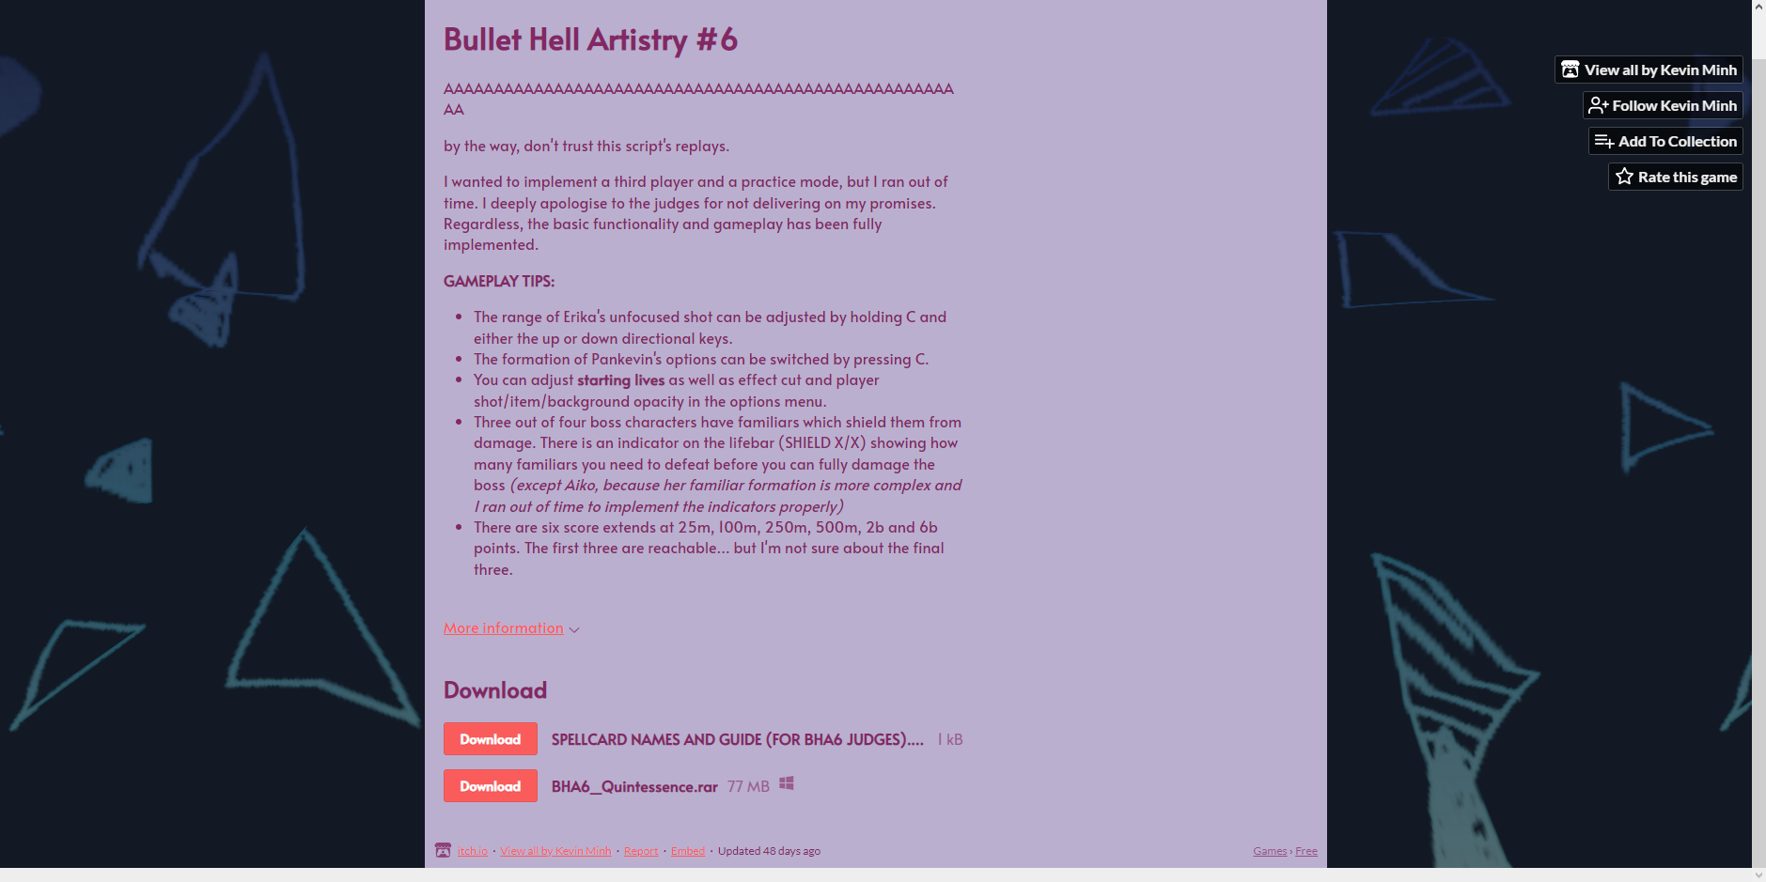

Quite a funky title theme by the way. Quick note, the spell cards names aren’t featured in the game, and are only present in a separate text file with judge tips. Weird.

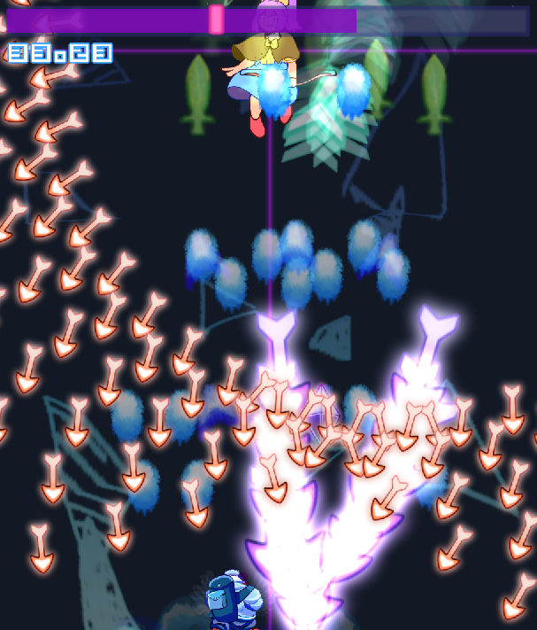

Attack 1: ***Skywards Arrow "Encompassing Heaven and Earth"*** | **Score: 21**

Without much introduction, we’re thrown right into the battle. The lack of danmaku sound effects deeply annoy me, honestly (edit: I noticed now there *are* sound effects, but they’re so soft and so low I didn’t even notice them). I kinda like how much of this attack is divided into phases.

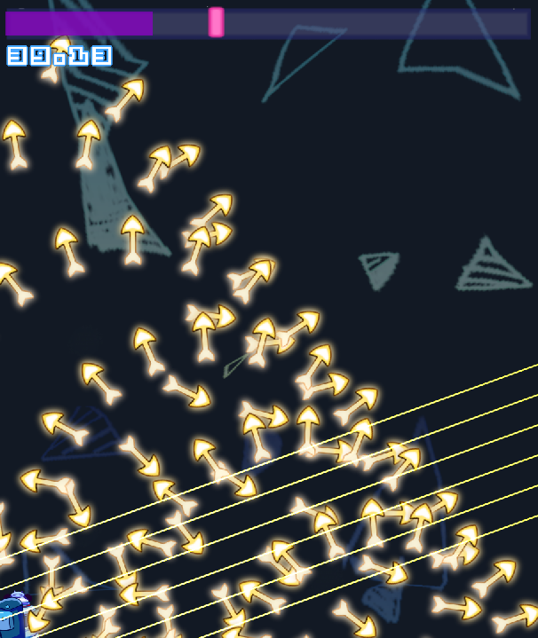

Attack 2: ***Condensed Energy "Revolutionary Arrow"*** | **Score: 24**

This one feels so tight. In general, I feel like this game’s playing field is so small, probably because everything just feels gigantic inside it. Which makes me feel very claustrophobic playing it. Not sure what to think, but it definitely doesn’t feel like normal mode.

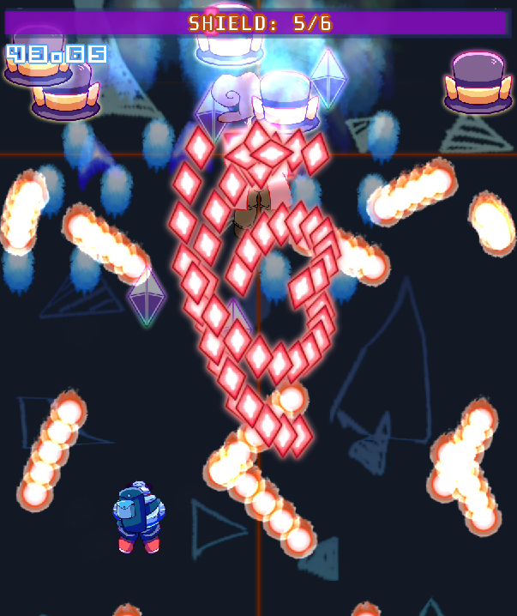

Attack 3: ***"The Puppeteer's Revolving Hat Show"*** | **Score: 27**

Looking better, I suppose. A little bit repetitive but the familiars and boss look so cute. The build up is pretty fun! I love how the hats are actually shields that change up the danmaku as you break them. I love this feeling of progression in a single pattern.

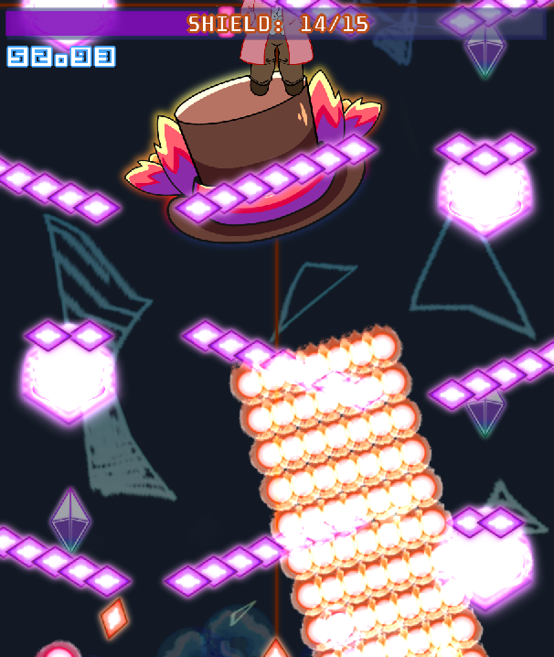

Attack 4: ***"Fire-Forged Path to A Successful Hat Boutique"*** | **Score: 26**

Chaotic, I’m diggin’ that. I love the giant hat bursting out these recurring flame waves with the descending familiars on the sides, I really like the way you can break them pretty easily.

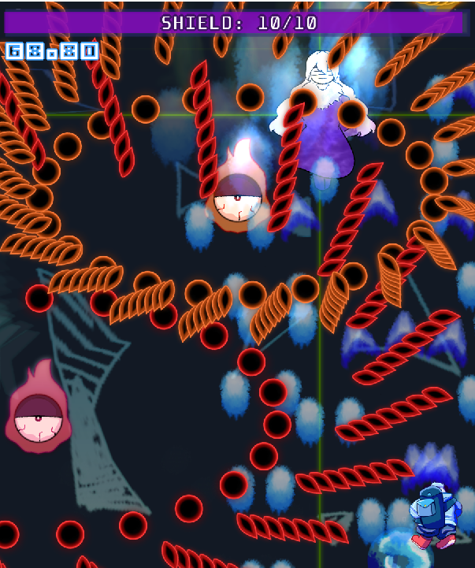

Attack 5: ***Aetheral Gaze "Circulation & Civilization of Magic"*** | **Score: 25**

Wtf Kobito jumpscare. The revenge bullet sorta deal here is pretty fun, but honestly it feels like way too much is going on to keep track of everything at once. Or maybe I’m too bad. I found this attack easier to time out than actually defeating it. (edit: on another note, perhaps focusing on killing the familiars ended up being better in the end)

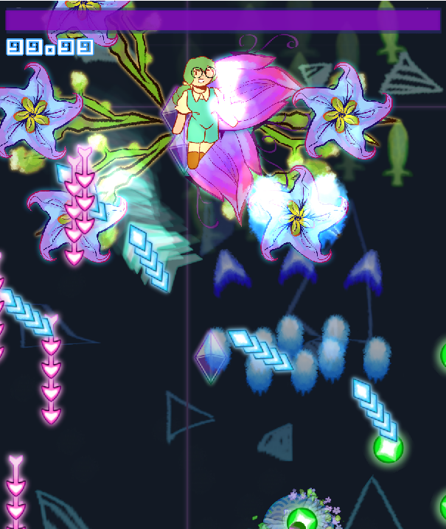

Attack 6: ***Organic Invention "Unstoppable Flora-Powered Chartereuse Queen"*** | **Score: 25**

A pretty fast attack. I find the boss aesthetic gorgeous, so props for that. Reminds me of Eternity, a little bit. Very interesting final pattern, I like how it keeps deconstructing itself up until it becomes a basic pattern and you finish off the boss at the end, kind of like removing petals off a flower.

The hitboxes feel fairly forgiving, so I’m glad it is that way because for some reason this game in general left me a bit disoriented, I don’t know why though. Loved the spell card names in the game.

Regarding ***beauty/atmosphere stuff***:

It’s definitely visible here this game reuses a lot of content from Kevin’s previous projects and I totally comprehend why Kevin wouldn’t publish this publicly and why he apologizes for this game, comparing it to his winning previous entry. There is a pretty big stark contrast between this game and the other one, but I won’t focus on that a lot, and I’d rather appreciate the present here. I’m very glad that, despite everything, the people who submitted, including Kevin, did. It’s a pleasure to be able to partake in judging and you don’t have to apologize for anything. Despite knowing you’re better than this, we can always learn something new together.

The main menu is very simple, the background image is kinda cute, but the options feel a bit crude in terms of visual complexity. There’s no transition effects (other than fading into the stage), things just look a bit dull.

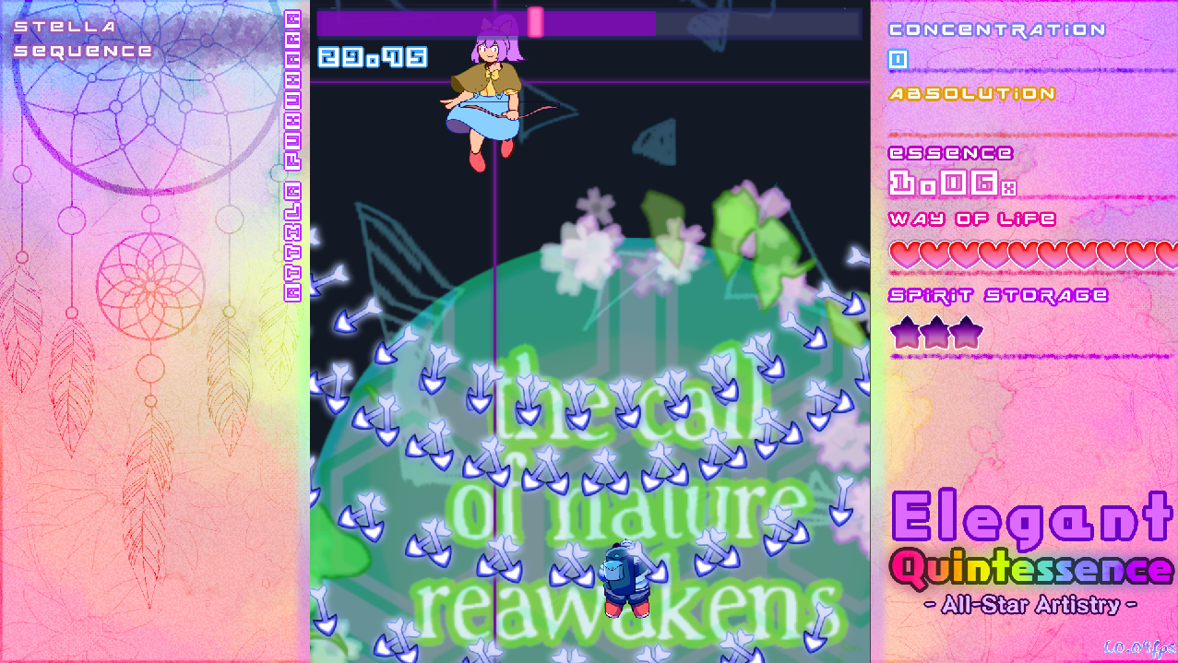

I really really enjoy the very cute idea of the HUD on the game, but maybe I’d darken it a little bit around the area with the important information relevant to the player. I’m not sure how much the font of the game’s logo matches the rest of the interface, unfortunately. Neither does the fps font, which I only really noticed when I took the screenshot above.

The player characters look cool, but I have a little bit of a difficulty regarding visibility with them, especially Erika’s focused shot type. I feel like the spinning wheel is a bit disorienting to me. In general, I found the first team’s shot type more pleasing to use. But that may be because I’m not much of a quirky shot type user, I know, what a shock. The “inspirational text” that comes up decreasing after you die is also a little bit over the top to me. But what bothers me the most is how unsatisfying *dying* feels like. I barely felt any impact when bullets hit me. The sound being so simple takes a big part on that I believe.

The sound design in this game irritates me a little, because, while coinciding a lot with the general design of the interface and the character styles, I don’t have the feeling that it’s actually bullets being shot that are deadly to me, it all feels so soft and it’s like I’m in the MLP world of friendship.

There’s absolute potential here.

***Score: 21***

Regarding ***miscellaneous stuff***:

Appreciating the different difficulty settings despite what seems to be a rushed game, as well as player shot selection. It’s always a neat detail to include those little random tips on the pause screen ala Tri-Focuser. The options menu has a few cool settings too.

Not sure what else to say. It's a simple game.

***Score: 7***